Dear

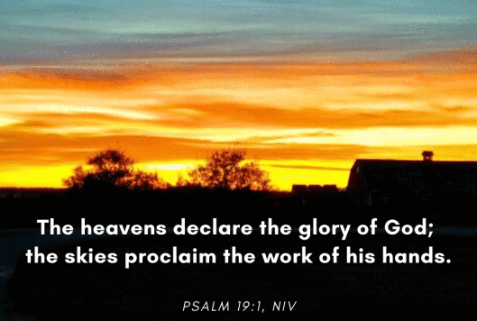
Given the beautiful sunsets of late, this verse came to mind.

Two short videos have been uploaded to YouTube. One is a short communion service, and the other is a bible reading and talk. Visit this YouTube link and click on each video to view. If you click ‘Subscribe’ you’ll be notified when we upload new content. I think it may be better to keep 2 videos, which can be viewed separately rather than combining them.

- If you haven’t already seen it, have a look at a wonderful video on Youtube that was posted last week. It is a short song by numerous church folk around the country. Enjoy and receive its message: Youtube: The UK Blessing
- ‘Thy Kingdom Come’ is a global movement that invites Christians around the world to pray from Ascension to Pentecost for more people to come to know Jesus. May 21st – May 31st is the focussed time to pray, an 11 day period. One suggestion for us is that we commit to pray the Lord’s Prayer at a particular time o of the day, on behalf of our family, friends and churches. Maybe 12.00 noon each day (and if we forget, still say the prayer when we remember). Revd Canon Chris Russell, Archbishop of Canterbury’s Advisor on Evangelism says ‘this year as we pray for others, we pray that they may come to give their lives to serve God’s Kingdom ... to pray for 5 others who don’t know the love of Christ. If you want to know more about this, search ‘Thy Kingdom Come 2020.’ Mark these dates on your calendar, pray for your 5 people and say the Lord’s Prayer for 11 days at noon.
- The Church of England has marginally changed the guidelines on the lockdown of churches. Now, the vicar (and members of their household) will be allowed into the church for private prayer and recording services. A small step towards the churches being open for public worship. So the service this week is from Whitmore. Next week and the week after, it will be from Maer and Chapel Chorlton. They will be communion services, so you are welcome to have bread and wine ready.

