Latest News – 2nd May 2020

**
Key workers to contribute to special vocations church service
Key workers will speak of how their Christian faith has helped give them strength to serve others during the coronavirus pandemic, in the Church of England’s national weekly online service to be broadcast on Sunday.
Matt Sanderson, a senior paramedic with 18 years of service in the NHS, and Robert Vassell, a bus driver, will speak about their faith as part of a live-streamed service marking Vocations Sunday – celebrating the call of people to serve in a range of different roles.
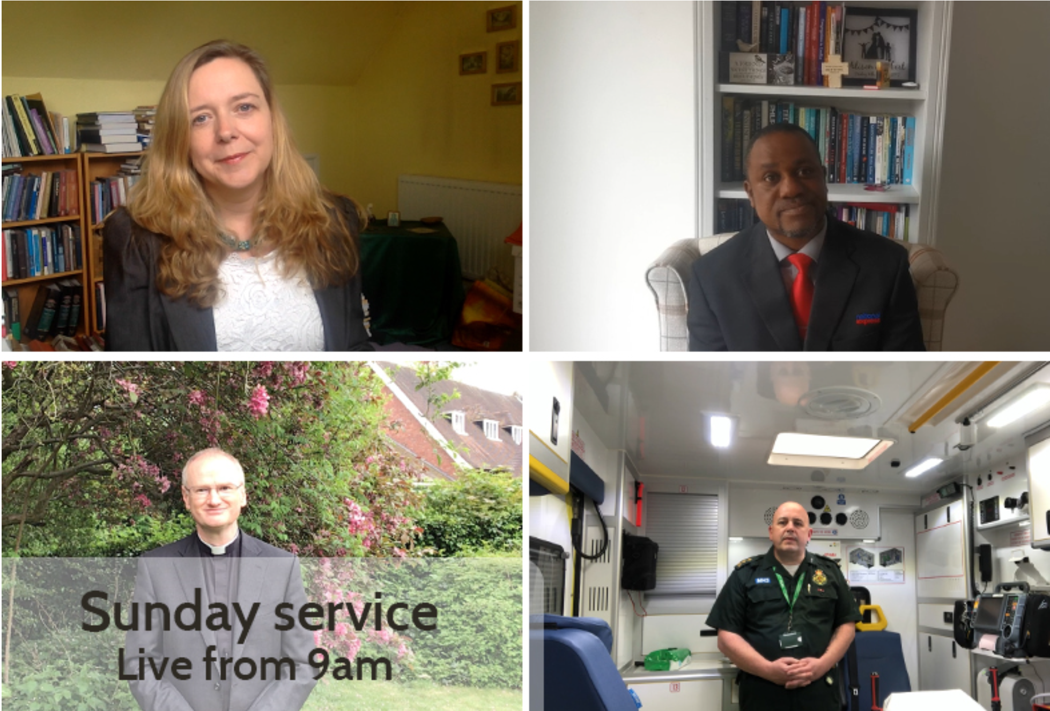
The service will be led by Dr Paula Gooder, Canon Chancellor of St Paul’s Cathedral, who is a licensed lay minister in London and Birmingham, with contributions from her husband, Revd Peter Babington.
Prayers will be read by Tak Muriro, a church youth leader who is taking part in the Church of England’s Ministry Experience Scheme in Sheffield.
Mr Sanderson, from Oldham, Greater Manchester, who is due to be ordained as a Deacon in the Church of England later this year, will speak of how God is always with us even at the most difficult times.
He will say: “My job challenges me, every day my colleagues and I walk into the unknown, to offer hope and relieve suffering as best we can. There is no better feeling than having made a difference in someone’s life and as frontline clinicians that is what drives us into work each and every day
“These are challenging times and the world has become a very scary place, fighting an invisible enemy. “
In his message, he discusses the challenges of physical distancing from family and friends.
“Yet throughout this pandemic, I am reminded by that still small voice: ‘I am not alone,” he continued.
Mr Vassell, from Wolverhampton, will speak of how interacting with passengers is the highlight of his job – and how his faith helps him to give reassurance to passengers and colleagues who are anxious and uncertain as a result of the pandemic.
“My trust and faith in God enables me to have peace, not to focus on myself but to look after my colleagues and my passengers. This enables me to go through each day with confidence that God is with me,” he will say.
In her sermon, Dr Gooder will say that God’s call to love is the same but takes ‘infinitely different’ forms in the lives of each one of us.
She will say: “At times like this, when our world feels turned upside down, living out our callings can be really hard. All those things we knew we used to be called to, feel at best fragile and at worst impossible. The ways we normally did things have fallen away and we are left feeling uncertain and often useless.
“At times like this all we can do is listen again to the voice of the God who calls, reminding us that we are loved with a love beyond measure, calling us by name and asking us to pour out this great love in any and every way we can.”
The service, for the Fourth Sunday of Easter, will be interpreted into British Sign Language with subtitles. The hymns have been contributed by singers from St Martin-in-the Fields Church in London. All contributions were recorded separately in accordance with the rules on physical distancing.
As in previous weeks, the service will be available from 9am on Sunday on the Church’s website, Facebook page and on YouTube.
**
Over 6,000 calls in the first 48 hours to Daily Hope, the free dial-in worship phone line amid coronavirus lockdown
The Archbishop of Canterbury, Justin Welby, launched Daily Hope on Sunday as a simple new way to bring worship and prayer into people’s homes, during the lockdown period.
The line – which is available 24 hours a day on 0800 804 8044 – has been set up particularly with those unable to join online church services in mind.
The service is supported by the Church of England nationally as well as through the Connections group based at Holy Trinity Claygate in Surrey and the Christian charity Faith in Later Life.
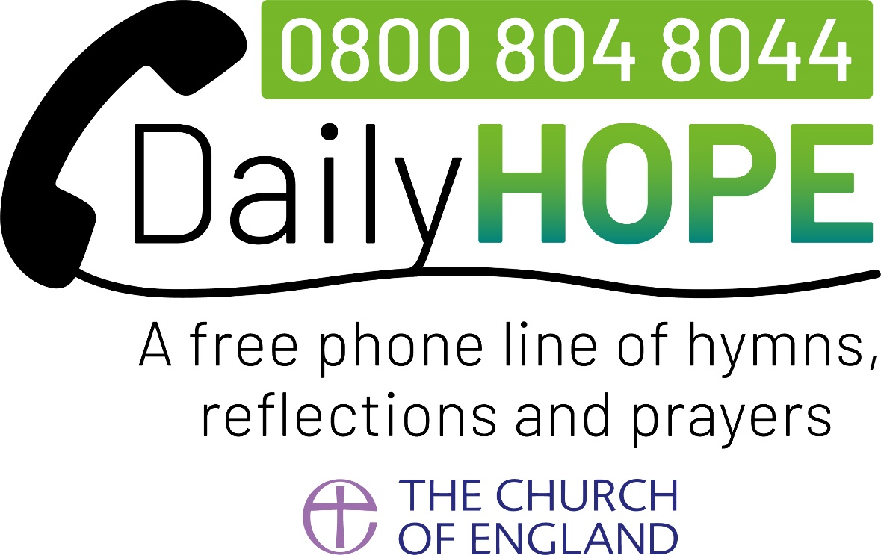
By 7am on Tuesday morning the line had received more than 6,000 calls from across the country, with many being referred by friends, family or members. Calls have so far spanned more than 50,000 minutes, with some of those accessing the service listening to the music, prayers and reflections for up to 50 minutes at a time.
The Revd Canon Dave Male, the Church of England’s Director of Evangelism and Discipleship, said: “The volume of calls over the first two days really shows that Daily Hope is meeting a need
The Archbishop of Canterbury, Justin Welby, launched Daily Hope on Sunday as a simple new way to bring worship and prayer into people’s homes, during the lockdown period.
The line – which is available 24 hours a day on 0800 804 8044 – has been set up particularly with those unable to join online church services in mind.
The service is supported by the Church of England nationally as well as through the Connections group based at Holy Trinity Claygate in Surrey and the Christian charity Faith in Later Life.
By 7am on Tuesday morning the line had received more than 6,000 calls from across the country, with many being referred by friends, family or members. Calls have so far spanned more than 50,000 minutes, with some of those accessing the service listening to the music, prayers and reflections for up to 50 minutes at a time.
The Revd Canon Dave Male, the Church of England’s Director of Evangelism and Discipleship, said: “The volume of calls over the first two days really shows that Daily Hope is meeting a need
“While we all long for the day when we can meet together in person in our churches again, we have a duty in these strange and difficult times to find new ways of bringing prayer and worship to people wherever they are, and this is one more way of helping people to connect with God from their own homes.
“This is such a simple idea – planned and launched all within a few short weeks by a small dedicated team – but I pray it will bring real comfort, hope and inspiration to people at this time.”
Carl Knightly, chief executive of Faith in Later Life, added: “The Church must be those who continue to offer hope to our nation at this time, so I’m delighted to see the significant number of people already using the ‘Daily Hope’ phone service during this lockdown.
“When I heard of the numbers of people calling in once the service was launched, I was not surprised, because Faith in Later Life has heard stories of many feeling isolated and alone.
“I am keen to see people continue to tell of Daily Hope if they haven’t already, sharing this free phone service with family, friends and neighbours.”
Pippa Cramer, founder of Connections, said: “I am really thrilled by the impact Daily Hope is already having on thousands of older people in just the first couple of days since its launch.
“Responses like the following just fuel my excitement and encourage me to keep praying: ‘I have been trying to call Mary for a while now but the line is engaged. Her son has just sent me a text and the reason for the engaged line fills me with joy and delight. She is listening to Daily Hope! Thank you, thank you’.”
Callers to the line hear a short greeting from the Archbishop before being able to choose from a range of options, including hymns, prayers, reflections and advice on COVID-19.
Options available include materials also made available digitally by the Church of England’s Communications team such as Prayer During the Day and Night Prayer, updated daily, from Common Worship, and a recording of the Church of England weekly national online service.
A section called Hymn Line offers callers a small selection of hymns, updated daily. An option entitled ‘Hymns We Love’, provides a hymn and reflection and is based on an initiative by the Connections group.

**

Nigel Beeton works in Radiology in a hospital in the East of England. During this time of the coronavirus crisis, he is writing a weekly diary of his life at the hospital.

On the Covid Frontline: 1st May 2020

Is it too early to start using the past tense with regard to Covid-19?
Well, yes, of course it is. To abuse Winston Churchill’s quote, this certainly is not the end, but it just might be the ‘end of the beginning’. At our hospital, we are down to just five patients remaining in intensive care, for which I (and many others) thank the Lord.
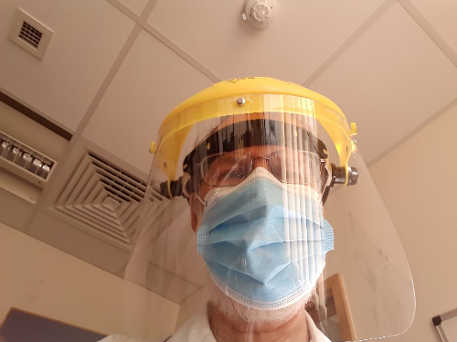I have a feeling that the turning point was Wednesday (22nd). Up to then I seemed to have my visor on as much as off, assisting my staff, mainly in CT.
Then, on Thursday, they didn’t call me at all! Friday was a bit busier, but today (Sunday) the feeling that things are calming down is becoming more widespread.
I write with some trepidation, for even as a Christian I’m superstitious about using the ‘Q’ word. (‘Quiet’. NEVER use that word in the presence of a working health professional!)
I apologise, Gentle Reader, for my darker blogs of a week or two ago, when I was raging at idiots for breaking the lockdown. Indeed, I was tired, and I can now share that I had fallen victim not to the virus but to a virus, when an agonizing rash spread across the right side of my body.
My GP asked me (on the phone) if I had been tired and run down. My slightly abrupt reply of ‘haven’t we all?’ got a grunt of assent before she diagnosed me with an attack of the shingles. But now I find it feels less as though I’ve lost a fight with an aggrieved stallion and my own mood is lifting along with many of my colleagues, so I find myself able to give thanks that so many did observe the lockdown, and now we begin to see the benefits.
Sometimes over the past few years the NHS has felt like a bit of a public whipping boy, and indeed sometimes we have let people down, and if you are one of those people I am genuinely very sorry; but please don’t ever think we do not care. We do. We get up in the morning in the hope of doing good, prepared to do daily battle with the forces that combine to do harm to the populations we serve. The Coronavirus is but one of those enemies, if you are concerned that any of the others have you in its grip, heart disease, cancer, anything, then do seek help; we in the NHS will do our best to help you and to protect you from any other kind of harm.
But suddenly we in the NHS are getting thanked. For forty years I have plodded towards various hospitals at various odd times of day or night, and never once has anybody stopped me and said ‘thank you’. Nor would I have expected it (they do pay me!) but that is exactly what happened to me on Monday morning. I was just getting onto the site when a lady who I have never met asked me if I worked at the hospital. I replied in the affirmative, wondering what was coming. “Thank you,” she said. “Thank you so much, all of you.”
Well, thank you, ma’am. I cannot tell you how much the appreciation and support of the general public has meant to us all. The rainbows in the windows, the ‘I love the NHS’ slogans appearing everywhere; the clapping on Thursday evenings. And let us pray that, standing together as we have done, perhaps we are all beginning to turn the corner.
Nigel Beeton

**

School’s out too soon for the summer
Any other year, unexpected freedom from end-of-term lectures and exam timetables would surely be cause for celebration. But this year, many students’ terms have ended with a tremendous anticlimax.
Spare a thought for those who, whether they’re sixth-formers or prospective grads, will have no summer term, no celebration party, no opportunity to hug their friends goodbye. Many had to leave their student houses and head home suddenly, now figuring out how to complete their degrees from a distance. It wasn’t meant to be like this. And there’s nothing they can do about it, except sit in the disappointment.
The temptation is to run from or deny this reality: be it watching all of TIGER KING in a weekend or bulldozing our emotions with ‘God’s in charge’ mantras. But the gospel shows us and the students we know a better way. Rather than a God who shows us how to escape disappointment, Christians believe in a God who shows up IN our disappointment.
The writer of the letter to the Hebrews captures this fact, in pointing out that Jesus is not ‘unable to feel sympathy for our weaknesses’ (4:15). Jesus dealt with disappointment too – we see it in His response to His townsfolk’s lack of faith, and His closest friends falling asleep when He needed them most.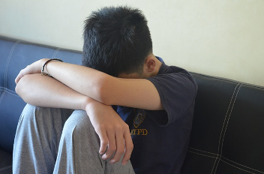
If disappointment was an experience for Jesus, we can be sure it will be an experience for those who follow Him. Recognising there is no quick fix, on-demand, life-hack solution might be a way to help the students we love to come to terms with their disappointment.
To do so might even be the first step towards a more profound truth: Christians do not believe that we face disappointment alone. He is IMMANUEL – God with us. And as we discover that reality, our disappointment might not only be validated, it might be transformed.
Knowing Jesus and trusting Him is a hope that ‘does not disappoint us’ (Romans 5:5). Because in God’s story, disappointment – whether a missed goodbye or a Saviour on a cross – is only momentary. The truth is that He’s putting this not-as-it-should-be world back together, as His kingdom comes, day by day. This is the hope of the gospel. And that kind of hope is good news for all of us, including students.
* (London Institute for Contemporary Christianity)

Take comfort

Pslam 91
Whoever dwells in the shelter of the Most High
will rest in the shadow of the Almighty.
² I will say of the Lord, “He is my refuge and my fortress,
my God, in whom I trust.”
³ Surely he will save you
from the fowler’s snare
and from the deadly pestilence.
⁴ He will cover you with his feathers,
and under his wings you will find refuge;
his faithfulness will be your shield and rampart.
⁵ You will not fear the terror of night,
nor the arrow that flies by day,
⁶ nor the pestilence that stalks in the darkness,
nor the plague that destroys at midday.
⁷ A thousand may fall at your side,
ten thousand at your right hand,
but it will not come near you…
⁹ If you say, “The Lord is my refuge,”
and you make the Most High your dwelling,
¹⁰ no harm will overtake you,
no disaster will come near your tent.
¹¹ For he will command his angels concerning you
to guard you in all your ways;…
¹⁴ “Because he^{[b]} loves me,” says the Lord, “I will rescue him;
I will protect him, for he acknowledges my name.
¹⁵ He will call on me, and I will answer him;
I will be with him in trouble,
I will deliver him and honour him.
¹⁶ With long life I will satisfy him
and show him my salvation.”

**

Some simple ideas

Pick up the phone. Why not decide to ring someone in your church and community, every day? Start a small group and design a ‘phone tree’ so that every participant both receives and makes a phone call each day.

For the more technically confident, introduce more people to video phone calls via Apple Facetime or Google Duo.

Is there a WhatsApp group on your street? Why not start one, to make sure that all your neighbours are safe, and no one is in need?

Become your street’s pastor: start praying each day for each one of your neighbours, and let it be known that you will help in any way if someone is in trouble. Kindness and compassion go a long way in a crisis.

Make the most of your family. Your children may drive you crazy at times but think about it: this is the only chance you may ever have to spend so much time with them. So do some home projects together, play games together, study together and cook together. Read the Bible with them, pray with them and TALK to them. How well do you actually know your own family?

**

Losing a loved one at this time.

Reverend Clive is here to listen and help at a time like this. Please contact him using the contact numbers given on this website or send him a message with your contact details.

What about the funeral?

Suppose you lose someone whom you love at this time?

Current guidelines from the Church of England, in light of the current restrictions over Coronavirus COVID-19, say that funerals may now only happen at the Crematorium or at the graveside. Only immediate family members can attend (if the crematorium allows).

When we lose someone we love, it is a time of great sorrow. A funeral is therefore a time for family and friends to express and share their grief, to give thanks for the life lived, and to commend the person into God’s keeping.
It is hard to bear the sadness and grief of losing a loved one if you cannot even go to their funeral. This may have a big impact on your grief and bereavement. Grief is a long and painful journey, and you may need additional support. (For more help please visit: www.churchofengland.org).

These prayers may be helpful for when you cannot go to a funeral

Dear God,
Thank you for xxxx, for all that they meant to me and others.
I so wanted to say goodbye, to be alongside my friends and family.
Help me to know you are there,
Holding all my hopes,
Holding all those I love, especially xxxx,
And holding me this day.
Be close this day with your peace and hope.
Amen.
Loving God,
Life is so strange just now – I don’t know what to do.
Comfort me with your presence,
Be with all who grieve
And give us strength and courage to face this and all the days ahead.
Amen.

Other News

Latest figures
The Johns Hopkins Covid-19 Dashboard appears to be one of the best source for statistics on the spread of the virus.

Joni Eareckson
The well-known American Christian writer and quadriplegic, Joni Eareckson Tada, talks about how Christians can meet the threat of the virus: ‘A Calming Word during the Coronavirus’

Mental health
- The Church of England has produced some mental health reflections to help you in this time of uncertainty. You can access them at: cofe.io/MentalHealth.
- The Mental Health Foundation has also produced some useful resources, which can be found at: https://www.mentalhealth.org.uk/coronavirus
- You can find a host of other mental health resources from a variety of different organisations and charities. https://www.mentalhealthatwork.org.uk/toolkit/coronavirus-and-isolation-supporting-yourself-and-your-colleagues/
- Some helpful books and resources are also available from Sacristy Press at https://www.sacristy.co.uk/books/coronavirus-church-resources#

Go to church this Sunday (virtually)
You can watch (and rewatch) the Church of England's virtual Sunday services here.

Time to Pray
The Church of England's Time to Pray app is now free to use.
The Easter Pilgrim app is also available for 40 days after Easter.

Are you rural?
The Arthur Rank Centre, an ecumenical Christian charity, has launched a resource hub to support rural Christians and churches, covering many aspects of rural Christian life.

What we should do in this crisis
Crises bring out the best in people. What has become immediately apparent over the last few weeks is that the reserves of kindness, generosity and love for each other are often far deeper than we could have imagined.
One of the challenges of this specific crisis is how inactive and intangible our help and selflessness must be. We can’t lean in, lend a hand and be present in the ways we would normally try to. Distance is a form of kindness and yet feels very unnatural. We have huge admiration for those in the NHS or other critical services who are on the physical frontline treating patients and at greater risk of exposure to the virus, but for most of us there is a sense of helplessness as the most beneficial thing we can do is wash our hands and sit on the sofa.
And we must pray. Pray for medical professionals, and government decision makers. Pray for those who are already isolated and concerned about cutting off vital connections. Pray for people who are at greater risk of more significant consequences of becoming infected. Pray for miracles. And pray for the witness of the church of Jesus Christ.
This is from the EA website at: https://www.eauk.org
Danny Webster, Evangelical Alliance
Coronavirus: a lesson from the past
‘So many people died that cities and villages in Italy … were abandoned and fell into ruin.’
That’s not a report about the impact of coronavirus, but an epidemic of smallpox that infected the Roman Empire in 165 AD. A second, equally devastating plague, possibly measles, swept the empire less than 100 years later.
Rodney Stark’s work The Rise of Christianity looks at the way Christianity spread in such a difficult context. The question is: How did this happen? Stark gives three reasons:
Firstly, Christianity offered a more satisfactory account of the world – and a better hope for the future – than the dominant pagan and Hellenic philosophies of the day.
Secondly, the Christian values of love and charity which characterised the early Christian community were also ‘translated’ into social service and community solidarity. In other words, those early Christians took care of the sick and vulnerable.
Stark quotes the early bishop Dionysius: ​“Most of our brother Christians showed unbounded love and loyalty, never sparing themselves and thinking only of one another. Heedless of danger, they took charge of the sick, attending to their every need and ministering to them in Christ, and with them departed this life serenely happy; for they were infected by others with the disease, drawing on themselves the sickness of their neighbours and cheerfully accepting their pains. Many, in nursing and curing others, transferred their death to themselves and died in their stead…” And the Romans marvelled at these Christians.
Thirdly, during the epidemic people lost the ‘social bonds’, the peer pressure, that had previously discouraged them from rebelling against prevailing ideologies and embracing the gospel.
Stark goes on to note that frequently in human history, crises produced by natural disasters have translated into crises of faith where the religion of the day is considered inadequate to the reality of people’s life-experience. In response to these failures of religion, societies often look elsewhere and adopt new faiths.
Of course, this all raises an important question: in light of coronavirus, how should Christians respond today? Inspired by those who have gone before us, perhaps I can offer three suggestions:
Firstly, we should use this period of ‘social distancing’ to reacquaint ourselves with the big story of the Bible. In the unfolding story of God and the world that we see in the Bible, we are presented with a robust and life-giving account of who God is, what the world is like, and what it means to be truly human.
Secondly, we need to ‘translate’ the Bible into our everyday lives. We need to practically live out ‘love of God and neighbour’. We should support our neighbours by offering to do shopping, collect parcels, post mail, and ensure they have someone to talk to on the phone.
Thirdly, we need to be sensitive to the fact that the current situation will unsettle people and, uninhibited by their social bonds, prompt them to think about God and the purpose of life, perhaps for the very first time, and we need to be ready for conversations about this.
In the second century, the Christian community responded to the smallpox epidemic not by being anxious or fearful, but by being courageous, prayerful, and deeply, and lovingly practical. We need to do the same, secure in the fact that ‘God is our refuge and strength, an ever-present help in trouble.’ (Psalm 46.1, NIV)
This may be found on the Bible Society website: https://www.biblesociety.org.uk/latest/news/coronavirus-lessons-from-our-past/
Paul Wooley, Bible Society

