BLACKROD, DAISY HILL, WESTHOUGHTON & WINGATES TEAM

Ascension Day

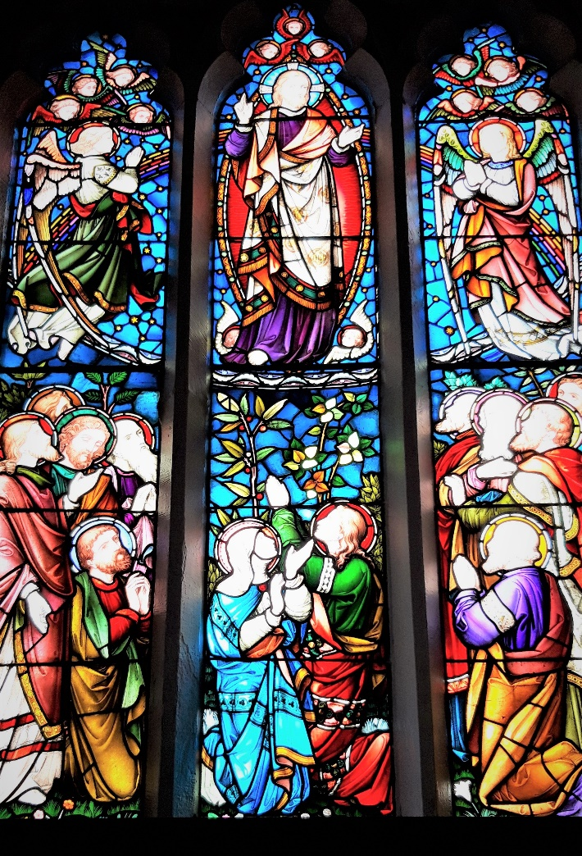

The East Window: The Ascension of Jesus, St John’s Wingates.

This beautiful window has Jesus at the centre with angels and cherubs around him as he ascends into the heaven. Beneath the feet of Jesus is the serpent to show he has overcome evil. The rainbow sweeping behind his shoulders reminds us of God’s covenant or promise. The lower part of the window shows Mary and the eleven disciples watching in wonder.

The window was given by John Pilkington, a local mill owner and benefactor of the church.
Preparation

O Lord, open our lips
and our mouth shall proclaim your praise.

Your throne has been established from of old;
you are from everlasting. Alleluia.

A Song of the King’s Glory

Blessed are you, Lord of heaven and earth,
to you be glory and praise for ever.

From the darkness of death you have raised your Christ
to the right hand of your majesty on high.
The pioneer of our faith, his passion accomplished,
has opened for us the way to heaven
and sends on us the promised Spirit.
May we be ready to follow the Way
and so be brought to the glory of his presence
where songs of triumph for ever sound:
Blessed be God, Father, Son and Holy Spirit.
Blessed be God for ever.

Opening Prayer

Almighty God,
your Son has opened for us
a new and living way into your presence.
Give us new hearts and constant wills
to worship you in spirit and in truth;
through Jesus Christ our Lord.

Amen.

The Word of God

Psalm 150

Glory to the Father and to the Son
and to the Holy Spirit;
as it was in the beginning is now
and shall be for ever. Amen.

Canticle: A Song of Christ’s Appearing

Christ was believed in throughout the world
and taken up in glory.

Christ Jesus was revealed in the flesh
and vindicated in the spirit.
He was seen by angels
and proclaimed among the nations.
Believed in throughout the world,
he was taken up in glory.
This will be made manifest at the proper time
by the blessed and only Sovereign,
Who alone has immortality,
and dwells in unapproachable light.

To the King of kings and Lord of lords
be honour and eternal dominion. Amen. 1 Timothy 3.16; 6.15,16

Christ was believed in throughout the world
and taken up in glory.

Scripture Reading

Acts 1: 1-11

This is the word of the Lord.
Thanks be to God.
Prayers

Intercessions are offered

The Collect of the day

Risen Christ,
you have raised our human nature to the throne of heaven:
help us to seek and serve you,
that we may join you at the Father’s side,
where you reign with the Spirit in glory,
now and for ever. Amen.

The Lord’s Prayer

Looking for the coming of his kingdom,
as our Saviour taught us, so we pray

Our Father in heaven,
hallowed be your name,
your kingdom come, your will be done,
on earth as in heaven.
Give us today our daily bread.
Forgive us our sins
as we forgive those who sin against us.
Lead us not into temptation
but deliver us from evil.
For the kingdom, the power, and the glory are yours
now and for ever. Amen.

The Conclusion

May Christ, who has opened the kingdom of heaven,
bring us to reign with him in glory. Amen.
New Patterns for Worship, material from which is included here,
is copyright © The Archbishops' Council 2002 and published by Church House Publishing.

Let us bless the Lord. Alleluia, alleluia.
Thanks be to God. Alleluia, alleluia.

