Reflection for Good Friday
From noon on, darkness came over the whole land^{[p]} until three in the afternoon. And about three o’clock Jesus cried with a loud voice, ‘Eli, Eli, lema sabachthani?’ that is, ‘My God, my God, why have you forsaken me?’ When some of the bystanders heard it, they said, ‘This man is calling for Elijah.’ At once one of them ran and got a sponge, filled it with sour wine, put it on a stick, and gave it to him to drink. But the others said, ‘Wait, let us see whether Elijah will come to save him.’ Then Jesus cried again with a loud voice and breathed his last. At that moment the curtain of the temple was torn in two, from top to bottom. (Matthew 27:46-50)

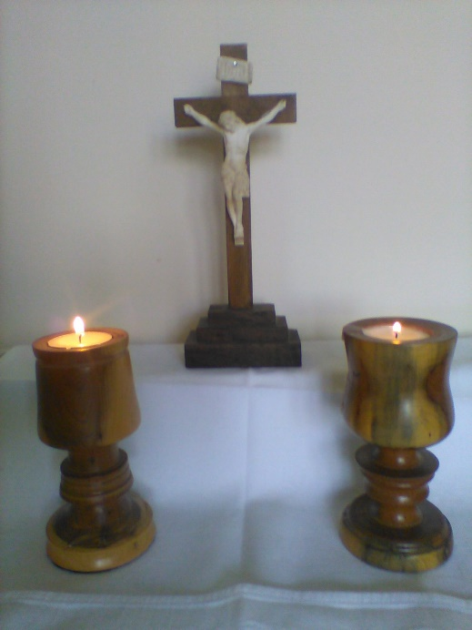

Humanity is pretty good at creating élites. However much people have tried, all through history, to level off society to some kind of just and true equality, there seem to be basic rules that twist all those attempts back in to different strata. Some people just seem to drift hopelessly downwards; some people claw their way resolutely upwards. Look at the great historical revolutions in France and Russia: in each case, an old aristocracy replaced by a new one.
The society that Jesus lived in two thousand years ago in Palestine was as much dominated by élites as any, and Jesus himself became a victim of most of them. There were the political rulers represented by Pontius Pilate, the Roman Procurator, and his Roman troops. And there were the religious rulers, represented by the Sanhedrin, the Jewish Council. Both these groups had vested interests to protect from crazy revolutionary prophets like Jesus of Nazareth.
To be fair, both groups perceived Jesus as a potential threat to peace and security. The Romans had established their Pax Romana across most of the known world, and all threats to that were ruthlessly put down: what was the life of one innocent man beside the lives that could be lost in a revolt? And the Sanhedrin had established an uneasy truce with Rome, whereby their people had an element of religious and cultural freedom under the Empire. Anyone who threatened the status quo could unleash a horror of oppression: what was the life of one innocent man beside the lives that could be lost in a revolt?
The answer to that is that any one life is important: life is God’s gift to us, and it’s not for us to take it away from any one of God’s children. But big political organisations seldom think on the individual scale. The result being that Jesus was the victim of a trumped-up charge by a kangaroo court, and of a successful threat against a governor who already had a black mark against him. Judicial murder, in fact.
So Jesus ended up on the cross: betrayed by one friend, deserted by the others, condemned for crimes he had not committed. From the sixth hour to the ninth hour, darkness covered the land, and then Jesus died. And the curtain of the temple was torn in two.
But wait a minute – what’s the significance of that? What has the temple curtain got to do with it?
One of the manifestations of the Jewish religious élite was that the priestly caste had taken God away from the ordinary people, and shut him up in the far end of the temple. The temple was a little bit like a Russian doll: every door you went in through led to another door, through which fewer people could enter. Right in the middle was the Holy of Holies, the place where the Ark of the Covenant used to be kept, where only the High Priest could go once a year. This was the place that was thought of as the very presence of God among His people; the trouble being that only the very exclusive could get anywhere near it.
The Holy of Holies was separated from the rest of the temple by a curtain. The religious élites, over the years, had hidden God away behind a curtain, and behind their rites and ceremonies and their sacrifices. The people could only meet with God through the mediation of the élite.
So this moment of the curtain being torn in half from top to bottom is incredibly powerful: Jesus’ death on the cross signalled the moment when the barriers came down. It was the moment when it was revealed that God is not shut away behind a curtain, speaking only to those at the top of the social scale. He is there, and there, and there, and every which where, loving each one of us equally wherever and whoever we may be.
In Christ there are no élites.

Lord God of all, we pray for all who suffer injustice from human powers, and all who feel cut off from your presence; be close to all who live under oppression and sustain them with your limitless love. Amen.

