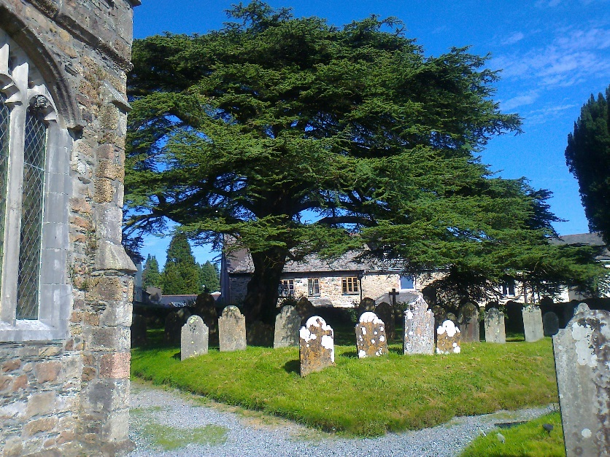
How are the mighty fallen!
16 October 2019
The Cedar of Lebanon tree in St Petroc’s Churchyard, South Brent, fell in the early hours today; no-one was hurt, and there is little damage.
Here it is photographed (right) in September 2014:
There seems to be no certain record of who planted the tree, or when; but judging from where it stands, in the raised eastern walled section of the churchyard, it may possibly date from the 1820’s or thereabouts.
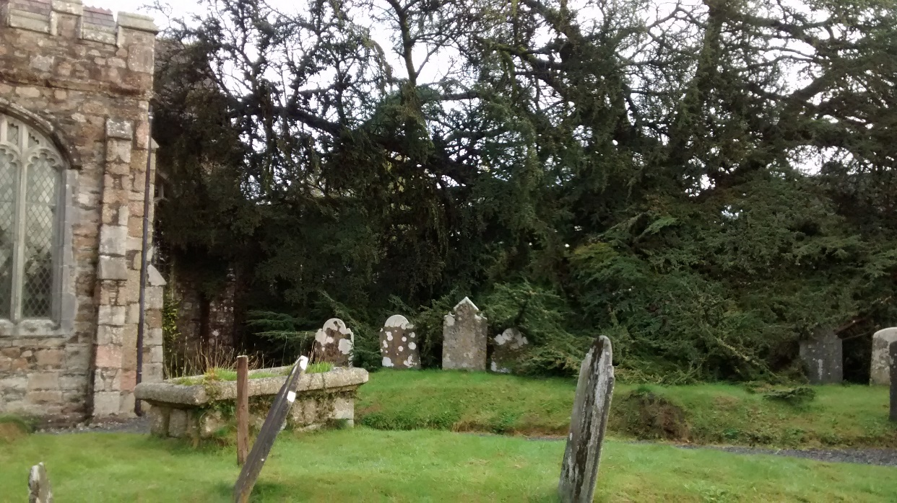
It is not surprising perhaps that so old a tree might fall, but down it came with a crash that woke nearby residents some time after midnight. It was a wet but relatively wind-free night.
Here is a view this morning of the same part of the churchyard:
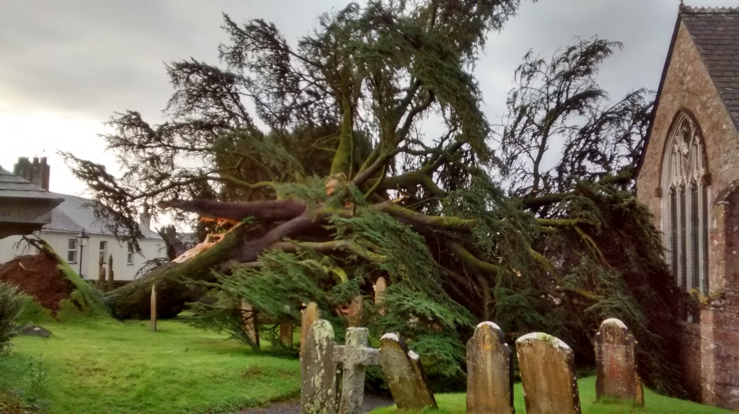
The gravestones visible in the first photo can be seen again here, still standing. (Only one stone has been broken it seems, and one other flattened, but all stones in this area were transcribed earlier this year.)
No-one was nearby to be hurt. And amazingly, it seems no serious damage was done to the church building—no windows broken or stonework damaged. Had this happened at some other time, the news could have been so much worse.
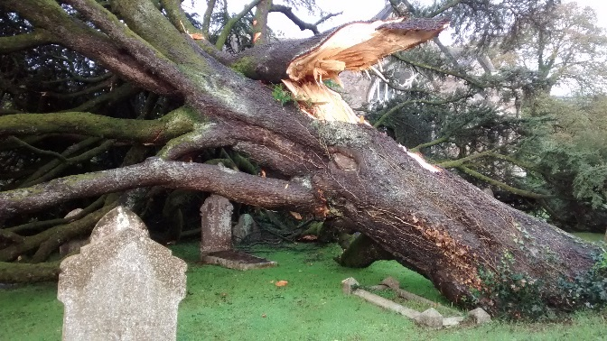
A crane may well be needed for the tree to be removed, and the churchyard will look strangely bare for months to come.

Advice will be taken on whether and what to plant in its place.
(left) A view from the east churchyard wall by the road. This view is looking west ... the east end of the church building can just be picked out through the broken branches.
Peter Taylor, 16 Oct 2019

