VISION2020
A modern Miracle Play for Weston-super-Mare
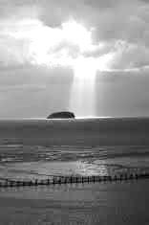
When: Sunday 7 June 2020
Where: The Italian Gardens, Weston-super-Mare
What: the Gospel story from Magi to Pentecost – and
beyond!
Why: to remind Weston of the story of Jesus’ life – to
remind, but also to bring it to some (most?) for the
first time

Who: YOU!
Both Church and Community. We need lots of people to get involved with
the planning and preparation, as well as actors, directors, “crowds”,
street marshals, and others “up-front” on the day. Apart from a few key
roles everything will be open to all who want to be involved, whether of
other faiths or no faith, with loads of experience, or none!

How: YOU!
- by joining any of the many practical Teams (eg costume, props,
admin); by great publicity (print, broadcast, as well as word-of-mouth);
by fund-raising; by great public relations (police, councils, businesses, hoteliers, shops, colleges); by just being available; by joining NOW!

- by acting – there are some main speaking roles, several that are non-speaking but still essential, plus many disciples, soldiers, critics, musicians, dancers and interested bystanders

- by praying for the whole enterprise

For more details please contact Jo Potter tavah@gertrudejames.co.uk

