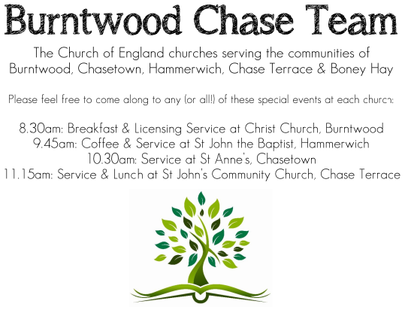
CHRIST CHURCH, BURNTWOOD
Registered Charity Nos: 1217129

SERVICE ON SUNDAY 11TH OCTOBER 2026 AT 10AM

MORNING WORSHIP

The 19th Sunday after Trinity

First Bible Reading – Philippians 4: 1-9
¹ Therefore, my brothers and sisters, whom I love and long for, my joy and crown, stand firm in the Lord in this way, my beloved.² I urge Euodia and I urge Syntyche to be of the same mind in the Lord. ³ Yes, and I ask you also, my loyal companion, help these women, for they have struggled beside me in the work of the gospel, together with Clement and the rest of my co-workers, whose names are in the book of life.⁴ Rejoice in the Lord always; again I will say, Rejoice. ⁵ Let your gentleness be known to everyone. The Lord is near. ⁶ Do not be anxious about anything, but in everything by prayer and supplication with thanksgiving let your requests be made known to God. ⁷ And the peace of God, which surpasses all understanding, will guard your hearts and your minds in Christ Jesus. ⁸ Finally, brothers and sisters, whatever is true, whatever is honourable, whatever is just, whatever is pure, whatever is pleasing, whatever is commendable, if there is any excellence and if there is anything worthy of praise, think about these things. ⁹ As for the things that you have learned and received and heard and noticed in me, do them, and the God of peace will be with you.

Gospel Reading – Matthew 22: 1-14

Once more Jesus spoke to them in parables, saying: ² “The kingdom of heaven may be compared to a king who gave a wedding banquet for his son. ³ He sent his slaves to call those who had been invited to the wedding banquet, but they would not come. ⁴ Again he sent other slaves, saying, ‘Tell those who have been invited: Look, I have prepared my dinner, my oxen and my fat calves have been slaughtered, and everything is ready; come to the wedding banquet.’ ⁵ But they made light of it and went away, one to his farm, another to his business, ⁶ while the rest seized his slaves, mistreated them, and killed them. ⁷ The king was enraged. He sent his troops, destroyed those murderers, and burned their city. ⁸ Then he said to his slaves, ‘The wedding is ready, but those invited were not worthy. ⁹ Go therefore into the main streets, and invite everyone you find to the wedding banquet.’ ¹⁰ Those slaves went out into the streets and gathered all whom they found, both good and bad, so the wedding hall was filled with guests.
¹¹ “But when the king came in to see the guests, he noticed a man there who was not wearing a wedding robe, ¹² and he said to him, ‘Friend, how did you get in here without a wedding robe?’ And he was speechless. ¹³ Then the king said to the attendants, ‘Bind him hand and foot, and throw him into the outer darkness, where there will be weeping and gnashing of teeth.’ ¹⁴ For many are called, but few are chosen.”
Collect for Today

O God, for as much as without you we are not able to please you; mercifully grant that your Holy Spirit may in all things direct and rule our hearts; through Jesus Christ your Son our Lord, who Is alive and reigns with you, in the unity of the Holy Spirit, one God, now and for ever.

Amen

Forthcoming Services in Church

Wednesday 14th October Morning Prayer 9.30am

Sunday 18th October Holy Communion 10am

Wednesday 21st October Morning Prayer 9.30am

Sunday 25th October Morning Worship 10am

Future Event For Your Diary

Saturday 14th November Christmas Fayre 2-4pm

Thanks to WI choir for concert and all who attended, £160 raised for church funds

Food bank

We are continuing to support this important ministry for people in need in our local community, for which the following items are always needed: ‘Long Life Milk, Custard, Rice Pudding, Cereals. Many thanks for your support. The Food Bank is very grateful for whatever you may be able to donate.

Floodlighting
If you would like to commemorate a special occasion by floodlighting our Church, please contact Chris Brown on 01543 683862 for details.

Prayer Chain

Christ Church is blessed with a very active prayer chain. If you, or anyone you know, feel that they would like others to pray for them, please speak to Chris Brown on 01543 683862.

Home Visits and Communion

For anyone who is unable to attend church and would like a Home Visit and Communion, please contact the Vicar and he will be able to carry this out.

Vicar’s Contact Details

Rev’d Stephen Morgan - Telephone: 07305 852152

Church Wardens Contact Details

Judith Rogers - Telephone: 01543 324718
Mike Holmes - Telephone: 01543 672970
Church Office Telephone: 01543 642187 [Please leave a message and we will respond in due course]

Church Web Site:www.christchurchburntwood.org.uk
Church Email: christchurchburntwood15@gmail.com
Facebook: www.facebook.com/group/christchurchburntwood/

Next Sunday’s Service – The 20th Sunday after Trinity

Sunday 18th October 2026 – Holy Communion at 10am
Bible Readings: 1 Thessalonians 1: 1-10 and Matthew 22: 15-22

