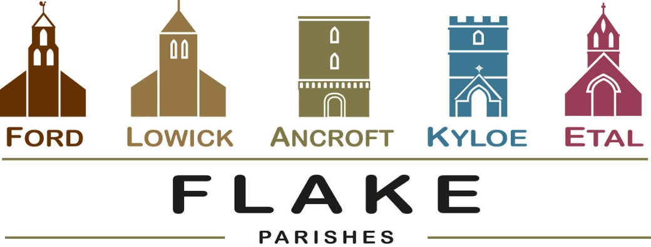

A very warm welcome to you, especially if you are visiting. Please take this sheet home with you and use it as a basis for prayer.

Sunday 25th October 2026
Lowick 9.15 Holy Communion
Ford 11am Holy Communion

Sunday 1st November 2026
No service at Lowick or Ancroft
11am Ford All Saints and All Souls
with an opportunity to remember those we have lost

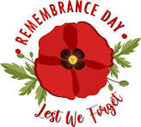
Sunday 8th November 2026
Lowick 9.15 Service of the Word
Ford 10.45 Holy Communion
Lowick 2pm in church Kyloe Memorial
2.30pm Lowick War Memorial
3.15 pm Barmoor Memorial

Sunday 15th November 2026
Lowick 9.15 Holy Communion
Ford 11am Holy Communion
Lowick 6pm Evensong




This evening 5-7pm
Lowick Village Hall
‘Let’s Talk About It’
‘What about the church?’


Autumn Housegroup Series
Tuesdays in Lowick Vicarage, 7.00 – 8.30pm
6 studies in Acts: What made the early Church grow
and what can we learn?
No meeting this week (half term)
3rd, 10th, 17th, 24th November

Thursdays in October 12 noon Porch Prayers

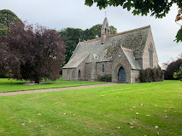
29th October
Etal Porch
15 mins

A Musical Soiree at the Etal organ. Our organists entertained us wonderfully – over £600 was donated.

Thursday 12th November: Quiz and Supper,
Etal Village Hall 7pm
Tickets £12 Hot Supper, Raffle, Bar
All for Ford loo project

- Sunday 15th November: 6pm Lowick Church
Come and sing Evensong (or worship with those who sing)

- Saturday 5th December at 4pm Evensong in Newcastle Cathedral and installation of new canons…sign up sheets for transport at back of church.


The Link to Hope Shoebox Appeal 2026 brings practical help, dignity, and hope to families and elderly people living in poverty across Ukraine and Eastern Europe Each shoebox supports an entire household or an elderly person facing isolation or hardship. Priority items are, toothbrushes & toothpaste, candles & holders, Small Games, Sweets/Chocolates,
Soap & Flannels.
Shoeboxes available today!

For more information, talk to Alex.

In our prayers
Those who suffer in body, mind or spirit, especially George Hall, Gail Calder, Don and Sam Quilty. We pray for all who have recently died, including Brenda Cossar. We remember Sandra and Sharon and their families as they mourn, together with all whose anniversaries of death fall at this time of year: Rosemary Haggar.

Flake Parishes Contacts

Revd Charlotte Osborn (Vicar) 01289 388591 ceosborn@mail.com 07957 367457
Revd Alex Firman (Assistant Curate) 07935 732811 alex_firman@hotmail.co.uk

Our other licensed clergy
Revd Margaret Sentamu 077871 204745
Canon Nick Sagovsky
Revd Marion Penfold 01289 305664

Church Contacts
Ancroft Leigh Yorke 07716 116739
Etal Andrew Joicey 01890 820540
Ford Kathleen Holmes 07951 099668
Lowick John Dickson 07967 343211

Parish Administrator
Sheena Atkinson
admin@flakeparishes.org

Safeguarding Officer
Philip Greene
safeguarding@flakeparishes.org
07555 412284

