Acrise Church News: October 2026
Church Services (all at 9.30am)
Sunday 4th October Holy Communion Sharon
Sunday 11th October Matins BCP Janet
Sunday 18th October Morning Prayer CW Bill
Sunday 25th October Service of the Word CW Janet
Future Dates
Saturday 28th November Christmas Fair at Elham Village Hall
Sunday 29th November Benefice Eucharist at Canterbury Cathedral: 11 am
Sunday 13th December Family Carol Service
Monday 14th December Village Carol Singing (TBC)
Sunday 20th December Traditional Carol Service
Family Harvest Service: Sunday 27th September
On a fine autumn morning we welcomed a large congregation of 40 adults and 16 children to our thanksgiving for harvest. It was good to meet up with our regular attendees as well as some who attended for the first time. Thanks to Janet for leading the service and to Irene for playing the organ: as well as the traditional ‘We Plough the Fields and Scatter’ we sang ‘Fruits of Creation’ and the lively ‘Harvest Samba.’
/……………………Our prayers centred on thanking God for all the fruits of the earth and thanking farmers who have had a difficult year with growing and harvesting because of the severe drought, with particular thanks to our local farming community who were well represented. Our prayers also recognised how global warming is affecting food supplies worldwide.
Many thanks to all our readers who did very well: it is good to see the confidence of the children. Congratulations in particular to Freddie who read only for the second time. During the service children and families brought up generous donations of food items to the altar. These will be taken to our local collection point for the Shepway Foodbank at the Rainbow Centre.
The children’s activities were creating a harvest scene with stickers and making hanging decorations. The children were also given a harvest decoration created by a friend of our church. There were also locally grown apples to take home. Thanks to our refreshment team who were busy throughout the service.
. Our next Family Service will be the Family Carol Service on Sunday 13th December.

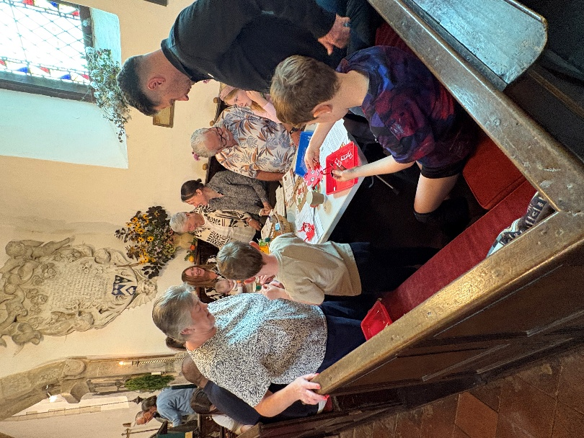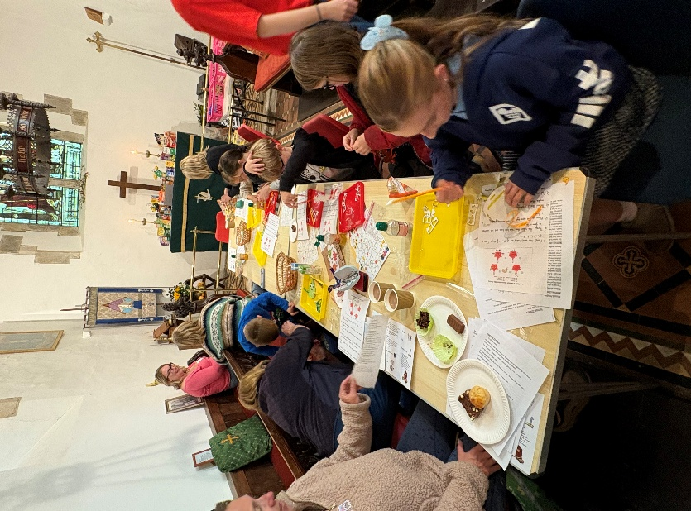

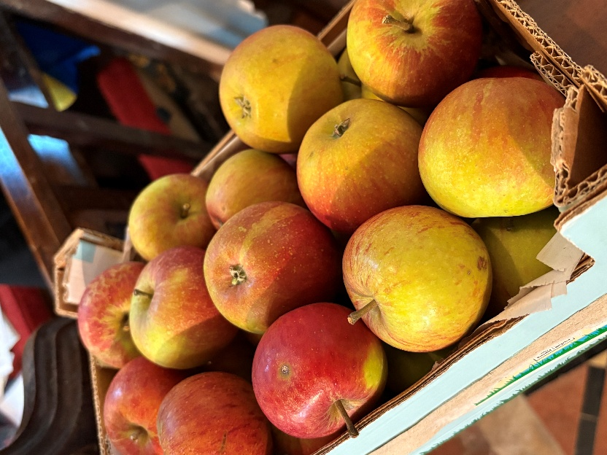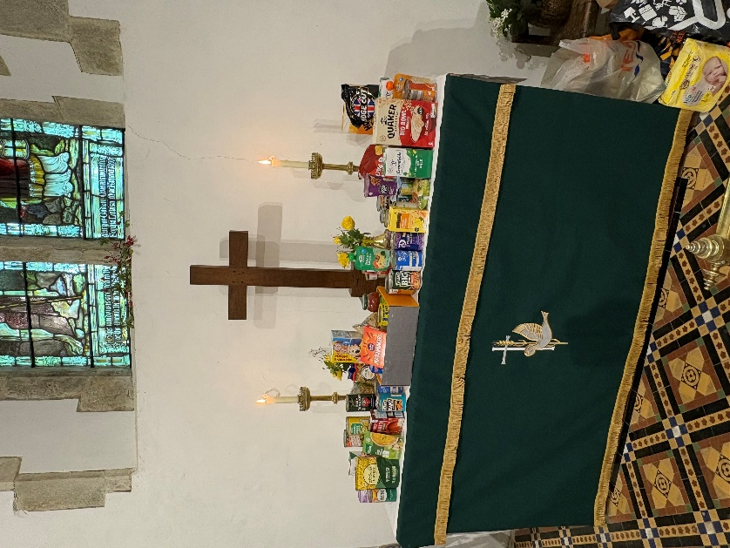

St John’s Commandery Swingfield: An English Heritage Site
It was open between 11th and 20th September. Nicky is an English Heritage Guide and was there on most days. She collected £50 in donations while there and there were around 200 visitors, which was a great success.

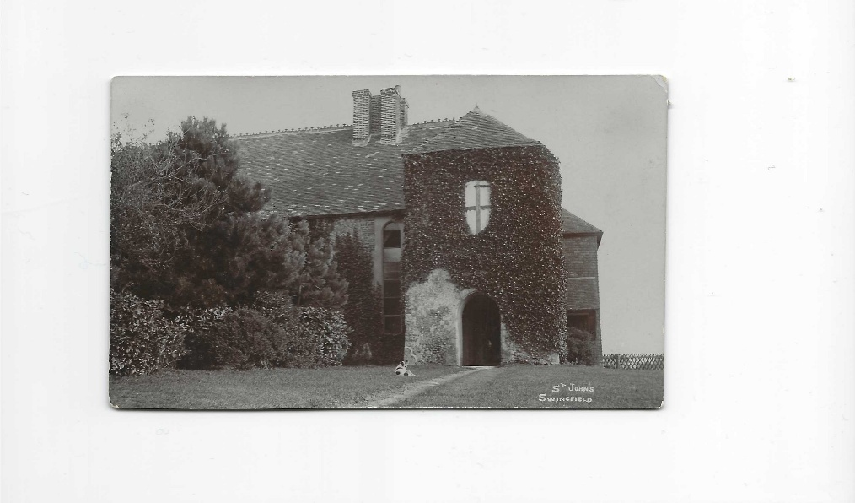
St Johns in 1908 when the Cross of St John was visible.

Ride and Stride for Friends of Kent Churches
This took place on Saturday12th September. Unlike last year, the weather was fine and those of us taking part had an enjoyable day. Richard and Simon visited the Canterbury churches from All Saints Military Road in the east, way out to St Nicholas Church Thannington in the west. They walked seven and a half miles, while Sue and Mike visited the Folkestone churches then drove to Cheriton to walk round the churches there.
Thanks to Joan and John and Lilian and Nicky who welcomed visitors to our church at St Martin’s and provided refreshments for those who wanted them. In all, we had eleven visitors.
Altogether, we collected £485.00 which was a great effort. Half of that will be returned to our church funds. Many thanks to all who sponsored us.
This year churches were encouraged to hold some sort of event on Ride and Stride day. In Folkestone the parish church of St Mary and St. Eanswythe was busy with a festival day: there was live music, bellringing, a variety of stalls and plenty of refreshments. Newington church had an interesting display of architectural drawings mainly from 1956 which were completed by John Martin who also kept a record of church activities during the time he worshipped at the church.
The Friends of Kent Churches provides grants for church repairs (30 were helped last year). It also organises events one of which is being held at St Mary the Virgin Stowting on Wednesday 28th October:
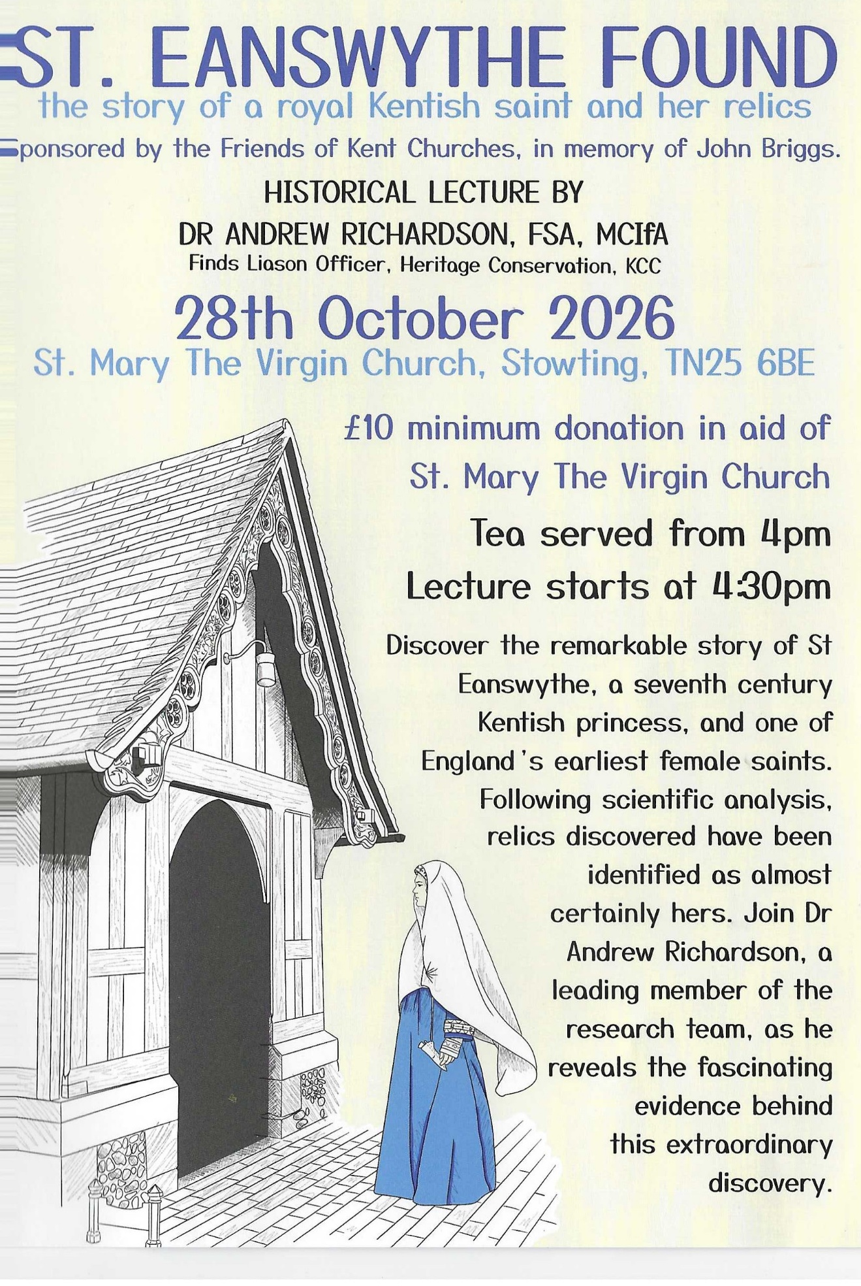

Acrise Environmental Group
Heritage Pond Project: Talk on Pond Archaeology
On Wednesday 16th September Mark Williams, Head of Archaeological Services at the Canterbury Archaeology Trust, gave a talk on ‘Pots, Ponds and Shards; how can archaeology help nature recover?’
In his talk Mark explored the archaeological potential of the Kent Downs heritage ponds, including some in Acrise and Swingfield, and some of the challenges that this presents. There will be a brief report on this talk in the next Acrise News.
Site Visit to the Sargeant Drew Memorial Orchard in Acrise
The opportunity to visit this hidden gem will be at 11.00am on Friday 9th October. The orchard is accessed through the Landmarc yard in Acrise on the road to Elham and just along from the church.
Sargeant Drew’s aircraft crashed into the garden of Orchard Lea in 1944 and he was killed. There was an article about him in the August Church News. Some of us attended the Service of Dedication for him on Friday 29th of July 2022 and met some of his descendants. We also spoke to members of the military about making the Orchard more accessible to local people.

Christmas Fair at Elham Village Hall
This will be on Saturday 28th November (10.00am – 2.00pm)
If you would like to book a table for this year’s Christmas Fair please contact Mrs Jean Grieb on 01303 892364 for a booking form.
More details will appear in the November Acrise Church News.

Shepway Foodbank: Folkestone Rainbow Centre
All donations of food from our harvest festival services will go to the local foodbank.

The Garage Sales Team
The Garage Sales Team, led by Richard, are involved with buying and selling secondhand items throughout the year, and not just at the Garage Sale or other fundraising events.
If you have any unwanted items that could be recycled to raise money for St Martin’s please contact Richard on:
01303 893 584 or 07919393302

