SUNDAY READING SHEET 18th October 2026 – 20th Sunday after Trinity
A Reading from Paul’s first letter to the Thessalonians

Paul, Silvanus, and Timothy,
To the church of the Thessalonians in God the Father and the Lord Jesus Christ:
Grace to you and peace.
We always give thanks to God for all of you and mention you in our prayers, constantly remembering before our God and Father your work of faith and labour of love and steadfastness of hope in our Lord Jesus Christ. For we know, brothers and sisters beloved by God, that he has chosen you, because our message of the gospel came to you not in word only, but also in power and in the Holy Spirit and with full conviction; just as you know what kind of people we proved to be among you for your sake. And you became imitators of us and of the Lord, for in spite of persecution you received the word with joy inspired by the Holy Spirit, so that you became an example to all the believers in Macedonia and in Achaia. For the word of the Lord has sounded forth from you not only in Macedonia and Achaia, but in every place where your faith in God has become known, so that we have no need to speak about it. For the people of those regions report about us what kind of welcome we had among you, and how you turned to God from idols, to serve a living and true God, and to wait for his Son from heaven, whom he raised from the dead—Jesus, who rescues us from the wrath that is coming. 1 Thessalonians 1:1-10

GOSPEL

The Pharisees went and plotted to entrap Jesus in what he said. So they sent their disciples to him, along with the Herodians, saying, ‘Teacher, we know that you are sincere, and teach the way of God in accordance with truth, and show deference to no one; for you do not regard people with partiality. Tell us, then, what you think. Is it lawful to pay taxes to the emperor, or not?’ But Jesus, aware of their malice, said, ‘Why are you putting me to the test, you hypocrites? Show me the coin used for the tax.’ And they brought him a denarius. Then he said to them, ‘Whose head is this, and whose title?’ They answered, ‘The emperor’s.’ Then he said to them, ‘Give therefore to the emperor the things that are the emperor’s, and to God the things that are God’s.’ When they heard this, they were amazed; and they left him and went away. Matthew 22:15-22


If you wish to make a donation to the church, then please hold Your phone’s camera over this image then touch the link that appears:

Royston Parish Church
Where all are welcome and God’s love is shared
Sunday 18th October 2026 20th Sunday after Trinity

If you would like regular copies of the Notice Sheet emailed to you please email the
Parish Office at admin@roystonparishchurch.org.uk

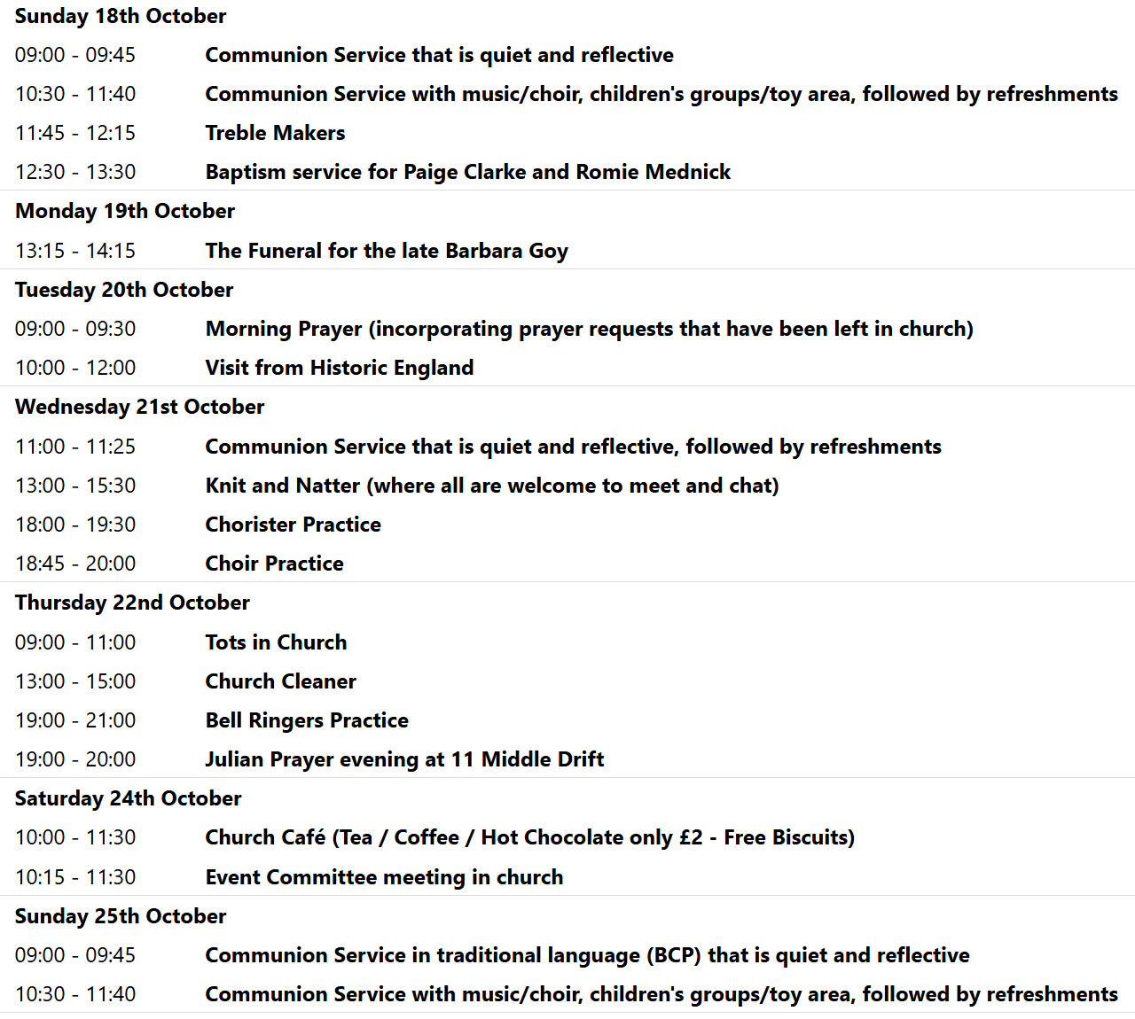

We pray for all Christians worldwide:
For all Christians in Belize, Guatemala, Honduras, Mexico
For all who worship at Therfield Chapel: Paul Dutton
For the work of our mission partners: GenR8

Pray for the community of Royston:
For our local health centres
For all our local uniformed organisations – Guides, Scouts etc.

We pray for our world and ECO projects:
International Walk to School Month

We pray for the sick and suffering:
4th October | 11th October | 18th October | 25th October
Emma Thompson | Pat Tidey | Val Brown | Peter Coates
Jackson Herbert | Mike Brown | Angie & Ken Rushall | Peggy Dawes
Marion | Clare Rice | Paula Walker | Chris Stratton
Rina Marias | Max Elliott | Sandra Landels  (nee Cornwell) | Keith & Elaine Edwards

We pray for those who have died in the faith of Christ:
Deceased Bereaved
Barbara Goy Kate, family and friends

We pray for those whose anniversaries fall at this time:
Maureen Smith

NOTICES

HELP NEEDED PLEASE: Saturday 17th October 11.30 am we would like to organise a work party to help with clearing ivy etc, moving corner stones, and sorting a stone cross, in the Additional Burial Ground. If you are able to help in anyway please speak to the Church wardens, Kay and Richard. We meet by the Chapel in the cemetery at 11.30 am, armed with gardening tools and gloves! Thank you.

Light Party October 31st.
Churches Together are once again running the Light Party at the Coombes Community Centre, as a Christian alternative to Halloween. The event has continued to grow year on year and many children look forward to the fun evening of games, craft, food and music. As always the party cannot happen without a band of willing volunteers and we are very grateful for those who have served in this way in the past. If you are willing to volunteer - again, or for the first time - please give your name to Duncan Rodgers. Thank you

BIBLE SOCIETY MEETING: Thursday 12th November 7.30 pm for 7.45 pm. Venue: Christ Church Royston (formerly Evangelical Church) SG8 5HJ. Guest speaker Neil Rees.

CHRISTMAS RAFFLE : We are going to run a Christmas Raffle as usual this year, with prizes of LUXURY hampers etc.
We would be very grateful for any donations towards the hamper contents. The hampers will have to be made up on Saturday 14th November and we will need your donations before then, please.
Please leave any items in the kitchen.
FOOD HAMPERS: We are looking for at least 2 good hampers plus some smaller prizes. Any LUXURY food or drink items especially Christmas foods, thank you.
TOILETRIES HAMPER: Any nice toiletries to make a small to medium sized hamper, please.
CHILDRENS HAMPER: We had a separate raffle for children last year which was well received. Any Christmas chocolates such as selection boxes, small toys, games etc.
If you need ideas and inspiration there is a suggestions list on the table at the back of Church.
This is a good fundraiser for the Church and we are very grateful for all your contributions.
THANK YOU. The Events Committee.

ANNUAL SHOEBOX APPEAL Link-to-Hope is a Christian charity which at Christmas sends shoeboxes containing gifts for poor families in Ukraine, Moldova, Bulgaria and Romania. Here at St. John's we support the shoebox appeal each year, and you are invited to join in by filling your own box during the month of October.
Please collect a leaflet from church, which suggests items you can put in your box - either for elderly folk, or for families with children. You can drop your box off at church any time, but the closing date is Sunday November 1st.. If you are unable to fill a box, you may wish instead make a financial donation towards the charity's costs. Please see Duncan Rodgers about this. THANK YOU!

JULIAN PRAYER EVENING: Thursday 22nd October 7 pm at 11 Middle Drift.

