
White Cross Mission Community News Sheet
Serving the Parishes of Aylesbeare, Clyst St George, Clyst St Mary, Exton, Farringdon, Woodbury, and Woodbury Salterton

Diocesan Intercessors’ Group: Are you someone who spends a lot of time in prayer, or spends time praying for the God’s kingdom to come and his will to be done? If so, the Diocese are launching a group just for you. Members of the group will commit 6 very achievable things including being rooted and praying for local Anglican Christian Community, using the Diocesan Prayer, and Prayer Diary, among others. If this is something that you would like to join or would like more information about, please speak with a member of the Clergy or LLM.

All Souls – A service for All Souls will be held on Sunday 1st November at 18.00 at Woodbury. If you would like the name of your loved one read out can you please add their name to the list at the back of the church.

St Swithun’s – Words and music concert – 31st October 7pm. This is the sixth concert of the ‘seven concerts in seven churches’. Quarter Peel will be rung. The Malsters are offering a meal before the concert with a 3 choice menu for £15 please book for 6pm by Wednesday 28th ringing 01395 232218. All money to go towards church projects. Details from Rev Tony Raven tony@theravens.org Please see posters in the church.

Governor for Woodbury School: Woodbury School is looking for a new ex-offio Foundation Governor. This is role which requires you to attend 4 Full Governor meetings per year and termly committee meetings. For more information please see the diocesan website and email Gillian Pyle at Woodbury School:
Be A School Governor - Diocese of Exeter

Pilgrimage – Lewis enjoyed travelling around each church in the Mission Community and it was lovely to be joined by many at the churches. It is a delight to be able to travel slowly around the WCMC, especially to experience the love that God has for us in the beauty of the earth. Rev Lewis invites you all to join him in May for his next pilgrimage.

Congratulations Rev Maggie – toasted by the church wardens and Vicars before her service to become a Prebendary of Exeter Cathedral. Later at the Cathedral after the ceremony.

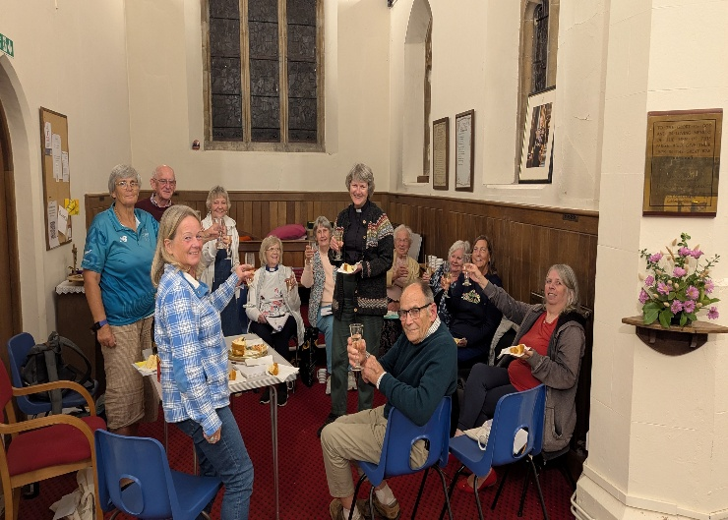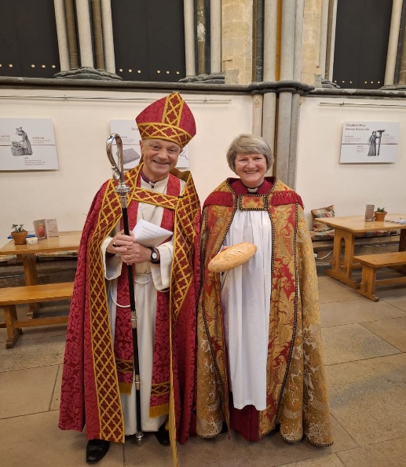

COLLECT God, our light and our salvation: illuminate our lives, that we may see your goodness in the land of the living, and looking on your beauty may be changed into the likeness of Jesus Christ our Lord.
MISSION COMMUNITY PRAYER. Heavenly Father, thank you for our Mission Community. Show us how you are working within our parishes and help us to join in. We ask for your blessing on all who live, work, and worship within our Mission Community. Send your Spirit upon us, so we may grow in faith, deepen in prayer, make new disciples, and serve your people with joy. In Christ’s name we pray. Amen

1st Reading – Isaiah 45.1-7 2nd Reading 1 Thessalonians 1.1-10
GOSPEL READING Matthew 22.15-22 When the chief priests and Pharisees had heard the parables, they realized that Jesus was speaking about them. Then the Pharisees went and plotted to entrap him in what he said. So they sent their disciples to him, along with the Herodians, saying, ‘Teacher, we know that you are sincere, and teach the way of God in accordance with truth, and show deference to no one; for you do not regard people with partiality. Tell us, then, what you think. Is it lawful to pay taxes to the emperor, or not?’ But Jesus, aware of their malice, said, ‘Why are you putting me to the test, you hypocrites? Show me the coin used for the tax.’ And they brought him a denarius. Then he said to them, ‘Whose head is this, and whose title?’ They answered, ‘The emperor’s.’ Then he said to them, ‘Give therefore to the emperor the things that are the emperor’s, and to God the things that are God’s.’ When they heard this, they were amazed; and they left him and went away.
POST COMMUNION PRAYER God our Father, whose Son, the light unfailing, has come from heaven to deliver the world from the darkness of ignorance: let these holy mysteries open the eyes of our understanding that we may know the way of life, and walk in it without stumbling; through Jesus Christ our Lord
Mid week worship |  | Sunday Scriptures
Every Monday, Wednesday, and Friday Morning Prayer on Zoom  9.00 Morning Prayer on Zoom,  contact  Chris Grist for the link  we_space@yahoo.co.uk  Last THURSDAY of the month  2pm Eucharist at Bronte Care Home, Ebford. All Residents and friends, welcome.  Every Wednesday – Holy Communion 10.30 Exton Church | Next Weeks – October 25th  9.30 AYL Holy Communion  9.30 WST Family Service with Harvest  11.15 WBY Holy Communion  Two Weeks – November 1st  8.00 WBY BCP Holy Communion  9.30 CSM Family Service  11.15 FAR Holyn Communion  16.00 AYL Family Service  18.00 WBY All Souls Service | Next Week – October 25th  Nehemiah 8.1-4  Colossians 3.12-17  Matthew 24.30-35

