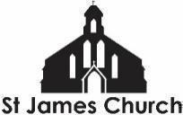
What’s On at St. James Church and in our local community from 24th October 2026 onwards

I hope you and your loved ones are doing well this week. Here is “What’s On” at St. James Church and some highlights from within our community this week.
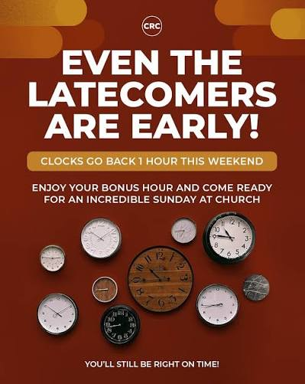
Saturday 24th October
QUIZ NIGHT 7pm - The next edition of the legendary St James Church Quiz Nights
£5 donation per adult (if affordable) / free for children. It is helpful if Hazel knows who is coming. Please bring any light bites / snacks to share, if able.

Sunday 25th October
DON’T FORGET - THE CLOCKS FALL BACK AN HOUR OVERNIGHT!!
9am Taize Holy Communion Service - Our 9am Holy Communion includes several well known chants from the Taize community in France. This service is on EVERY Sunday. It is a smaller, quieter, more contemplative service than our 11am. All are welcome.

10am Coffee and conversation in the church. A chance to meet and spend time with one another before or after worship

11am Morning Worship - Bible Sunday
This week myself and Rev Debbie will be leading our worship. There will be a focus on The Bible inc. a free bible for any home that hasn’t got one!. We will have Godly Play for Primary School age, a Youth session with Jeremiah, and a great range of soft play for pre-schoolers.

6pm Black History Month Celebration Ecumenical Service (Gloucester Cathedral)
Christian communities from across Gloucester come together for a service of words, music, and worship celebrating Black heritage and contributions. The evening includes children's activities, teen interviews, and a social gathering with tea and biscuits afterward.

Monday to Friday at 8.30am and 6pm: Morning and Evening Prayer on ZOOM

Tuesday 27th October
10.30-11.30am Coffee and Chat - At the Friendship Cafe

Wednesday 28th October
9.15-10.45am English Corner - English conversation class for all levels. FREE

10.45-12.15pm Stay and Play - A free hour of soft play for you and your pre-school children. Tea, coffee and soft drinks also available (help yourself)
Because it is half term we will also have space for primary school age children to do some art and craft activities, play table tennis etc.

Thursday 29th October
6 - 7.30pm Youth Group in the church. This week we will be preparing for the All Age Service on Sunday 1st November + maybe a bit of creative pumpkin carving to let the light shine out!

Advance Notice
Saturday 31st October - Working morning in church. Everyone is invited to come and make St James look beautiful as we enter November and a season of remembrance and a time when we think about Christ the King. Between 10am and 12noon we drink tea, eat biscuits and work on whatever we would like (or, sit and watch other’s work!)

More Community What’s On
Friendship Cafe Community Lunch - Every Monday at 12.30pm in the main hall. Free but donations welcomed.

The Fair Shares Allotments, Upton Street, are open on Monday, Wednesday and Thursday from 10am - 4pm - You can pick up some freshly picked vegetables, help to look after the crops, and find activities for children. As well as a cup of tea and a sit down! Everyone is welcome to go along.

St James City Farm - Do pop along and say hello to the animals on any day of the week, especially “Nature Craft and Play” on Thursdays 10.30am - 12noon.

Bartongate Children and Family Centre - 1.30 - 3pm Stay and Play session every Wednesday

In other news…
We are looking for someone to help with our pre-school children on a Wednesday and Sunday morning. If you know of anyone who might like to serve in this way then please let me or Fola know. It would be a great chance to gain experience before applying for a course or a paid role.

We are planning a Global garden - 4 raised beds growing food from Jamaica, Nigeria, Sri Lanka, and the UK. Would you be interested in being a part of this - helping to plan, plant, and nurture one of the beds? Speak to me or Chioma for more information.

As always, if you would like me to pray for, or have a conversation about anything then do get in touch. I am available to listen and share in whatever might be arising for you at this time.

God Bless,

Rev Steve 07503164309

