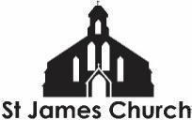
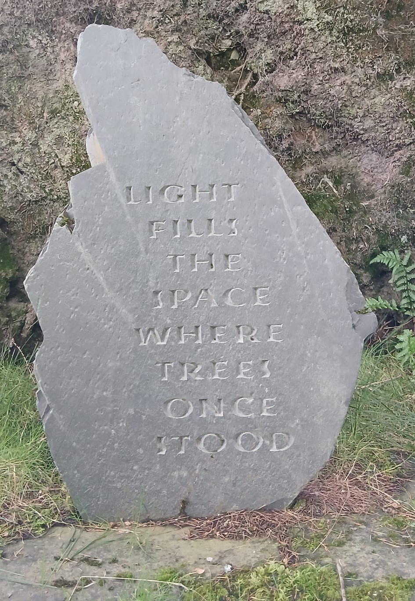
What’s On at St. James Church and in our local community from 3rd October 2026 onwards

I hope you and your loved ones are doing well this week. Here is “What’s On” at St. James Church and some highlights from within our community this week.
The picture is of a poem carved into stone and placed where a great tree had been uprooted during a storm. It was taken whilst visiting the Corbenic Camphill Community poetry and sculpture trail in Scotland.

Sunday 4th October
9am Taize Holy Communion Service - We have developed our 9am Holy Communion so it now includes several well known chants from the Taize community in France. This service is on EVERY Sunday. All are welcome before…
10am Coffee and conversation in the church. A chance to meet and spend time with one another before or after worship
11am Harvest Festival - Cabbages and Greens, Broccoli and Beans...Yes, it's another Harvest Festival! Our All age service this Sunday will be an opportunity to worship God together and give thanks for the Harvest. DONATIONS gratefully received for GARAS: They particularly ask for tinned tomatoes, tinned pasta, rice, tinned chickpeas, tinned fish. In addition, if you have any veg from around the world, Africa, Asia, Americas please bring that to and it will form part of our Harvest offering.

Monday 5th October
Monday to Friday at 8.30am and 6pm: Morning and Evening Prayer on ZOOM
Bible Study 2pm - at Charter Court

Tuesday 6th October
7pm Bible Reflection and Sharing Group - At the vicarage

Wednesday 7th October
1pm Art4Life + Wednesday Welcome
6.30 - 7.30pm Youth Choir - Young people between 10 and 16 are invited to come and learn a range of new songs for Autumn, in a fun and friendly choir. Free.
7.30pm Everything Slips at the Cathedral
Come and hear the wonderful “Everything Slips” by Verity Standen at Gloucester Cathedral AND the new pieces of music that will be performed by all the singers that have been rehearsing at St James. Click here for tickets (pay what you)

Thursday 8th October
6 - 7.30pm Youth Group in the church

Saturday 10th October
7pm HARVEST SUPPER. This promises to be a wonderful evening of food and music. There is no cost to attend but, if able, do bring some food to share.

More Community What’s On
The Fair Shares Allotments, Upton Street, are open on Monday, Wednesday and Thursday from 10am - 4pm - You can pick up some freshly picked vegetables, help to look after the crops, and find activities for children. As well as a cup of tea and a sit down! Everyone is welcome to go along.
St James City Farm - Do pop along and say hello to the animals on any day of the week, especially “Nature Craft and Play” on Thursdays 10.30am - 12noon.
Bartongate Children and Family Centre - 1.30 - 3pm Stay and Play session every Wednesday

In other news…
We are looking to employ a youth worker for our Friday evening youth group. If you know of anyone who might be interested in this then please ask them to contact me.
In addition, we are looking for someone to help with our pre-school children on a Sunday morning. If you know of anyone who might like to serve in this way then please let me or Fola know.
We are planning a Global garden - 4 raised beds growing food from Jamaica, Nigeria, Sri Lanka, and the UK. Would you be interested in being a part of this - helping to plan, plant, and nurture one of the beds? Speak to me or Chioma for more information.

As always, if you would like me to pray for, or have a conversation about anything then do get in touch. I am available to listen and share in whatever might be arising for you at this time.

God Bless, Rev Steve 07503164309

