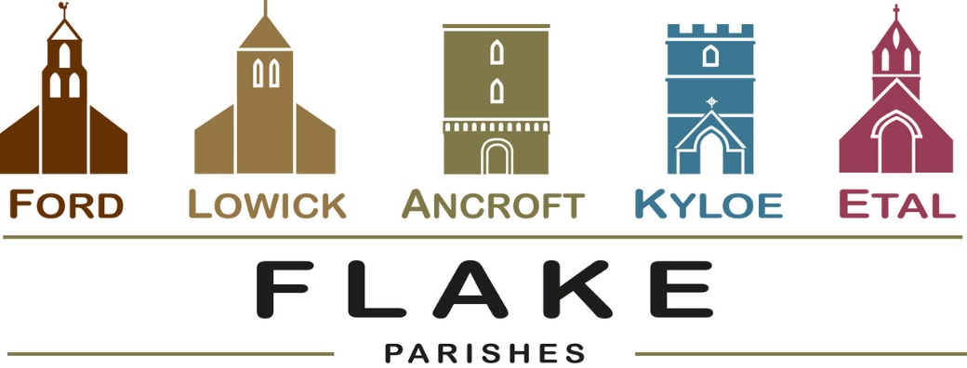

A very warm welcome to you, especially if you are visiting. Please take this sheet home with you and use it as a basis for prayer.

Sunday 4th October 2026
Lowick 9.15 Holy Communion
Ford 11am Holy Communion

Sunday 11th October 2026
Lowick 9.15 Holy Communion
Ford 11am Holy Communion

Sunday 18th October 2026 (St Luke)
Lowick 9.15 Holy Communion
Ford 11am Holy Communion
Prayers for healing will be offered at both services

Sunday 25th October 2026
Lowick 9.15 Holy Communion
Ford 11am Holy Communion
Lowick 12 noon Holy Baptism




This evening 5-7pm
Lowick Village Hall
‘Let’s Talk About It’
Why and How can I Pray?

- Tuesday 6th October: Ford PCC meeting,
5.30pm Fordhill House,

- Saturday 10th October: Lowick Village Hall Soup Saturday 12-1.30pm £7 to include one strip of raffle tickets


Autumn Housegroup Series
Tuesdays in Lowick Vicarage, 7.00 – 8.30pm
6 studies in Acts:
What made the early Church grow
and what can we learn?
Tuesdays 13th, 20th October,
3rd, 10th, 17th, 24th November

Thursdays in October 12 noon Porch Prayers

8th October Etal
15th October Ford
22nd October Lowick

Late October and November Events


- Wednesday 21st October at 6.30pm
A Musical Soiree at the Etal organ. Our organists entertain. Drinks and nibbles. Donations in aid of Ford church loo.

- Thursday 12th November: Quiz and Supper,
Etal Village Hall, also in aid of the loo.

- Sunday 15th November: 6pm Lowick Church
Come and sing Evensong

In our prayers

All who suffer in body, mind or spirit, especially Heather Piper, George Hall, Gail Calder, Don and Sam Quilty, Sue Pattinson. We pray for those who mourn, and for all who mark anniversaries of death at this time of year.

Flake Parishes Contacts

Revd Charlotte Osborn (Vicar) 01289 388591 ceosborn@mail.com 07957 367457
Revd Alex Firman (Assistant Curate) 07935 732811 alex_firman@hotmail.co.uk

Our other licensed clergy
Revd Margaret Sentamu 077871 204745
Canon Nick Sagovsky
Revd Marion Penfold 01289 305664

Church Contacts

Ancroft Leigh Yorke 07716 116739
Etal Andrew Joicey 01890 820540
Ford Kathleen Holmes 07951 099668
Lowick John Dickson 07967 343211

Parish Administrator
Sheena Atkinson
admin@flakeparishes.org

Safeguarding Officer
Philip Greene
safeguarding@flakeparishes.org
07555 412284

