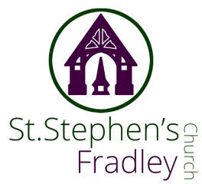
BULLETIN

1st November 2026 All Saints Day
9am. Holy Communion at St. Stephen’s
10.00am BENEFICE SERVICE AT ALL SAINTS CHURCH
Welcome to our Worship today. If you are visiting for the first time, please introduce yourself so that we may welcome you personally. Refreshments are served after the service
ST. STEPHEN’S CHURCH IS OPEN 10am-3pm daily for Private Prayer and Reflection
Collect  God of holiness,  your glory is proclaimed in every age:  as we rejoice in the faith of your saints,  inspire us to follow their example  with boldness and joy;  through Jesus Christ our Lord.  Readings  Revelations 7.9-end 1 John 3.1-3  Matthew 5. 1-12  Post Communion.  God, the source of all holiness and giver of all good things:  may we who have shared at this table  as strangers and pilgrims here on earth  be welcomed with all your saints  to the heavenly feast on the day of your kingdom;  through Jesus Christ our Lord  +++++++  PLEASE NOTE THERE WILL BE HOLY COMMUNION AT ST. STEPHEN’S THIS SUNDAY AT 9.00A.M  Dates for Diary  Monday 2nd November 10-12 Craft Group  Tuesday 3rd November 7-9pm Community Choir Rehearsal  Wednesday 4th November 11.30 Burial of Ashes – Deakin  2-4pm Wednesday Welcome  4.15-5.15pm Bible Study  Photographic Competition results  Nature  1st in Category White swan at Fradley Sally Steel  2nd in Category Hang on in there Julia Usher  3rd in Category Dragonfly Peter King  Landscapes  1st in Category Down a Country Lane Mike Wilcox  2nd in Category Fradley Junction Peter King  3rd in Category Fradley from the Sky Chris Williams  Light/Shadow  1st in Category Mystery of Light Sally Steel  2nd in Category Hebridean Sunset Derek Lloyd  3rd in Category Fradley Nature Reserve Peter King  Childrens  1st in Category Alrewas Poppy Roberts  2nd in Category Nanna’s Butterfly Poppy Roberts  Overall Winner was Mystery of Light  photographed by Sally Steel  ++++++++++++++++++  St Chad’s & St Stephen’s  Walking Group  Next walk!   Sunday 29th November  Meet at 1.30pm  Waitrose Car Park, Lichfield WS13 6RX  A short afternoon walk (45-60 minutes) around the green lands at the back of the new Birmingham Road estate.  It will encompass a sturdy path, some grassland and roads on the housing estate, a steady incline up to a small information board and art installation about the Buck Brothers  (18th Century topographic artists).  Good views of Lichfield and its Cathedral!  For those who wish to undertake a longer walk, we will continue with a walk through the housing estate and back into the country park in the opposite direction  Warm hat and sturdy shoes suggested  Refreshments at 15 Gaia Lane WS13 7LW afterwards  More details -contact Angela - 07913563901 | URGENT REQUEST    We really need your help for our next  Christmas Sales Table on  7th November please!  As well as our Breakfast Baps, tea/coffee and cake, we are having a  CHRISTMAS SALES TABLE  Where we will be selling home made preserves and cakes including  Limited Christmas Cakes  Also, we need either new, unwanted or preloved gifts you may have around the house,  So please start searching!  There is a box in church, near the organ, which will be emptied each day, in which to leave anything suitable.  Home-made cakes are always popular, so any bakers out there, we would really appreciate your contributions.  A BIG THANK YOU TO EVERYONE WHO CAN OFFER SOMETHING FOR US ON THE 7TH NOVEMBER!      Memorial Presentation  St. Stephen’s Church, Fradley  Thursday 19th November 2026 at 7:30 p.m.    Admission Free Donations accepted  Lest we forget    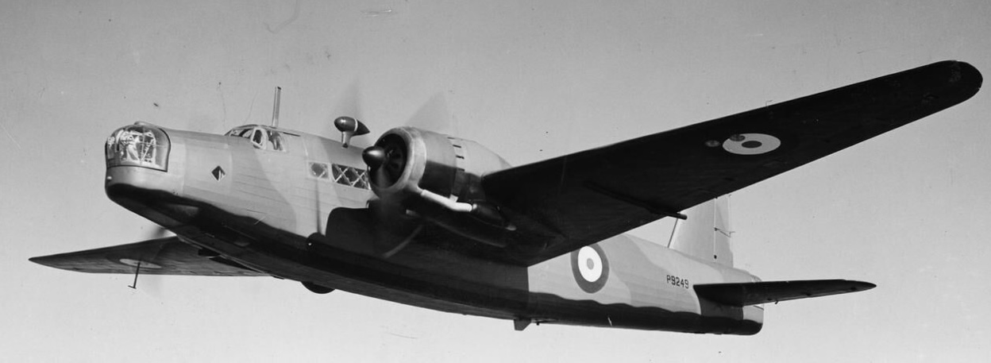  The Story of Sergeant Joe Turnbull RAAF and the crew of Wellington Bomber L7815  RAF Lichfield’s largest fatal Air Crash  on the 13th of September 1942  which claimed the lives of 9 Air Force Personnel  Presented by Richard Green Secretary of FHG in Memory of Lyn Tyler late Chair of FHG  Refreshments served after presentation  ++++++++++++++++++++  Lichfield u3a Chamber Orchestra  & Recorder Ensemble  Invite you to an Autumn Concert  Sunday, 8th November 2026, 2.30pm  at St. Chad’s Church, Lichfield, WS13 7ND  Tickets £5 (cash only) at the door  with proceeds to St. Giles Hospice  Refreshments will be available at the interval  
Notices for inclusion in the bulletin please email me by Tuesday of each week
Officeststephenfradley@gmail.com Please take bulletin away with you
If you would like to support St Stephen’s Church at this time donations can be made via our Just Giving Page. We are grateful for donations large or small https://www.justgiving.com/fundraising/ststephensfradley
Contact us
Priest in Charge: Rev. Jonathan Nicholas vicar@alrewasallsaints.church 01283 384 000 Mobile:07920239190
Churchwardens Marian Derry 01283 79157Katie Williams07776182760warden.ststephens.fradley@gmail.com
St Stephen’s Administrator: Di Cooper 07930162991 officeststephenfradley@gmail.com
Find us on ACNY https://www.achurchnearyou.com/church/4123/Facebook www.facebook.comststephensfradley

