Music for Sunday 4th October

800th anniversary
of the death of St Francis 1226

ALL TOGTHER WORSHIP

1. Bind us together Lord

2. My ears have heard the music of the
herald of the kings

3. Make me a channel of your peace

4. Good Francis our saint, in poverty lived
(our own version of colours of the day)
What’s on this week

Monday 5th October
1-4pm Community Hub

Tuesday 6th October
9-12 midday Babies and Toddler

Wednesday 7th October
1-4pm Community Hub

Thursday 8th October
10am Morning Prayer
10.30 – 12 midday Coffee and chat

Friday 9th October
10am – 12 midday Church Office Open

Saturday 10th October
6.30 – 9.30 Harvest Supper

Sunday 11th October
10am Parish Eucharist Harvest

St Francis of Assisi
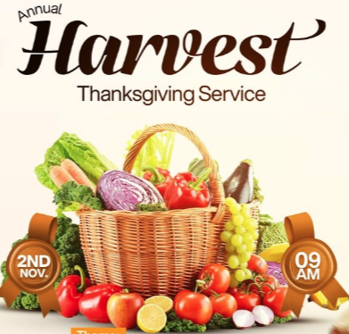

Sunday 11th October
10.00am

Social Events

Sat 10th October HARVEST SUPPER
6.30 for 7pm with entertainment

Performers needed from congregation

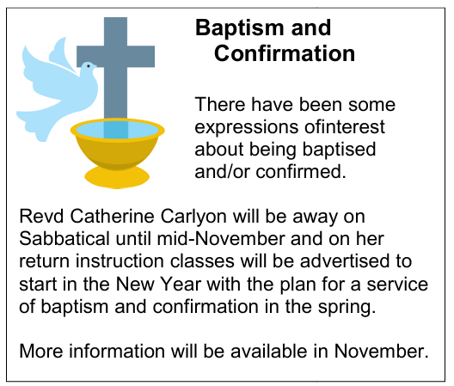

Volunteers needed to help with the sound system this is easier than it looks.
Training given.

Contact. Erica on Stfrancissaxongreen1@gmail.com or Tel: 07890 829461
For Hall bookings Tel: 07557 520338

