All Saints’ Church, Orton

Notice Sheet
Sunday 11th October: 18th Sunday after Trinity
8.30 a.m. Holy Communion (BCP) with the Revd. Becca Gilbert
Old Testament: Isaiah 25:1-9 New Testament: Philippians 4:1-9
(Reader: John Dunning) Gospel: Matthew 22:1-14

THIS WEEK
Monday 12th: 9.15 a.m.: Benefice Ministry Team meeting at Kirkby Stephen
10.30am – 12.30pm: Drop In at The Hub, St. James’, Tebay.

Wednesday 14th: 10.30 a.m. – 12 noon: Drop In at Orton Chapel Schoolroom. Free coffee, cakes and friendly conversation.
12.00 noon: Open The Book rehearsal in Orton Chapel Schoolroom

Friday 16th: 7.30 p.m. Orton bell-ringing practice

Next Sunday, 18th October: 19th Sunday after Trinity
“SEEDS, SOIL AND SMILES” – a family celebration of creation
10.00 a.m. Combined 5-churches Brunch and Harvest Service
at Tebay Methodist Chapel
(See overleaf)
The five churches are: Tebay and Orton Methodist churches, St. James’, Tebay, All Saints’, Orton, and St. Oswald’s, Ravenstonedale

Harvest Supper results
Bill Lawler, our treasurer, reports that so far tickets for the supper brought in £620 for church funds and money from the raffle and donations so far made £294 for Christian Aid.
‘There may be some more money (and invoices) coming, and - if previous experience is any guide - there may well be a few "stragglers".’

https://allsaintschurchorton.com/
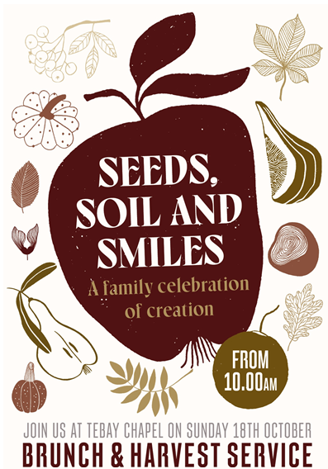
Hello from Upper Eden Food Bank

Thank you so very much for the donation of much food following your Harvest Festival Church Service and Orton C of E School Harvest Service. Please can you pass on our thanks to those who were involved?

For some people life continues to be challenging as families and individuals are forced to make hard choices, and UEFB would not be able to provide support for them without the kindness of others. Thank you all.

With best wishes
UEFB Team

