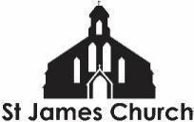
What’s On at St. James Church and in our local community from 10th October 2026 onwards
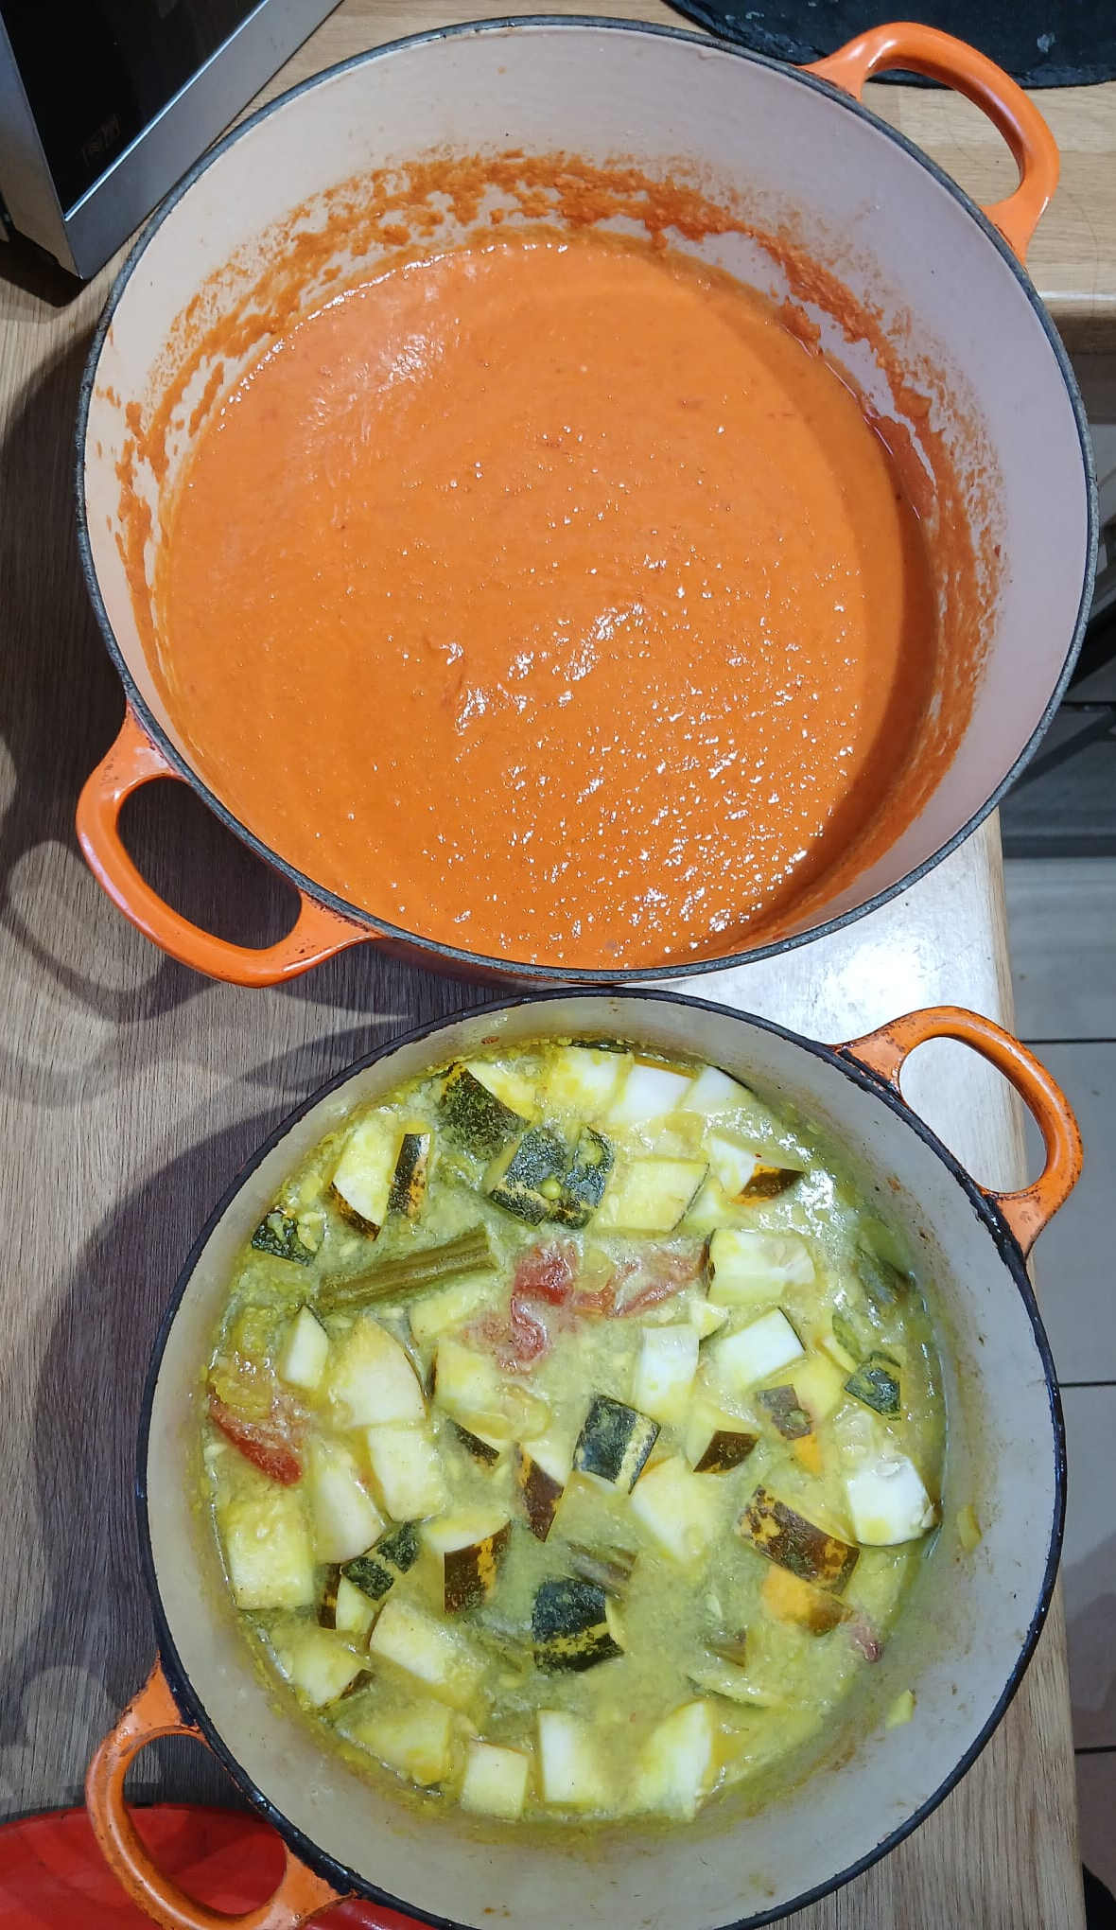
I hope you and your loved ones are doing well this week. Here is “What’s On” at St. James Church and some highlights from within our community this week.

The picture is of a spicy tomato soup and a currently unnamed and unspecified Sri Lankan Curry that were cooked during Youth Group last night in preparation for the HARVEST SUPPER. It was a successful evening in which the only fingers chopped off were the Sri Lankan Drumsticks (Murungaikkai)!

Saturday 10th October
1pm Sian is getting baptised! All are welcome.

7pm HARVEST SUPPER. This promises to be a wonderful evening of food and music. There is no cost to attend but, if able, do bring some food to share. There will be amazing food from around the world. Bring yourself and bring your friends or discover new friends once you arrive.

Sunday 4th October
9am Taize Holy Communion Service - Our 9am Holy Communion includes several well known chants from the Taize community in France. This service is on EVERY Sunday. It is a smaller, quieter, more contemplative service than our 11am. All are welcome.

10am Coffee and conversation in the church. A chance to meet and spend time with one another before or after worship

11am Holy Communion. This week we are exploring Jesus’s parable of The Wedding Banquet. Jeremiah Adebayo will be preaching.
We have children’s work for primary and secondary school age. There are fun activity sheets for all children to complete. We also have a soft play area for pre-schoolers.

Monday 5th October
Monday to Friday at 8.30am and 6pm: Morning and Evening Prayer on ZOOM

Tuesday 6th October
9am St James Junior School Harvest Service - Parents of school children are welcome to attend.

10.30-11.30am Coffee and Chat - At the Friendship Cafe

7-9pm Deanery Synod - This is like the parliament of the Gloucester group of churches. Everyone is welcome to attend and discover more about what goes on and to more confidently pray for all that is happening across our city. It is at St. James, Quedgely, GL2 4PN.

Wednesday 7th October
9.15-10.45am English Corner - English conversation class for all levels. FREE

**NEW** 10.45-11.45 Stay and Play - A free hour of soft play for you and your pre-school children. Tea, coffee and soft drinks also available (help yourself)

6.30 - 7.30pm Youth Choir - Young people between 10 and 16 are invited to come and learn a range of new songs for Autumn, in a fun and friendly choir. Free.

Thursday 8th October
6 - 7.30pm Youth Group in the church. Last week we cooked up a storm (well, spicy tomato soup!). This week….come along to find out!

More Community What’s On
The Fair Shares Allotments, Upton Street, are open on Monday, Wednesday and Thursday from 10am - 4pm - You can pick up some freshly picked vegetables, help to look after the crops, and find activities for children. As well as a cup of tea and a sit down! Everyone is welcome to go along.
St James City Farm - Do pop along and say hello to the animals on any day of the week, especially “Nature Craft and Play” on Thursdays 10.30am - 12noon.
Bartongate Children and Family Centre - 1.30 - 3pm Stay and Play session every Wednesday

In other news…
We are looking for someone to help with our pre-school children on a Wednesday and Sunday morning. If you know of anyone who might like to serve in this way then please let me or Fola know. It would be a great chance to gain experience before applying for a course or a paid role.
We are planning a Global garden - 4 raised beds growing food from Jamaica, Nigeria, Sri Lanka, and the UK. Would you be interested in being a part of this - helping to plan, plant, and nurture one of the beds? Speak to me or Chioma for more information.

As always, if you would like me to pray for, or have a conversation about anything then do get in touch. I am available to listen and share in whatever might be arising for you at this time.

God Bless, Rev Steve 07503164309

