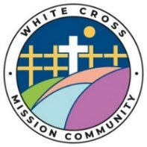
White Cross Mission Community News Sheet
Serving the Parishes of Aylesbeare, Clyst St George, Clyst St Mary, Exton, Farringdon, Woodbury, and Woodbury Salterton

Baptism – Charlotte will be baptised at Clyst St George Church today. Welcome Charlotte

Diocesan Intercessors’ Group: Are you someone who spends a lot of time in prayer, or spends time praying for the God’s kingdom to come and his will to be done? If so, the Diocese are launching a group just for you. Members of the group will commit 6 very achievable things including being rooted and praying for local Anglican Christian Community, using the Diocesan Prayer, and Prayer Diary, among others. If this is something that you would like to join or would like more information about, please speak with a member of the Clergy or LLM.

All Souls – A service for All Souls will be held on Sunday 1st November at 18.00 at Woodbury. If you would like the name of your loved one read out can you please add their name to the list at the back of the church.

St Swithun’s – Words and music concert – 31st October 7pm. This is the sixth concert of the ‘seven concerts in seven churches’. This concert of words and music will include music from Phil Bonser ( Clarinet) Dorothy and Tony Raven ( piano duet), Catherine Eden ( singing and flute), Paul Raven and Zoe ( keyboard and singing), Julia Thornton and Cherry Liall (reading) plus other local artists. Leading up to the concert a Quarter Peel will be rung. The Malsters are offering a meal before the concert with a 3 choice menu for £15 please book for 6pm by Wednesday 28th ringing 01395 232218. All money to go towards church projects. Details from Rev Tony Raven tony@theravens.org

Pilgrimage – Lewis enjoyed travelling around each church in the Mission Community and it was lovely to be joined by many at the churches. It is a delight to be able to travel slowly around the WCMC, especially to experience the love that God has for us in the beauty of the earth. Rev Lewis invites you all to join him in May for his next pilgrimage.

Congratulations Rev Maggie – toasted by the church wardens and Vicars before her service to become a Prebendary of Exeter Cathedral. Later at the Cathedral after the ceremony.

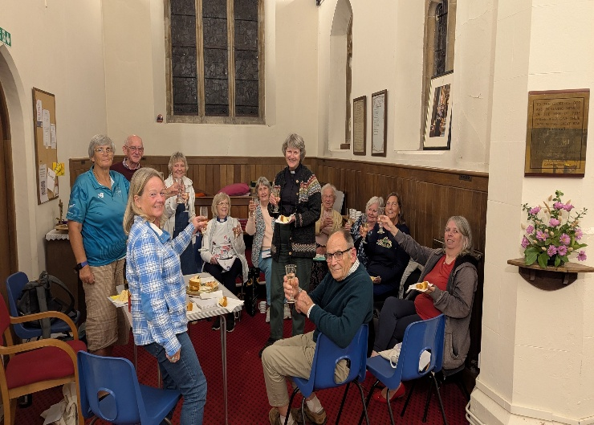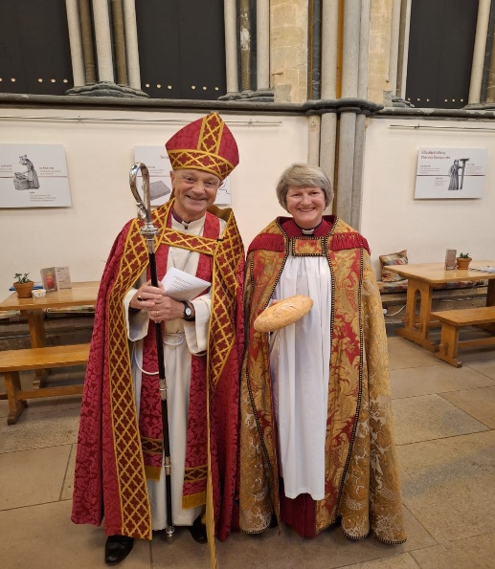

COLLECT. Faithful Lord, whose steadfast love never ceases and whose mercies never come to an end: grant us the grace to trust you and to receive the gifts of your love, new every morning, in Jesus Christ our Lord.
MISSION COMMUNITY PRAYER. Heavenly Father, thank you for our Mission Community. Show us how you are working within our parishes and help us to join in. We ask for your blessing on all who live, work, and worship within our Mission Community. Send your Spirit upon us, so we may grow in faith, deepen in prayer, make new disciples, and serve your people with joy. In Christ’s name we pray. Amen

1st Reading Isaiah 25.1-9 2nd Reading Philippians 4.1-19
GOSPEL READING Matthew 22.1-14 Once more Jesus spoke to the chief priests and Pharisees in parables, saying: ‘The kingdom of heaven may be compared to a king who gave a wedding banquet for his son. He sent his slaves to call those who had been invited to the wedding banquet, but they would not come. Again he sent other slaves, saying, “Tell those who have been invited: Look, I have prepared my dinner, my oxen and my fat calves have been slaughtered, and everything is ready; come to the wedding banquet.” But they made light of it and went away, one to his farm, another to his business, while the rest seized his slaves, maltreated them, and killed them. The king was enraged. He sent his troops, destroyed those murderers, and burned their city. Then he said to his slaves, “The wedding is ready, but those invited were not worthy. Go therefore into the main streets, and invite everyone you find to the wedding banquet.” Those slaves went out into the streets and gathered all whom they found, both good and bad; so the wedding hall was filled with guests. But when the king came in to see the guests, he noticed a man there who was not wearing a wedding robe, and he said to him, “Friend, how did you get in here without a wedding robe?” And he was speechless. Then the king said to the attendants, “Bind him hand and foot, and throw him into the outer darkness, where there will be weeping and gnashing of teeth.” For many are called, but few are chosen.’
POST COMMUNION PRAYER Holy and blessed God, you have fed us with the body and blood of your Son and filled us with your Holy Spirit: may we honour you, not only with our lips but in lives dedicated to the service of Jesus Christ our Lord.
Mid week worship |  | Sunday Scriptures
Every Monday, Wednesday, and Friday Morning Prayer on Zoom  9.00 Morning Prayer on Zoom,  contact  Chris Grist for the link  we_space@yahoo.co.uk  Last THURSDAY of the month  2pm Eucharist at Bronte Care Home, Ebford. All Residents and friends, welcome.  Every Wednesday – Holy Communion 10.30 Exton Church | Next Weeks – October 18th  9.30 CSM Holy Communion  9.30 WBY Family Service HARVEST  11.15 AYL Holy Communion  11.15 FAR Morning Worship  Two Weeks – October 25th  9.30 AYL Holy Communion  9.30 WST Family Service with Harvest  11.15 WBY Holy Communion | Next Week – October 18th  Isaiah 45.1-7  1 Thessalonians 1.1-10  Matthew 22.15-22

