
SPIRE & LIGHT United Churches
United Benefice of St Keverne, St Ruan with St Grade & St.Wynwallow (The Lizard)

*If you do not wish to receive these notices, please let your Churchwarden know*

1st November 2026

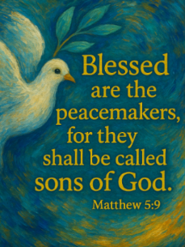
Readings
Revelation 7:9-end
Psalm 34:1-10
1 John 3:1-3
Matthew 5:1-12

9.30am – Holy Communion - St.Peter’s, Coverack
9.30am – All Saints/All Souls - A contemplative service including Holy Communion, to remember loved ones departed - St.Wynwallow, The Lizard
11.15am – Morning Prayer – St.Ruan, Ruan Minor
4pm – All Soul’s Service (a contemplative service to remember loved ones departed – St.Keverne


Next week – Nov 8th REMEMBRANCE SUNDAY

10.45am – St.Ruan - Memorial followed by service in church
10.45am – St.Keverne – The Square followed by service in church
10.45am – St.Wynwallow - Memorial followed by service in church
12.15pm – St.Peter’s, Coverack – Act of Remembrance
3pm – St.Grade - Evensong


Tickets also available at Tregullas Farm Shop, The Lizard.

The Prayer Spot



We pray especially for young Christians in China who are being severely restricted in living out their faith, prevented from entering church buildings and accessing religious materials.
We all have a duty of care to be together and to do everything in the name of Jesus Christ our Saviour. God has given us the great gift of prayer, to pray for His help and guidance in our lives and the lives of others and ask God to be with us in all we do.
Please pray for -
- those in our community who need God's help in their lives which sometimes can be difficult.
- the people in the Ukraine who need Gods help - we pray that they will have God's presence in their lives.
- all those who need hospital treatment, that God will be present with them and their family and meet their needs.
- that God will be with us all, giving us the gift of love to share with all
- for our Clergy, that God will guide them in all they do for us. Give them the gifts they need in their care for us.
We thank you heavenly Father for your gifts of forgiveness, kindness, justice, generosity and peace - all gifts to share with others.
Remember God is ever present in your life. Be blessed in all you do.
Faithful Father we begin today giving you thanks, your love endures for ever, it never fails. Though there are many ways in which we have failed, we have not exceeded the supply of your mercy and grace. We thank you for revealing yourself to us through your word. As we open our bible today, we pray we would hear your voice. We ask that your Holy Spirit would be at work in opening our ears to hear and our hearts to receive your word. May we be transformed into your likeness through Jesus Christ Saviour. Amen
Mighty God, everything you do reveals your glory and majesty. Open our eyes to see what you are doing in our lives. Let us marvel at your good gifts and your wise provision . Your acts are amazing Lord. We cannot comprehend the number of blessings you pour out on us from day to day. Transform us Lord and make us more like you through Jesus Christ our saviour. Lord Amen
God bless you all. Samuel Buchanan

The Diocese of Truro’s Prayer Diary for this week
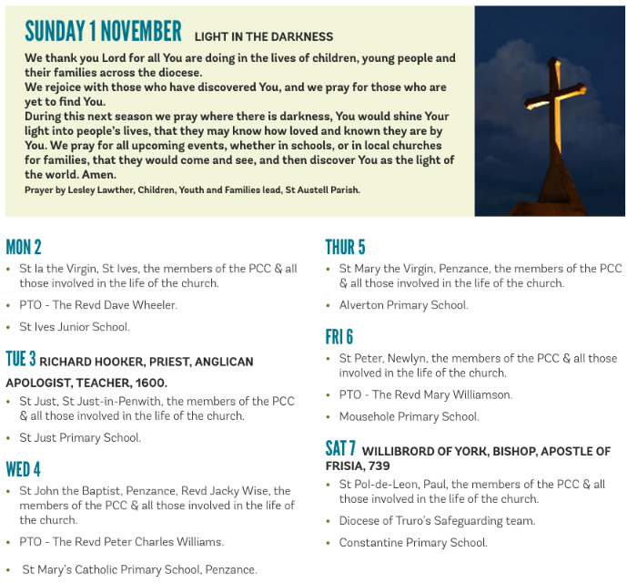

On The Way Prayers

As we enter this period of Remembrance, let us for a moment remember one of our loved ones who we see no longer. We pray for all those suffering with dementia, who cannot remember even who their loved one is. Lord we thank you for memories, some may worry us but many can bring us great joy.

A reflective prayer for All Hallows Eve: Lord, we will face all that most concerns us: our fears, the shadowed places of the mind; the coming of winter darkness; the cold thin place between waking and sleep. We call to mind the powerless, the lonely, those who most fear the knock at the door; all those deceived by the world’s empty promises; all those cowed by menaces or threats. We stand with those weak in body, mind or spirit and those seduced by treats or hurt by tricks. Lord, your light shines into every darkness. You told us: pray ‘deliver us from evil’. Your Spirit gives us hope, gives us courage, a candle in the window unhurt by the wind.

A prayer for All Saints Day: Almighty and everlasting God, we praise your holy name for all the saints throughout the ages who have kept the lamp of faith burning brightly. Grant that we who are following in their steps may keep that light shining, that the darkness of this world may be lit by him who is the light of the world, ever your Son, our Saviour, Jesus Christ.

A prayer for All Souls Day: God of time and space, in your hands you hold all that you have made. You breathe new life into all creation; and without you there is no life, for our lives are hidden in you. As we remember those we love, but see no longer, help us to believe that none are forgotten by you, and eternal rest grant to them, O Lord, and let perpetual light shine upon them. May their souls and all the souls of the faithful departed, through the mercy of God, rest in peace. Amen

As our children enjoy the freedom and fun of the half term break, let’s just take a moment to pray for them. Life is a game – help them Lord to play it. Life is an adventure, help them Lord to be daring and adventurous and learn through all their experiences. We pray that they will all be safe.

We pray for anything that is troubling us, for anyone who needs the comfort of our collective prayers or to give thanks for something that has happened in our churches or communities this past week.

Finally we pray for each other, for the problems that we each harbour in our hearts, for the things that keep us each awake at night and for the strength to keep going, to keep our own churches alive and our communities drawn to both the vibrancy and the peace and tranquillity that can be found in the walls of our beautiful buildings.

And so until we meet again may God be within us, God be beside us, God be behind us, and God be before us. Amen

