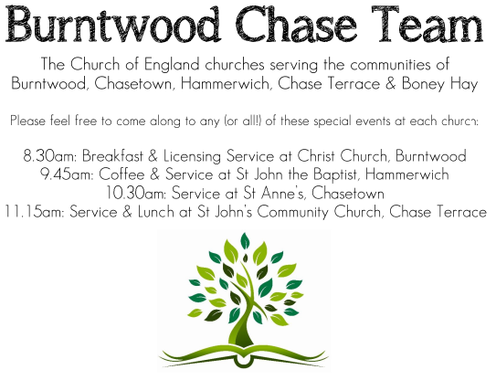
CHRIST CHURCH, BURNTWOOD
Registered Charity Nos: 1217129

SERVICE ON SUNDAY 18TH OCTOBER 2026 AT 10AM

HOLY COMMUNION

The 20th Sunday after Trinity

First Bible Reading – 1 Thessalonians 1: 1-10

Paul, Silvanus, and Timothy,
To the church of the Thessalonians in God the Father and the Lord Jesus Christ:
Grace to you and peace.

² We always give thanks to God for all of you and mention you in our prayers, constantly ³ remembering before our God and Father your work of faith and labour of love and steadfastness of hope in our Lord Jesus Christ. ⁴ For we know, brothers and sisters beloved by God, that he has chosen you, ⁵ because our message of the gospel came to you not in word only but also in power and in the Holy Spirit and with full conviction; just as you know what kind of persons we proved to be among you for your sake. ⁶ And you became imitators of us and of the Lord, for in spite of persecution you received the word with joy from the Holy Spirit, ⁷ so that you became an example to all the believers in Macedonia and in Achaia. ⁸ For the word of the Lord has sounded forth from you not only in Macedonia and Achaia but in every place your
faith in God has become known, so that we have no need to speak about it. ⁹ For they report about us what kind of welcome we had among you and how you turned to God from idols to serve a living and true God ¹⁰ and to wait for his Son from heaven, whom he raised from the dead—Jesus, who rescues us from the coming wrath.

Gospel Reading – Matthew 22: 34-46

Then the Pharisees went and plotted to entrap him in what he said. ¹⁶ So they sent their disciples to him, along with the Herodians, saying, “Teacher, we know that you are sincere, and teach the way of God in accordance with truth, and show deference to no one, for you do not regard people with partiality. ¹⁷ Tell us, then, what you think. Is it lawful to pay taxes to Caesar or not?” ¹⁸ But Jesus, aware of their malice, said, “Why are you putting me to the test, you hypocrites? ¹⁹ Show me the coin used for the tax.” And they brought him a denarius. ²⁰ Then he said to them, “Whose head is this and whose title?” ²¹ They answered, “Caesar’s.” Then he said to them, “Give therefore to Caesar the things that are Caesar’s and to God the things that are God’s.” ²² When they heard this, they were amazed, and they left him and went away.

Collect for Today

God, the giver of life, whose Holy Spirit wells up within your Church: by the Spirit’s gifts equip us to live the gospel of Christ and make us eager to do your will, that we may share with the whole creation the joys of eternal life: through Jesus Christ your Son our Lord, who is alive and reigns with you, in the unity of the Holy Spirit, one God, now and for ever.

Amen

Forthcoming Services in Church

Wednesday 21st October Morning Prayer 9.30am

Sunday 25th October Morning Worship 10am

Wednesday 28th October Morning Prayer 9.30am

Sunday 1st November Holy Communion 10am

Future Event For Your Diary
Saturday 14th November Christmas Fayre 2-4pm

Food bank

We are continuing to support this important ministry for people in need in our local community, for which the following items are always needed: ‘Long Life Milk, Custard, Rice Pudding, Cereals. Many thanks for your support. The Food Bank is very grateful for whatever you may be able to donate.

Floodlighting
If you would like to commemorate a special occasion by floodlighting our Church, please contact Chris Brown on 01543 683862 for details.

Prayer Chain

Christ Church is blessed with a very active prayer chain. If you, or anyone you know, feel that they would like others to pray for them, please speak to Chris Brown on 01543 683862.

Home Visits and Communion

For anyone who is unable to attend church and would like a Home Visit and Communion, please contact the Vicar and he will be able to carry this out.

Vicar’s Contact Details

Rev’d Stephen Morgan - Telephone: 07305 852152

Church Wardens Contact Details

Judith Rogers - Telephone: 01543 324718
Mike Holmes - Telephone: 01543 672970

Church Office Telephone: 01543 642187 [Please leave a message and we will respond in due course]

Church Web Site:www.christchurchburntwood.org.uk
Church Email: christchurchburntwood15@gmail.com
Facebook: www.facebook.com/group/christchurchburntwood/

Next Sunday’s Service – The 21st Sunday after Trinity

Sunday 25th October 2026 – Morning Worship at 10am

Bible Readings: 1 Thessalonians 2: 1-8 and Matthew 22: 34-46

