
SPIRE & LIGHT United Churches
United Benefice of St Keverne, St Ruan with St Grade & St.Wynwallow (The Lizard)

*If you do not wish to receive these notices, please let your Churchwarden know*

4th October 2026


Readings
Isaiah 5:1-7
Psalm 80:9-17
Philippians 3:4b-14
Matthew 21:32-end

9.30am – Holy Communion - St.Peter’s, Coverack
9.30am – Holy Communion (BCP) - St.Wynwallow, The Lizard
11am - St.Keverne – Harvest at Methodist Chapel

11.15am – Morning Prayer – St.Ruan, Ruan Minor
3pm Pet Service – St.Grade

Next week – Oct 11th
9.30am – Morning Prayer – St.Peter’s, Coverack
11am – Harvest at Methodist Chapel - St.Ruan, Ruan Minor
11am – Holy Communion - St.Keverne
11.15am – Café Church – St.Wynwallow, The Lizard
3pm – Evensong – St.Grade

As we hold our Harvest services below is a list of foods the Foodbank is in particular in need of at the moment-


The Prayer Spot



We all have a duty of care to be together and to do everything in the name of Jesus Christ our Saviour. God has given us the great gift of prayer, to pray for His help and guidance in our lives and the lives of others and ask God to be with us in all we do.
Please pray for -
- those in our community who need God's help in their lives which sometimes can be difficult.
- the people in the Ukraine who need Gods help - we pray that they will have God's presence in their lives.
- all those who need hospital treatment, that God will be present with them and their family and meet their needs.
- that God will be with us all, giving us the gift of love to share with all
- for our Clergy, that God will guide them in all they do for us. Give them the gifts they need in their care for us.
We thank you heavenly Father for your gifts of forgiveness, kindness, justice, generosity and peace - all gifts to share with others.
Remember God is ever present in your life. Be blessed in all you do.
Faithful Father we begin today giving you thanks, your love endures for ever, it never fails. Though there are many ways in which we have failed, we have not exceeded the supply of your mercy and grace. We thank you for revealing yourself to us through your word. As we open our bible today, we pray we would hear your voice. We ask that your Holy Spirit would be at work in opening our ears to hear and our hearts to receive your word. May we be transformed into your likeness through Jesus Christ Saviour. Amen
Mighty God, everything you do reveals your glory and majesty. Open our eyes to see what you are doing in our lives. Let us marvel at your good gifts and your wise provision . Your acts are amazing Lord. We cannot comprehend the number of blessings you pour out on us from day to day. Transform us Lord and make us more like you through Jesus Christ our saviour. Lord Amen
God bless you all. Samuel Buchanan

The Diocese of Truro’s Prayer Diary for this week

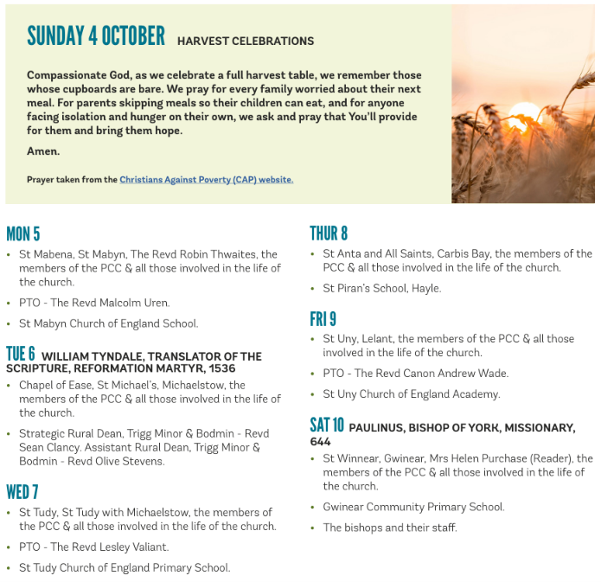

On The Way Prayers

Just for a moment try and think back to your life as a teenager – the things you did, the friends you had and the relationship you had with your parents and teachers.

Lord we pray for all young people today particularly for those in our Deanery; for the problems that seem to be piling up for them. We hear so much about the danger of social media, something that none of us would have had to contend with. Let us pray that the tech giants can find ways to keep our young people safe online and that technology can help rather than hinder their developing lives. We pray for any young person in our deanery who is being bullied or abused in any way; for those who are suffering illness or a recent bereavement and for all those who are themselves caring for another family member.

Lord we ask that as churches we can also find ways to give young people safe spaces to be with other young people. When we get annoyed with the disturbance and petty vandalism that some of our young people get involved in, let that be a time for us to think what we could do for them. Help us to find ways of engaging with them and providing them with support, even if that support is just to regularly pray for them.

We pray for the two secondary schools in our Deanery – for Mullion and Helston, for the headteachers - Michelle Dunleavy and Alex Lingard and for all who work in these two schools. Between them they will be caring for more than 2000 of our young people – Lord help them all in this incredibly difficult task. We pray too for the Diocesan team that focus on Children and Young People, for Lee Moscato our Director of Education and for Jonny Lewis the Growing Younger Lead. We give thanks too for the work of Isaac MacNish the Head of Ministry who has a background for working in this area.

As our young people develop, explore, experiment and test boundaries, Lord we pray that you are alongside them, and that you help us to help them.

Now pray for anyone in your congregation or community who really needs praying for at this time. And let’s continue to pray for Stewart as he and Heather settle into Constantine Vicarage.

Sunday is the Feast Day of St Francis of Assisi, marking the end of Creationtide. We give thanks for all the things we have done to celebrate that in our churches this past month. And now we finish our prayers with the prayer of St Francis.
Lord, make me an instrument of your peace: where there is hatred, let me sow love;
where there is injury, pardon; where there is doubt, faith;
where there is despair, hope; where there is darkness, light; where there is sadness, joy.
O divine Master, grant that I may not so much seek to be consoled as to console,
to be understood as to understand, to be loved as to love.
For it is in giving that we receive, it is in pardoning that we are pardoned,
and it is in dying that we are born to eternal life. Amen

