St James the Great  Wrightington with Heskin  www.stjamesthegreat.net  Facebook https://www.facebook.com/share/1P2dybXWY/ | 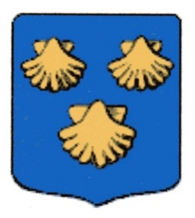 | 92 Church Lane  Wrightington  WN6 9SP  Phone 07976179206  maree@nwss.co.uk

11th October The Nineteenth Sunday after Trinity
09.00am Holy Communion - David Gaskell
10.30am Family Service
5.00pm 30@5 (last before half term)

Christmas is coming – oh no it’s not I hear you say, but to start the festivities, we have booked a Parish Meal at the White Lion on Thursday 3rd December at 7.45pm. Please look out for the sheet at the back of Church if you would like to join us, fill in the form with your names etc and please leave a £10.00 deposit per person in the marked box.

With Christmas still in mind, our Christmas Fair is on Saturday 21st November and we are starting to collect the usual items for Bathroom, Tombola, Bottle and cake stalls (cakes on the day or day before please). Thank you

Chris Bannister Concert on 23rd October – see Joan or Anne for tickets.

*+*+*+*+*+*+*+*+*

Tues 13th 7.30pm Mothers Union – Christmas Cards with Pauline
Wed 14th 10.30am Play & Praise Toddler Group

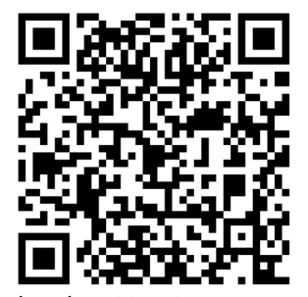
18th October The Twentieth Sunday after Trinity
09.00am Holy Communion - Helen Coffey
10.30am Holy Communion - Mike Hatton
5.00pm No 30@5

