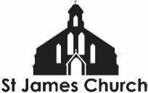
What’s On at St. James Church and in our local community from 30th October 2026 onwards

I hope you and your loved ones are doing well this week.
It has now been almost exactly a year since I came to St James Church on Monday 3rd November 2025. This should be the Newsletter #52 so I have missed one along the way! It has been a hugely enjoyable and rewarding year getting to know the church and many people in the local community. I thank God for all He is doing in Barton and Tredworth, amongst so many diverse lives and communities. Thank you to all those who have welcomed both Juliette and I into this wonderful area. On a personal note, it’s been quite an eventful year with heart surgery and, more recently, my mum dying. Indeed, her funeral is tomorrow (Friday) so your prayers would be appreciated as the family gathers to remember and celebrate her life. She will be greatly missed.

Here is “What’s On” at St. James Church and some highlights from within our community this week.

Saturday 31st October
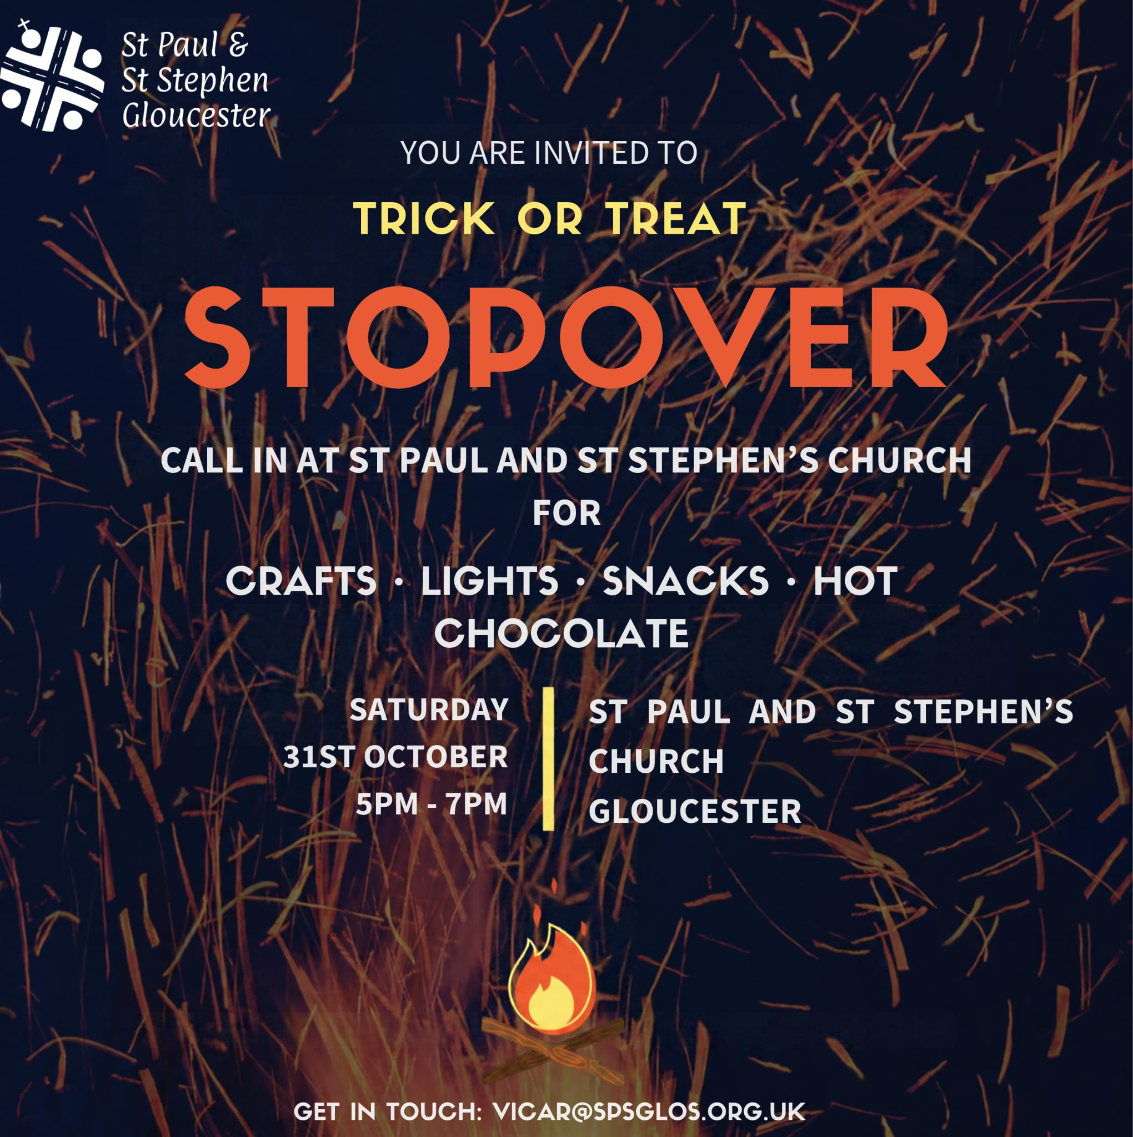
10-12 noon Working morning in church. Everyone is invited to come and make St James look beautiful as we enter November, our Black History Month Awards on Thursday evening with Bishop Rachel, and the season of remembrance. Between 10am and 12noon we drink tea, eat biscuits and work on whatever we would like (or, sit and watch other’s work!)

5-7pm Do visit St Pauls and St Stephens if you are out trick or treating with children. They will have snacks, crafts and hot chocolate to nourish the soul and keep you warm.

Sunday 1st November
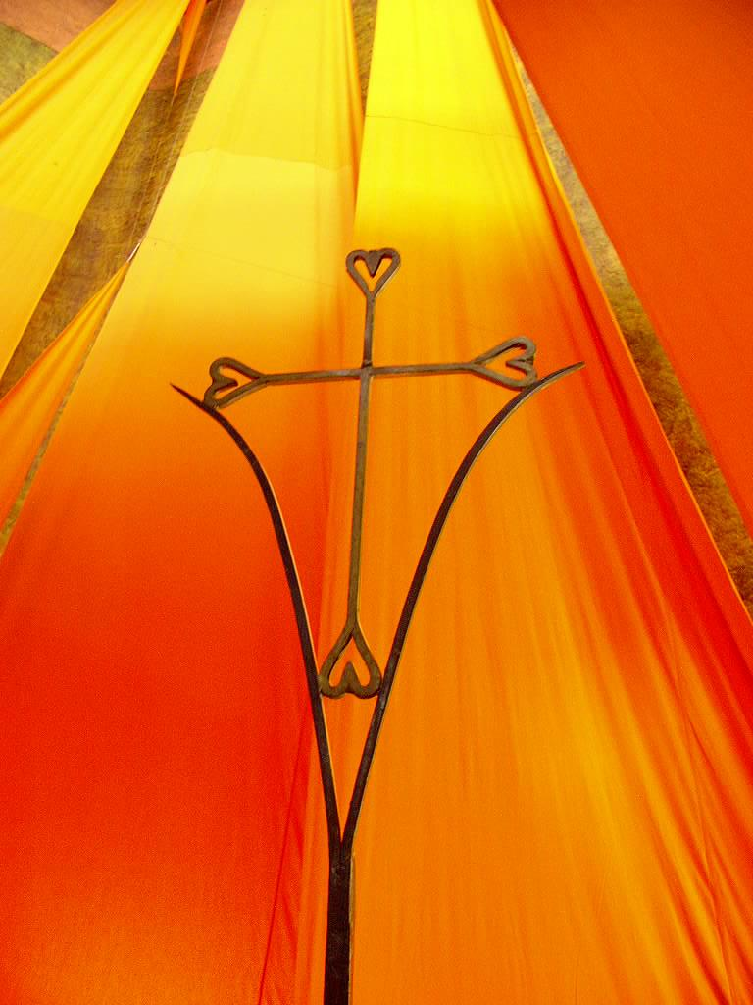
9am Taize Holy Communion Service - Our 9am Holy Communion includes several well known chants from the Taize community in France. This service is on EVERY Sunday. It is a smaller, quieter, more contemplative service than our 11am. All are welcome.

10am Coffee and conversation in the church. A chance to meet and spend time with one another before or after worship

11am Morning Worship
This week it is our ALL AGE worship. The focus is on the Festival of All Saints. It is a service where we encourage our children and young people to get more involved in our time of worship, alongside those of us with greater life experience!

4pm All Souls Service of Remembrance
On Sunday afternoon we will gather to remember those close to us who have died. At the service of All Souls there is an opportunity to pause, to pray, to light a candle, and to bring to God all that is on our hearts at this time.

Monday to Friday at 8.30am and 6pm: Morning and Evening Prayer on ZOOM

Monday 2nd November
2pm Bible Study - Dig deeper into scripture with Hazel and Trevor @ Charter Court

Tuesday 3rd November
7pm Bible reflection and sharing - At the vicarage (contact Rev Steve for more info)

Wednesday 4th November
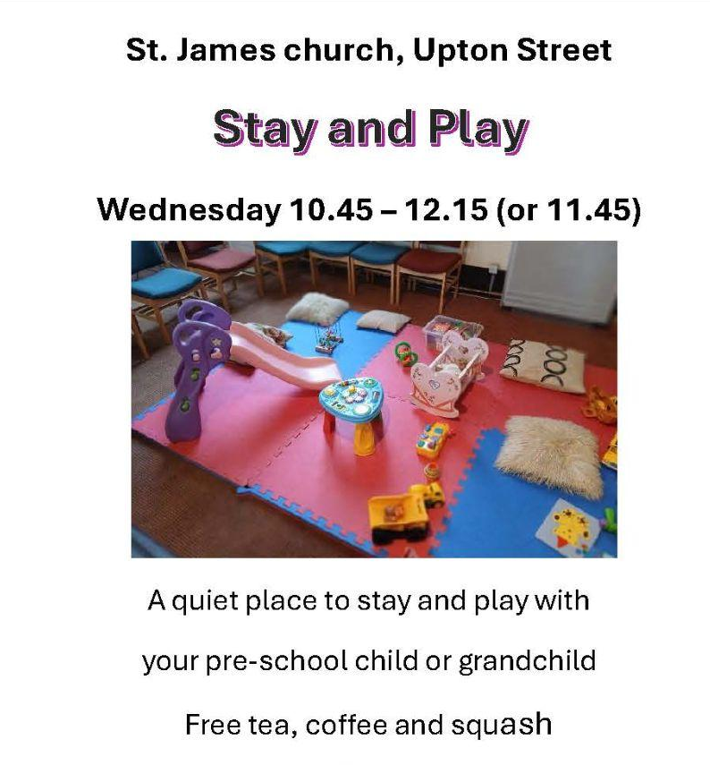
9.15-10.45am English Corner - English conversation class for all levels. FREE

10.45-12.15pm Stay and Play - A free hour of soft play for you and your pre-school children. Tea, coffee and soft drinks also available (help yourself)
Because it is half term we will also have space for primary school age children to do some art and craft activities, play table tennis etc.

1-2.30pm Art4Life
Open to all adults to come and get creative with our artist-in-residence, Rozsa.
1-2.30pm Wednesday Welcome
Come and share a cuppa with friends from St James. There is also plenty of wool to knit with, if that is your thing!

4-5pm **NEW** KS2 Dance Workshop - 4 classes throughout November for those in school years 3-6 to do some dance with Ruth, a drama and dance teacher connected to Sportily. You can just turn up on the day but do get in touch with me for any more information.
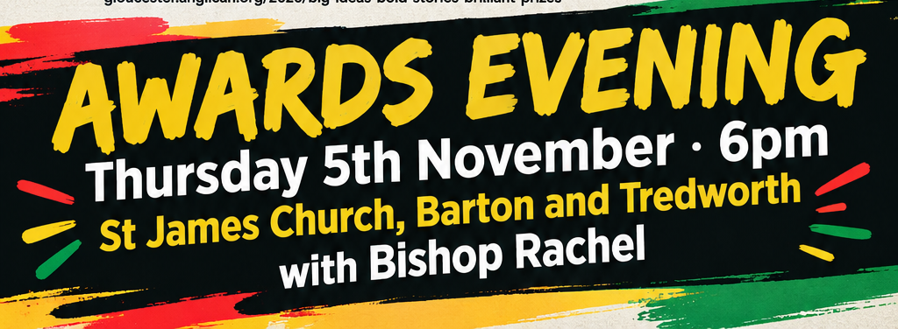
Thursday 5th November
6-7pm Black History Month Awards with Bishop Rachel at St James Church
Come and celebrate the end of Black History Month with the Awards evening for all those children and young people who have submitted entries into the BHM competition. It will be a

6 - 7.30pm Youth Group in the church. This week we will be participating in the Black History Month Awards - as it is on at the same time! We might be serving refreshments, part of the choir, welcoming visitors, etc.

Advance Notice
Saturday 7th November 7pm - Skittles @ The Farmers Club. Everyone is invited. For more information contact myself, Hazel Croly, or Trevor Henry.
Saturday 21st November 7pm - Big Band Jazz from The Metz Band. Swing into the Christmas Season at St James with our ever popular Big Band evening. Entry is free with a retiring collection for Gloucester Feed the Hungry and St James Church Outreach
Saturday 28th November 7pm - Special Praise Celebration. A special evening of all your favourite praise hymns and songs.
Sunday 13th December 5pm - Carols by Candlelight at St. James
Wednesday 23rd December 4pm - Farmyard Nativity - Carols amongst the animals at St James City Farm.

More Community What’s On
Friendship Cafe Community Lunch - Every Monday at 12.30pm in the main hall. Free but donations welcomed.

The Fair Shares Allotments, Upton Street, are open on Monday, Wednesday and Thursday from 10am - 4pm - You can pick up some freshly picked vegetables, help to look after the crops, and find activities for children. As well as a cup of tea and a sit down! Everyone is welcome to go along.

St James City Farm - Do pop along and say hello to the animals on any day of the week, especially “Nature Craft and Play” on Thursdays 10.30am - 12noon.

Bartongate Children and Family Centre - 1.30 - 3pm Stay and Play session every Wednesday

In other news…
We are looking for someone to help with our pre-school children on a Wednesday and Sunday morning. If you know of anyone who might like to serve in this way then please let me or Fola know. It would be a great chance to gain experience before applying for a course or a paid role.

We are planning a Global garden - 4 raised beds growing food from Jamaica, Nigeria, Sri Lanka, and the UK. Would you be interested in being a part of this - helping to plan, plant, and nurture one of the beds? Speak to me or Chioma for more information.

As always, if you would like me to pray for, or have a conversation about anything then do get in touch. I am available to listen and share in whatever might be arising for you at this time.

God Bless,

Rev Steve 07503164309

