
SPIRE & LIGHT United Churches
United Benefice of St Keverne, St Ruan with St Grade & St.Wynwallow (The Lizard)

*If you do not wish to receive these notices, please let your Churchwarden know*

18th October 2026



Readings
Isaiah 45:1-7
Psalm 96:1-9
1 Thessalonians 1:1-10
Matthew 22:15-22

9.30am – Holy Communion - St.Peter’s, Coverack
9.30am – Holy Communion - St.Wynwallow, The Lizard
11am – St.Keverne - Special service at Methodist Chapel
(Please note, no service at St.Keverne Church)
11.15am – Family Service – St.Ruan, Ruan Minor
3pm - Sea Harvest – St.Mary’s, Cadgwith

Monday 19th 7pm St.Constantine Church – Licensing service for Revd Stewart Shaw. All are welcome. Please car share where possible.

Next week – Oct 25th
9.30am – Morning Prayer – St.Peter’s, Coverack
9.30am – Holy Communion - St.Ruan, Ruan Minor
11am – Holy Communion - St.Keverne
11.15am – Café Church – St.Wynwallow, The Lizard

The Prayer Spot



We all have a duty of care to be together and to do everything in the name of Jesus Christ our Saviour. God has given us the great gift of prayer, to pray for His help and guidance in our lives and the lives of others and ask God to be with us in all we do.
Please pray for -
- those in our community who need God's help in their lives which sometimes can be difficult.
- the people in the Ukraine who need Gods help - we pray that they will have God's presence in their lives.
- all those who need hospital treatment, that God will be present with them and their family and meet their needs.
- that God will be with us all, giving us the gift of love to share with all
- for our Clergy, that God will guide them in all they do for us. Give them the gifts they need in their care for us.
We thank you heavenly Father for your gifts of forgiveness, kindness, justice, generosity and peace - all gifts to share with others.
Remember God is ever present in your life. Be blessed in all you do.
Faithful Father we begin today giving you thanks, your love endures for ever, it never fails. Though there are many ways in which we have failed, we have not exceeded the supply of your mercy and grace. We thank you for revealing yourself to us through your word. As we open our bible today, we pray we would hear your voice. We ask that your Holy Spirit would be at work in opening our ears to hear and our hearts to receive your word. May we be transformed into your likeness through Jesus Christ Saviour. Amen
Mighty God, everything you do reveals your glory and majesty. Open our eyes to see what you are doing in our lives. Let us marvel at your good gifts and your wise provision . Your acts are amazing Lord. We cannot comprehend the number of blessings you pour out on us from day to day. Transform us Lord and make us more like you through Jesus Christ our saviour. Lord Amen
God bless you all. Samuel Buchanan

The Diocese of Truro’s Prayer Diary for this week

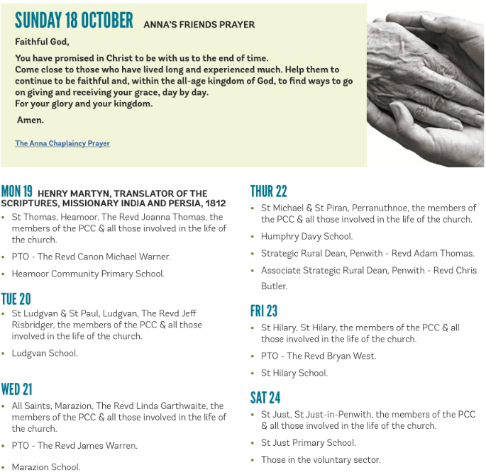

On The Way Prayers

“Let nothing disturb you. Let nothing frighten you. All things are passing away: God never changes. Patience obtains all things. Whoever has God lacks nothing; God alone suffices.” (St Teresa of Avila)

Dear Lord we ask that you will make us all more patient. Help us not to get frustrated in our daily lives when things don’t move as quickly as we’d like; when we have to wait on the phone for ages to actually get to talk to someone, when we’re queuing in the supermarket, or waiting for traffic to move. Give us more patience when, in our Deanery and Diocese, things seem to take forever, or we can’t get to talk to people when it’s convenient for us. Give us more patience in our own churches – with the people and the things that frustrate us. Help us always to remember that “patience obtains all things”! We give thanks that our patience has been rewarded and on Monday we will welcome the third stipendiary post to our Ministry Team and Heidi and Susie will be afforded their official titles. Let us pray for Stewart and for his wife Heather that they may they find a warm welcome in our midst.

Let us also keep remembering that God never changes, but that he will always be with us through change, through troubled or tough times, and as we change and evolve to respond to the world around us, he will still be constant – always there, always caring and always listening to our prayers. Lord help us to remember this.

We bring before you Lord our troubled world. We pray for peace in all places currently at war. We pray for world leaders that they may work for the good of all and not just for their country. With the rising cost of fuel let us pray for all who are worried about coping this winter, those whose livelihoods depend on diesel for their vehicles and for the people of Ukraine as their energy infrastructure continues to be hit and destroyed.

We pray for Pope Leo and for all who are living with a cancer diagnosis whilst giving thanks for the work of charities and scientists who all the time are seeking new cures and treatments.

We pray for each other, for the problems that we each harbour in our hearts, for the things that keep us each awake at night and for the strength to keep going, to keep our own churches alive and our communities drawn to both the vibrancy and the peace and tranquillity that can be found in the walls of our beautiful buildings.

Amen

