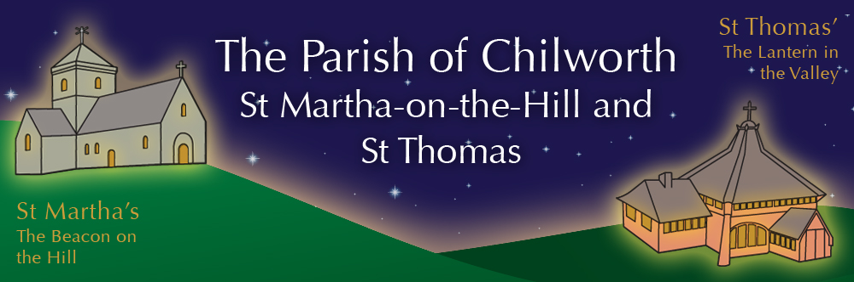

NOTICES: - 18th OCTOBER 2026
Priest David Oakden – Revdavid@parishofchilworth.org.uk - 01483 534293 (day off Friday)
Do let me know of anybody or anything that you would like to be prayed for.
www.parishofchilworth.org.uk and find us on https://www.achurchnearyou.com

*******1 Thessalonians 1: 9-10 (NRSVA)******
For the people of those regions report about us what kind of welcome we had among you, and how you turned to God from idols, to serve a living and true God, and to wait for his Son from heaven, whom he raised from the dead—Jesus, who rescues us from the wrath that is coming.
***********************************

Opportunities to pray together: -
Ecumenical Prayer Breakfast 1st Saturday of the month at the Vicarage, from 9am, prayer, coffee and croissant. Next is the 7th of November – Tuesday afternoons 2:30 – 3:30pm

This Sunday Services: – 20th after Trinity
09:30 St Thomas’s Holy Communion.
11:15 St Martha’s Matins.

Next Sunday Services: - 25th October
09:30 Albury Holy Communion.
11:15 St Martha’s Holy Communion.

Looking further ahead: -
Tots and Toddlers: St T’s Monday 9:15am.
ALPHA Course: St T’s 7pm Thursdays.
Dog Blessing Service: 18th Oct, 2pm at St M’s

Food & Hygiene Bank: -
The Foodbank Larder box is located in the porch of St Thomas Church. Please help!
'Thank you to all who have donated recently putting us in a better situation.
Donations of LL milk, tinned meat, fish, veg & beans, sachets rice, toiletries and cleaning products always needed. We have sufficient pasta for the moment.

Chilworth Tinies and Toddler Group: -
Mondays from 9:15 -10:30 meet in St Thomas, play chat, pray and support.

ALPHA Course Thursday evenings: -
ALPHA course is running at St Thomas Church, there will be food a short video and an opportunity to think and chat about the topic for that night in an open and friendly atmosphere, it is free and everyone is welcome, but the course is particularly suitable for non-believers, new Christians, or anyone curious about faith. Please do think therefore if you know anyone that falls into these categories and tell them about the course, and ideally perhaps offer to come with them. We meet and eat at 7pm, finishing at 9:15pm. There is no charge, but it is helpful to know how many are coming for catering purposes. Email me if you would like to know more or to let me know you intend to come at revdavid@parishofchilworth.org.uk

Tim’s Farewell: -
Huge thanks to everyone who was involved in ensuring that Tim had a good farewell weekend as he retired as Rector of the benefice. The work is beginning on recruiting our next Rector and as such it would be good to hear your response to the following question:
What 3 qualities are you looking for in a new Rector?
Please send your responses to Wiebke Tickner.wiebke@tillingbournebenefice.org

In Memory of: -
Simple service where we light a candle for each name read out. Please let David know the name you would like remembered, or email admin@parishofchilworth.org.uk . St Martha’s service is 1st November at 3pm. St Thomas service is 15th November at 3pm.

Act of Remembrance 8th November: -
Our morning services will incorporate an Act of Remembrance, so start at different times, St Thomas 10:30, St Martha’s 10:50 also we hope the RAF Chinook will once again do a fly over at around 11am. We meet at the outside War Memorial in Dorking Road at 3pm as well.

