SUNDAY
11am Holy Communion Rev Mark & Rev Jan

Readings Philippians 4¹⁻⁹, Matthew 22¹⁻¹⁴

13 October EDWARD the CONFESSOR
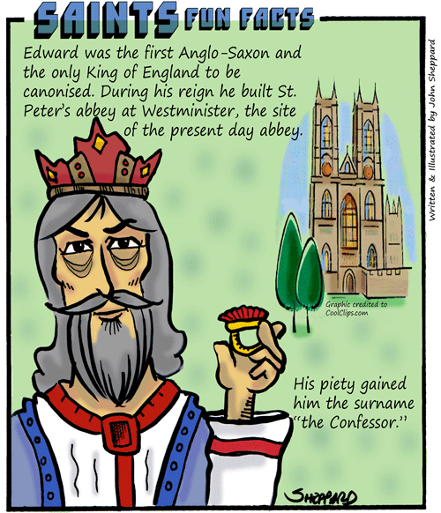 If you approve of giving money to help cathedrals survive, then Edward the Confessor (1003 – 66) is the saint for you. This early King of England was the virtual founder of Westminster Abbey. And never mind entrance charges – at one point in his life, Edward was giving a full tenth of his income to Westminster Abbey. Crowned King in 1042, scholars have argued over how much success Edward had as a king. As a Christian, though, there is no doubt. Edward’s holiness was evident to all. He made himself accessible to his people, he was generous to the poor, and chaste. He was also reputed to have seen visions and even achieved miraculous cures for people through prayer. During the Middle Ages Edward was a very popular saint and widely considered to be England’s patron saint for a time.

WEDS (14th)
10:30am Holy Communion Rev Mark

Readings Galatians 5^{18 to end}, Luke 11⁴²⁻⁴⁶

Services for next week

Sun 18th 8:00am Holy Communion [BCP]
11:00am Holy Communion [CW]

Weds 21st 10:30am Holy Communion

Looking ahead
Every Tues. 10:30am KETTLE’S ON at St B’s.

Every Weds 1:00-2:30pm and 7:30pm-9:00pm
THE PRAYER COURSE, held in St B’s.

Sat. 17th Oct. 10am-4pm QUIET DAY at St M’s.

Sat. 24th Oct. 10am-3pm ILLUMINATE exhibitin

BRF
Thought for the Week
To pray is to serve our neighbours, especially those we can’t see or who are far away; God uses our prayers for these others to bring blessing, strength and hope to a needy world.

Please remember to pray for Derek & Pam Johnson, Derek Cotgrove, Guy Negus, Janice Millar, Sue Burton, Tessa Yates. Carol Atkins, Mark Banham, Jane Barrett, Chris Weekes, Wendy Haji and Bruce Tomsett.

If you are interested in knowing/understanding more about Holy Communion, Baptism, Confirmation and The Nicene Creed, there are some handouts at the back of church - please do take/ask for them.

