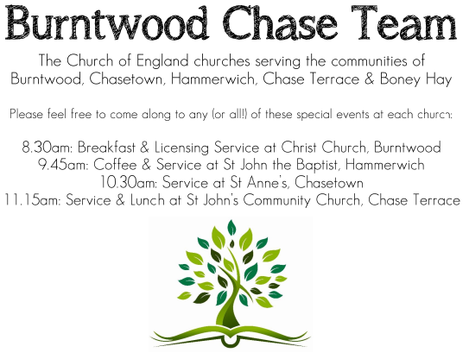
CHRIST CHURCH, BURNTWOOD
Registered Charity Nos: 1217129

SERVICE ON SUNDAY 27TH SEPTEMBER 2026 AT 10AM

MORNING WORSHIP

The 17th Sunday after Trinity

First Bible Reading – Philippians 2:1-13

If, then, there is any comfort in Christ, any consolation from love, any partnership in the Spirit, any tender affection and sympathy, ² make my joy complete: be of the same mind, having the same love, being in full accord and of one mind. ³ Do nothing from selfish ambition or empty conceit, but in humility regard others as better than yourselves. ⁴ Let each of you look not to your own interests but to the interests of others. ⁵ Let the same mind be in you that was in Christ Jesus,⁶ who, though he existed in the form of God, did not regard equality with God as something to be grasped, ⁷ but emptied himself, taking the form of a slave, assuming human likeness. And being found in appearance as a human, ⁸ he humbled himself and became obedient to the point of death—even death on a cross. ⁹ Therefore God exalted him even more highly and gave him the name that is above every other name,¹⁰ so that at the name given to Jesus every knee should bend, in heaven and on earth and under the earth, ¹¹ and every tongue should confess that Jesus Christ is Lord, to the glory of God the Father. ¹² Therefore, my beloved, just as you have always obeyed me, not only in my presence

but much more now in my absence, work on your own salvation with fear and trembling, ¹³ for it is God who is at work in you, enabling you both to will and to work for his good pleasure.

Gospel Reading – Matthew 21:23-32

When he entered the temple, the chief priests and the elders of the people came to him as he was teaching and said, “By what authority are you doing these things, and who gave you this authority?” Jesus said to them, “I will also ask you one question; if you tell me the answer, then I will also tell you by what authority I do these things. Did the baptism of John come from heaven, or was it of human origin?” And they argued with one another, “If we say, ‘From heaven,’ he will say to us, ‘Why, then, did you not believe him?’ But if we say, ‘Of human origin,’ we are afraid of the crowd, for all regard John as a prophet.” So they answered Jesus, “We do not know.” And he said to them, “Neither will I tell you by what authority I am doing these things.

“What do you think? A man had two sons; he went to the first and said, ‘Son, go and work in the vineyard today.’ He answered, ‘I will not,’ but later he changed his mind and went. The father went to the second and said the same, and he answered, ‘I go, sir,’ but he did not go. Which of the two did the will of his father?” They said, “The first.” Jesus said to them, “Truly I tell you, the tax collectors and the prostitutes are going into the kingdom of God ahead of you. For John came to you in the way of righteousness, and you did not believe him, but the tax collectors and the prostitutes believed him, and even after you saw it you did not change your minds and believe him.

Collect for Today

Almighty God, you have made us for yourself, and our hearts are restless till they find their rest in you: pour your love into our hearts and draw us to yourself, and so bring us at last to your heavenly city

where we shall see you face to face; through Jesus Christ your Son our Lord, who is alive and reigns with you, in the unity of the Holy Spirit, one God, now and for ever.

Amen

Forthcoming Services in Church

Wednesday 30th September Morning Prayer 9.30am

Sunday 4th October Harvest Holy Communion 10am

Wednesday 7th October Morning Prayer 9 30am

Sunday 11th October Morning Worship 10am

Future Event For Your Diary
Saturday 3rd October Art Café 3pm

Monday 5th October Cameo Café (£1) 10am

Saturday 14th November Christmas Fayre 2-4pm

Food bank

We are continuing to support this important ministry for people in need in our local community, for which the following items are always needed: ‘Long Life Milk, Custard, Rice Pudding, Cereals. Many thanks for your support. The Food Bank is very grateful for whatever you may be able to donate.

Floodlighting
If you would like to commemorate a special occasion by floodlighting our Church, please contact Chris Brown on 01543 683862 for details.

Prayer Chain

Christ Church is blessed with a very active prayer chain. If you, or anyone you know, feel that they would like others to pray for them, please speak to Chris Brown on 01543 683862.

Home Visits and Communion

For anyone who is unable to attend church and would like a Home Visit and Communion, please contact the Vicar and he will be able to carry this out.
Vicar’s Contact Details

Rev’d Stephen Morgan - Telephone: 07305 852152

Church Wardens Contact Details

Judith Rogers - Telephone: 01543 324718
Mike Holmes - Telephone: 01543 672970
Church Office Telephone: 01543 642187 [Please leave a message and we will respond in due course]
Church Web Site:www.christchurchburntwood.org.uk
Church Email: christchurchburntwood15@gmail.com
Facebook: www.facebook.com/group/christchurchburntwood/

Next Sunday’s Service – The 18th Sunday after Trinity
Sunday 4th October 2026 – Harvest Holy Communion at 10am
Bible Readings: Philippians 3:4b-14 and Matthew 21: 33 to the end

