Psalm 34: 1 to 10

Please stand, if able, and join in with the verses in bold italics

I will extol the Lord at all times;
his praise will always be on my lips.
Mothers’ Union and Friends Christmas Meal
If you would like to come along to the Christmas meal on 2nd Wednesday at 12noon at the Newdigate in West Hallam, please ask Janet for a menu and price list.
I will glory in the Lord;
let the afflicted hear and rejoice.
Glorify the Lord with me;
let us exalt his name together.

I sought the Lord, and he answered me;
he delivered me from all my fears.
Those who look to him are radiant;
their faces are never covered with shame.
This poor man called, and the Lord heard him;
he saved him out of all his troubles.
The angel of the Lord encamps around those who fear him,
and he delivers them.

Taste and see that the Lord is good;
blessed is the one who takes refuge in him.
Fear the Lord, you his holy people,
for those who fear him lack nothing.
The lions may grow weak and hungry,
but those who seek the Lord lack no good thing.

Glory be to the Father and to the Son and to the Holy Spirit,
as it was in the beginning, is now and ever shall be,
world without end. Amen
Evening Services
Our evening services are now at 4pm and we are meeting to worship in Friendship House.
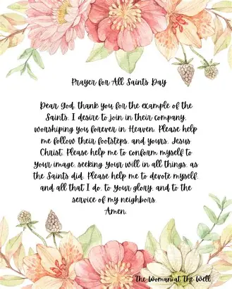

In our weekly prayers for our parish
This week we pray for God’s blessing on Ribblesdale, Ridgeway Drive and Rowan Close.

All Saints Church
Distribution of Communion
Bishop Jackie has asked all parishes to return to having the ‘common cup’ at services of Holy Communion. When Rev’d Christine is presiding, we will have at the altar two chalices, one where the priest will continue to dip the wafer into the wine and a separate chalice for those who want to sip the wine. Other visiting priests may just use the one chalice to sip from.
Refreshments After the Morning Service
Please stay seated after the service and a hot drink will be brought to you in the pews. Do not get up and head to the back of church, it is becoming a hazard, and a risk as trays of hot drinks could be knocked over.
Church contact information
Contact: Rev’d Christine - revchristine@outlook.com
The Rectory, The Village, West Hallam, DE7 6GR
Landline 0115 646 1497
Rev’d Ailsa -revailsahunt@gmail.com
Tel - 07356064856

Churchwardens – Mrs Janet Wheeldon, -Tel: 0115 8771593
Mrs Linda Gregory – linda.gregory3@icloud.com
https://www.achurchnearyou.com/church/13402/
https://www.facebook.com/allsaintskirkhallam
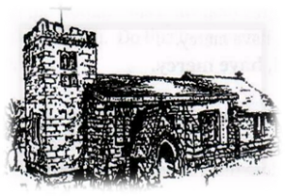
Kirk Hallam
Disabled Toilet in Friendship House.
Disabled Toilet in Friendship House.

Working with God to transform lives & communities.
Please can you ensure your mobile is on silence, or off during the service, it is affecting people with hearing aids and the loop system.
1st November – All Saints Day
10.00am CW Communion Service with Fr Bob Boyle
4.00pm BCP Evening Prayer with Eileen

Forthcoming Events
Mon 2nd 11.00am Funeral for Ronald Jarvis in church
Tues 3rd 9.30am Dallimore School in church
Tues 3rd 11.00am Mid Week Act of Remembrance
Tues 3rd 6.30pm Home Group in Friendship House
Weds 4th 9.30am Morning Prayer at UCAS
Weds 4th 9.30am Dallimore School in church
Weds 4th 2.00pm Mothers’ Union meeting in church
Fri 6th 6.00pm Choir in Friendship House
Sat 7th 10.00am Prayer Meeting in Friendship House

8th November – Remembrance Sunday
10.00am Iona Communion Service with Rev’d Christine
3.00pm Building Faith at Com Centre with Rev’d Ailsa
4.00pm Iona Evening Prayer with Rev’d Christine
‘Peace I leave with you; my peace I give to you, I do not give to you as the world gives. Do not let your hearts be troubled and do not be afraid’ John 14:27
It’s Good to Talk! If you spot that someone is missing, please pop a news sheet through their door, & if you’ve time, call for a chat - just to check they’re OK & to let them know that they are not forgotten!

