St Thomas’ Church and Community Project
“A Place for You”
November Newsletter

If you are reading this on 1st November it will be 55 days to go until Christmas Day dawns and we celebrate the birth of God becoming flesh in a stable place in Bethlehem. Can you believe it? We are only just getting over the hottest summer on record and the coolest we will ever remember!
November is a busy month as we begin to plan our festivities and to look forward to Advent and all the new learning and understanding that might bring for us.
First, we have firework night to celebrate the failure of the Gunpower Plot. As children do we remember “Penny for the Guy” before Trick or Treat took over? I remember being in the back garden while Dad set off fireworks for me, and me wearing a mask and then eating Baked Potatoes! And does anyone remember this nursery rhyme by an unknown traditional author?
Remember, remember the Fifth of November,
The Gunpowder Treason and Plot,
I know of no reason
Why the Gunpowder Treason
Should ever be forgot.
Guy Fawkes, Guy Fawkes, t'was his intent
To blow up the King and Parli'ment.
Three-score barrels of powder below
To prove old England's overthrow;
By God's providence he was catch'd
With a dark lantern and burning match.
Holla boys, Holla boys, let the bells ring.
Holloa boys, holloa boys, God save the King!
And what should we do with him? Burn him!
Then we move on to Remembrance Day when we remember all those people and animals who lost their lives in conflict during World Wars and in active service today.
During our act of worship that day we will join in with BBC to watch proceedings at the Cenotaph and to share in the two minutes of silence. We will lay down our poppies and hear the Reveille and repeat the words of the Kohima Epitaph. Our hearts will grieve the fallen and our souls pray for an end to violence, war and bloodshed asking that we may all live the abundant life that Jesus wants for us (John10:10).
An Abundant Life in Everyday Life looks like someone who can face stress, money worries or illness and still feel calm and peaceful inside because we know Jesus is our constant companion, comforter and helper. It is not about what we have, but about how we live.
A few of us were talking recently about learning at school the Lord’s Prayer and the 23rd Psalm and having been grateful that we could just recite the words. There have been (or will be) times in our lives when we want to pray but find ourselves unable to for various reasons. These are the times when knowing the prayer Jesus taught us, and the words of the psalm are so useful. The bring us peace and healing, and they open a channel for prayer when nothing else will. The words of the Lord’s prayer appear later in this newsletter but here are the words of the 23rd psalm just in case you have forgotten them or never learned them. I am very sad these are no longer taught in schools. In my opinion, knowing where to find them is not enough.

Psalm 23 New International Version - UK
¹ The Lord is my shepherd, I lack nothing.
² He makes me lie down in green pastures,
he leads me beside quiet waters,
³ he refreshes my soul.
He guides me along the right paths
for his name’s sake.
⁴ Even though I walk
through the darkest valley,^{[a]}
I will fear no evil,
for you are with me;
your rod and your staff,
they comfort me.
⁵ You prepare a table before me
in the presence of my enemies.
You anoint my head with oil;
my cup overflows.
⁶ Surely your goodness and love will follow me
all the days of my life,
and I will dwell in the house of the Lord
for ever.
.
Rev Sue Round

November church services
If you want to discover more, come and join us any Sunday morning or at any of our community activities throughout the week.
Sunday 1st November – Holy Communion for All Saints Day
Sunday 8th November – Morning Prayer and Act of Remembrance
Sunday 15th November – Holy Communion & Safeguarding
Sunday 22nd November – Morning Prayer
Sunday 29th November – Holy Communion for Advent Sunday

Children are always welcome to join us. We have some toys for babies and will provide activities for older children to do in their seats. Please do not worry if you arrive a bit late or need to leave before the end.

If you are on the rota to read during November, please assume that you will be reading the gospel. These may be subject to change. The readings are listed here in case you want to practice:

Sunday 1st | Matt 5 vv 1-12
Sunday 8th | Matt 25 vv 1-13
Sunday 15th | Matt 25 vv 14-30
Sunday 22nd | Matt 25 vv 31-end
Sunday 29th | Mark 13 vv 24 - end


October was Vegetarian Awareness Month and we thought about how food production causes a quarter of global greenhouse gas emissions – about 60% of which is caused by meat production.
Eating vegetarian meals for one year is equivalent to taking a small car off the road for 6 months. We may not want to give up eating meat – I enjoy eating meat, it’s a lifelong habit and I don’t think I could give it up completely but I know that every meat-free meal I eat reduces my carbon footprint a little bit, so I try to have two or three non-meat days a week.
How about trying this easy and comforting recipe from Ferne McCann –

Cauliflower, Leek and Broccoli Cheese Gratin – Serves 2
Ingredients
½ medium cauliflower, cut into florets
½ medium head broccoli, cut into florets
20g butter, plus extra for cooking the leeks
50g baby leeks, sliced
170ml milk
20g flour
70g mature cheddar, grated
2 tbsp fresh breadcrumbs
salt and pepper
Method
1. Preheat the oven to 220C/200C Fan/Gas 7.
2. Cook the cauliflower and broccoli in boiling water for 5–6 minutes until just tender. Drain well and tip into a deep baking dish.
3. Melt a knob of butter in a frying pan and fry the leeks for 3–4 minutes, stirring frequently until softened. Arrange them in the dish with the florets.
4. Heat the milk, flour and butter in a saucepan over a medium heat, whisking constantly until the sauce comes to the boil and thickens. Reduce the heat and whisk over a low heat for 1–2 minutes. Remove from the heat, stir in 50g of the grated cheese and season to taste.
5. Pour the sauce over the vegetables and sprinkle over the breadcrumbs and the remaining cheese. Bake for 20 minutes or until the top is golden brown and bubbling.
6. Serve with crusty bread – Enjoy!
Linda Nugent
Parish Environmental Champion

Christmas 2026 services
Sunday 29th November at 10.00am
Come and join us for our Advent Service at the start of the season of Advent when we light the first advent candle. This will be a quiet and reflective service as we recover from the Bazaar’s exertions of the previous day.
Sunday 6th December at 10.00am
Our annual memorial service - an opportunity to pause and remember those you have loved and lost. Sometimes this is called a Blue Christmas Service.
Everyone is welcome
Christmas Eve December 24th at 6.00pm.
Carols by Candlelight
A traditional family service to put you in the Christmas mood followed by refreshments afterwards.
Christmas Day December 25th 10.00am
Informal worship with Holy Communion
Everyone is welcome to join us for worship any Sunday morning at 10.00am

Everyday Faith

What is ‘Everyday Faith’?

Everyday Faith is the name given to a wide range of activities across the church of England that support and equip us all to ‘find and follow God’ in our everyday lives – Sunday to Saturday.

When we are together worshipping on Sunday, we are as a GATHERED church. When we are active as Christians Monday to Saturday, we are the SENT church. Whatever we are doing for the glory of God in our hearts is also worship.

Worship, prayer, teaching and Christian fellowship doesn’t just happen in church on Sunday mornings, the church is active out in the community throughout the week.

- Stay and Play group for babies and toddlers on Monday (resumes 2nd November)

- Children’s club with fun and games, crafts, cooking, activities, challenges and bible stories on Mondays from 4.00 till 5.30 and youth club 5.45 till 7.15 – resumes 2nd November

- Young Adults discipleship group – Monday evenings from 7.30 till 8.30

- A church service Heartlands Care home happens twice monthly

- Pastoral visits at West Hall Court every other Thursday morning and at Heartlands Care Home on Friday afternoons.

- Godly Play at Oasis Blakenhale Juniors every Tuesday – Christian teaching with classes from years 3 to year 6.

- The Open the Book team make monthly visits to the school assembly at Oasis Blakenhale Infants School. If anyone is interested in joining the team please speak to Susan, Jo, Linda or Jan - it's great fun and very rewarding

- Activities for those over 50 on Thursday and Friday – homemade hot soup is now being served throughout the winter months.

- We are also being Everyday Faith when we are chatting at the school gates, talking to someone in a coffee shop, the library, the post office etc, or reading quietly at home etc.

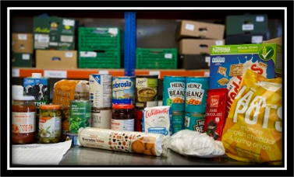
Foodbank Update
October was a busy month for the foodbank as October usually is. We had lots of food donations coming in from local schools; this often involves our foodbank volunteers participating in school visits to church and attending Harvest assemblies and bringing all the tinned and packet foods donated by families back to church and sorting it out and putting it into our stock.
We are grateful to the students, staff and families at the following schools: Brays School, Lyndon Green and Shirestone; St Peter's church Tile Cross and Digbeth in the Field URC.
As winter approaches and with the current financial pinch on families we are experiencing greater need with new clients registering for help. We have also been able to distribute clean good quality winter clothing and shoes (but please ask before donating clothing because we have very little storage space) As well as enjoying hot drinks and toast our clients enjoy the cakes donated every week by Brothers Union.
Please keep the regular small donations of basic food supplies coming in and we have opened what we call our Christmas Treat Box and through November we are collecting extras to distribute to clients in the weeks before Christmas; for example, fancy biscuits, sweets and chocolates, mince pies, small Christmas puddings, savoury snacks etc.
Thank you to everyone from our volunteer team Rev Susan, Jo, Jan, Ray, Dan, Debbie, Barabara and Sue Deane.
If you have any spare shopping bags, or bags-for-life, we will be very grateful for them and we are happy to re-use plastic carrier bags you may have. Please leave them in the donation boxes or pass to Jan or Jo.

Website update
Our website reflects everything that happens in church on Sundays, including other acts of worship and study groups, as well as what happens during the week, all in the name of St Thomas. Please have a look if you are able. If you have any comments, observations of additional thoughts, please contact Rev Sue. In future all our newsletters will also be available on the website so don’t worry if you lose it. If you would like your own copy emailed to you, again, please contact Rev Sue.

Our web address is www.st-toms.com

If you use Facebook please like and follow us on St Thomas Church & Community Project.

Please note that our internet connection is still unstable. We do have connection through an alternative method than Virgin, but it doesn’t reach the church. It will be fixed shortly but, in the meantime, if you are responsible for preparing the worship please bring the service backed up to a flash drive or your own laptop.

Prayer Requests and Prayer Pointers

Prayer means putting ourselves into a communicating relationship with the divine God. Prayer is often used to build a relationship with God, offering thanksgiving, asking for help, and seeking forgiveness. It is described as a means to express gratitude and find comfort and strength. It is a gift for our own sense of identity as children of God, and for our own sense of purpose. It is often helpful to end or begin our prayer time with the prayer Jesus taught us:
Our Father in heaven,
hallowed be your name,
your kingdom come,
your will be done,
on earth as in heaven.
Give us today our daily bread.
Forgive us our sins
as we forgive those who sin against us.
Lead us not into temptation
but deliver us from evil.
For the kingdom, the power, and the glory are yours
now and for ever.
Amen.

In your prayers this month please consider including these pointers:
- Pray for all those who are currently unwell, receiving treatment, recovering from illness or surgery and those in residential care.
- For those who work in nursing and caring roles in hospitals, residential homes and at home. For social workers and those who work in prisons.
- For those families grieving the loss of those serving in active combat.
- For world leaders striving to negotiate peace.
- For the UK Government and our new Prime Minister.
- For our congregation to continue to grow in faith and numbers.
- For our work in local care homes and at Oasis Blakenhale School.
- For yourself, and your own family and friends.

Please pray for the family of Sylvia Carroll who passed away
October 27th. She was a regular on Thursdays for a while with a lovely smile and cheeky sense of humour!

Journey to the Stable will happen this year
Thursday 3rd December and Friday 4th December.
Please pray for the Stable Team as we share the story of the first Christmas with local year 2 classes.


Rochelle Dance Academy are open for new recruits, our Tiny Stars from age 3yrs upwards, right up to our senior superstars, experienced dancers also welcome.
RDA is more than a dance school, it’s a family where we make memories, have lots of fun, and make lifelong friendships.
So, if you have a little one, bursting with energy and loves to dance bring them along for a free trial.
Contact Debbie for more information 07957460968.

Gardening Work
New lawn has been laid in front of the Community Centre entrance on Rotherfield Rd. The area under the canopy where the rain doesn’t fall has died. This will be removed and replaced with a border to match the other side. It will be mulched with bark to control weed growth. Mr Squirrel has also dug a small hole to bury his nuts! This will be filled in. The gardener will return when it stops raining to strim back the wildflower meadow at the front of the building.

Stay and Play

Are you left at home with an active toddler? Come and join us on Monday mornings from 9.00 till 11.00 to meet other parents and carers with pre-school children. Lots of toys and activities for you to enjoy with your children and to help them make friends, grow and confidence and learn social and communication skills in a friendly, relaxed atmosphere. We have free time where parents, carers and children can play together, be creative and grow together in preparation for nursery or school. After play time the children sit together for toast and then we finish with sing along and story time.
Cost is £2.00 per child (£1.00 for siblings), pay by cash or card, includes free refreshments. Come along for a free trial session and bring some friends and share your ideas for play with us.


Our Coffee Afternoon was an amazing success and we were really busy! We raised £400!!! Thanks to all those who baked and ate!

https://us02web.zoom.us/j/88974274575pwd=VFU3S2VIMnZXZlFSYk1xWlhUOE43Zz09 passcode: 718707 meeting ID 88974274575)
It’s not to late to join in!

Line Dancing Evening

This event is being organised by Sharon Ellgood (Sam’s Mum) who runs the weekly Line Dancing sessions. Please come along for this evening of dancing! Yee – Haa!!!!


Saturday 14th November
Doors open 3.00pm for 3.30pm start
In the hall at St. Thomas’ Church,
Garrett’s Green Lane

£5 per head, to include hot vegetarian food, tea, coffee and soft drinks (or bring your own alcoholic drinks).
Get your teams together (maximum of six per team) or join someone else’s team.
Tickets from Linda Nugent : nugent.linda@gmail.com
07834 606 244

For a quiet moment

It's easy to look at the brokenness in the world and wonder why things are the way they are. But sometimes the questions that change us most are the ones that invite us to become part of the answer. A little more kindness. A little more compassion. A little more patience. A little more love.
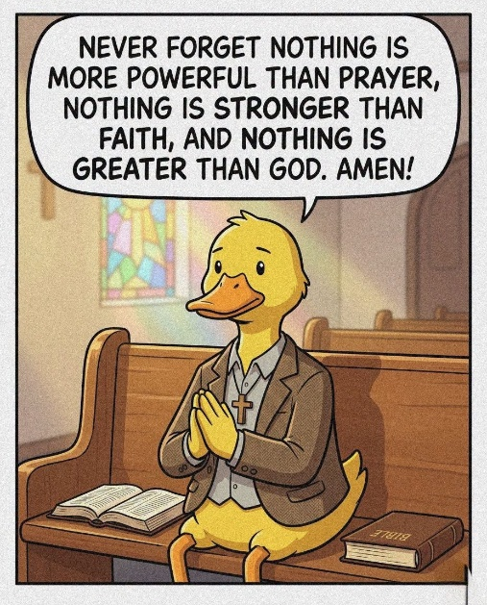
None of us can solve every problem, but each of us can make someone's burden a little lighter today. And perhaps that's where meaningful change begins.
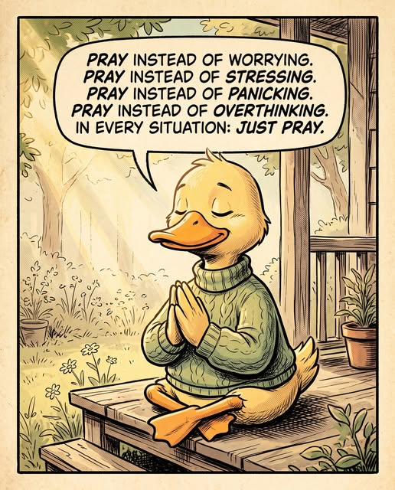




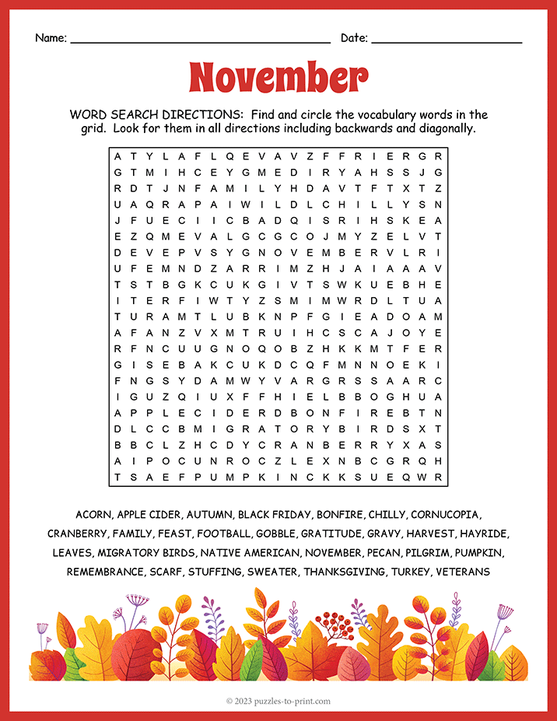


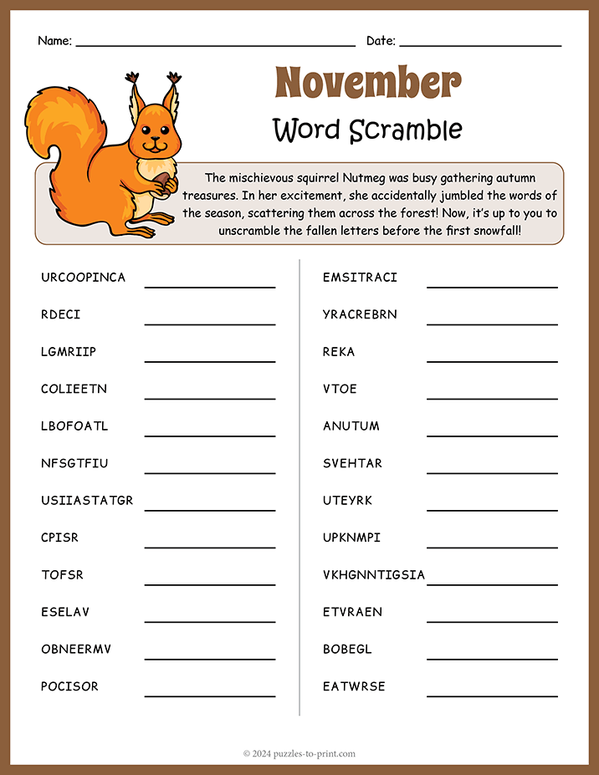

Items and articles for this newsletter are always welcome.
For the December Newsletter please send your articles and items of interest to
Revd Sue Round Sue.Round@st-toms.com
Clergy contact details:
Rev Paul Bracher 0121-783 2319 paul.bracher@Saintrichards.org.uk
Rev Sue Round 0777 343 1028 sue.round@st-toms.com
Rev Susan Larkin 0785 038 7183 revsusan@st-toms.com

Main telephone number for the office 0121-743 7040
The office is manned on a part-time basis but our posh new phone will take an answerphone message and forward as an email to the recipient.

