
SPIRE & LIGHT United Churches
United Benefice of St Keverne, St Ruan with St Grade & St.Wynwallow (The Lizard)

*If you do not wish to receive these notices, please let your Churchwarden know*

11th October 2026

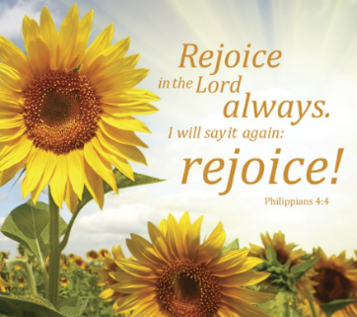
Readings
Isaiah 25:1-9
Psalm 23
Philippians 4:1-9
Matthew 22:1-14

9.30am – Morning Prayer – St.Peter’s, Coverack
11am – Harvest at Methodist Chapel - St.Ruan, Ruan Minor
11am – Holy Communion - St.Keverne
11.15am – Café Church – St.Wynwallow, The Lizard
3pm – Evensong – St.Grade

Next week – Oct 18th
9.30am – Holy Communion - St.Peter’s, Coverack
9.30am – Holy Communion - St.Wynwallow, The Lizard
11am – Morning Prayer - St.Keverne
11.15am – Family Service – St.Ruan, Ruan Minor
3pm - Sea Harvest – St.Mary’s, Cadgwith



As we hold our Harvest services below is a list of foods the Foodbank is in particular in need of at the moment-


The Prayer Spot



We all have a duty of care to be together and to do everything in the name of Jesus Christ our Saviour. God has given us the great gift of prayer, to pray for His help and guidance in our lives and the lives of others and ask God to be with us in all we do.
Please pray for -
- those in our community who need God's help in their lives which sometimes can be difficult.
- the people in the Ukraine who need Gods help - we pray that they will have God's presence in their lives.
- all those who need hospital treatment, that God will be present with them and their family and meet their needs.
- that God will be with us all, giving us the gift of love to share with all
- for our Clergy, that God will guide them in all they do for us. Give them the gifts they need in their care for us.
We thank you heavenly Father for your gifts of forgiveness, kindness, justice, generosity and peace - all gifts to share with others.
Remember God is ever present in your life. Be blessed in all you do.
Faithful Father we begin today giving you thanks, your love endures for ever, it never fails. Though there are many ways in which we have failed, we have not exceeded the supply of your mercy and grace. We thank you for revealing yourself to us through your word. As we open our bible today, we pray we would hear your voice. We ask that your Holy Spirit would be at work in opening our ears to hear and our hearts to receive your word. May we be transformed into your likeness through Jesus Christ Saviour. Amen
Mighty God, everything you do reveals your glory and majesty. Open our eyes to see what you are doing in our lives. Let us marvel at your good gifts and your wise provision . Your acts are amazing Lord. We cannot comprehend the number of blessings you pour out on us from day to day. Transform us Lord and make us more like you through Jesus Christ our saviour. Lord Amen
God bless you all. Samuel Buchanan

The Diocese of Truro’s Prayer Diary for this week

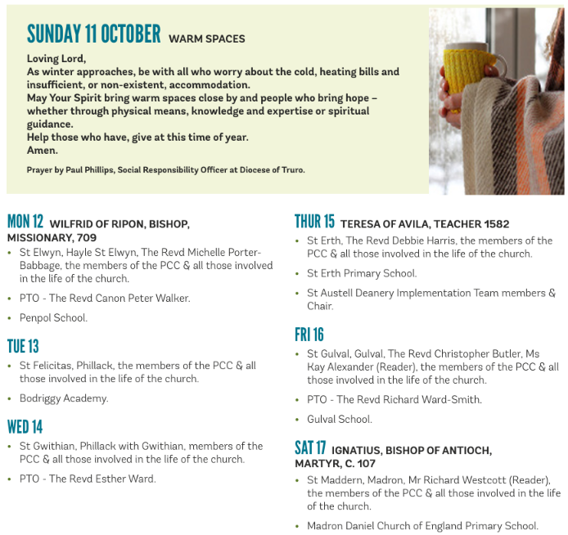

On The Way Prayers

Lord we pray for our small corner of your church here in Kerrier – that we will all grow in faith and bring others to faith. We particularly pray for Stewart and his wife Heather as they settle into our Deanery, learn, our often quirky, ways and hopefully learn to love this place as we all do. We pray for each of our churches, particularly for the smaller congregations among us, and for the sessions that Heidi is running next week for churchwardens on hospitality.

We give thanks today for all who minister in our churches and communities – our Readers, Local Worship Leaders, Local Lay Leaders and all churchwardens who also take services. We pray Lord that you will help us all grow, find continued inspiration and strive to serve you as best we can. Lord, we know that we are on a journey, but we trust that you are with us, showing us the way.

Let us pray for all who are discerning their future within our Diocese; anyone who may be thinking of putting themselves forward for further training, priests who may be considering moving to Cornwall either for retirement or in earlier stages of their career. Lord guide all who would seek to serve you further.

All the unrest, both political and racial, wars and violence, can make us doubt. We know how important it is to pray for peace. Let us take a moment to bring before you the Holy Land, as the world commemorates the third anniversary of the Hamas attack on all those young people, we pray for an end to the atrocities in Gaza, for the violence and hatred that the conflict there is spreading throughout your world. We pray for all Jews in our communities – that they can still go about their daily lives without fear. Let us also remember the ongoing conflict in Ukraine. Prince of Peace bring peace to your world, to our community, to our homes and into our hearts.

We give thanks that we are blessed to live in a place of peace and incredible beauty. Most of our churches have now celebrated harvest and are preparing for the winter months that lie ahead. Let us pray for our farmers, fishermen and all those involved in the tourist industry as they prepare for the quieter, colder, winter months. And our churches also enter a new period – a time of reflection, remembrance and rejuvenation. Let us now pray for anyone or anything that is large in our minds and hearts at the moment.

Amen

