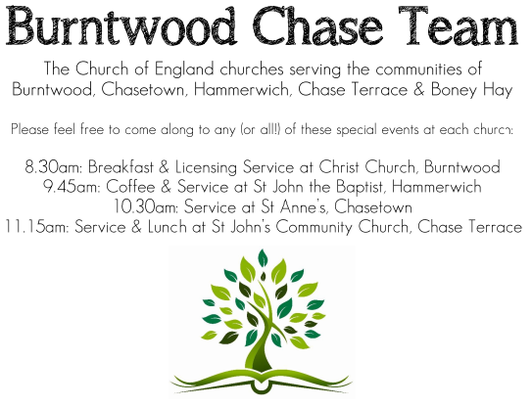
CHRIST CHURCH, BURNTWOOD
Registered Charity Nos: 1217129

SERVICE ON SUNDAY 4TH OCTOBER 2026 AT 10AM

HARVEST HOLY COMMUNION

The 18th Sunday after Trinity

First Bible Reading – Philippians 3: 4b-14

If anyone else has reason to be confident in the flesh, I have more: ⁵ circumcised on the eighth day, a member of the people of Israel, of the tribe of Benjamin, a Hebrew born of Hebrews; as to the law, a Pharisee; ⁶ as to zeal, a persecutor of the church; as to righteousness under the law, blameless. ⁷ Yet whatever gains I had, these I have come to regard as loss because of Christ. ⁸ More than that, I regard everything as loss because of the surpassing value of knowing Christ Jesus my Lord. For his sake I have suffered the loss of all things, and I regard them as rubbish, in order that I may gain Christ ⁹ and be found in him, not having a righteousness of my own that comes from the law but one that comes through faith in Christ, the righteousness from God based on faith. ¹⁰ I want to know Christ and the power of his resurrection and the sharing of his sufferings by becoming like him in his death, ¹¹ if somehow I may attain the resurrection from the dead.
¹² Not that I have already obtained this or have already reached the goal, but I press on to lay hold of that for which Christ has laid hold of me. ¹³ Brothers and sisters, I do not consider that I have laid hold of it,

but one thing I have laid hold of: forgetting what lies behind and straining forward to what lies ahead, ¹⁴ I press on toward the goal, toward the prize of the heavenly call of God in Christ Jesus.

Gospel Reading – Matthew 21: 33 - 46

“Listen to another parable. There was a landowner who planted a vineyard, put a fence around it, dug a winepress in it, and built a watchtower. Then he leased it to tenants and went away. ³⁴ When the harvest time had come, he sent his slaves to the tenants to collect his produce. ³⁵ But the tenants seized his slaves and beat one, killed another, and stoned another. ³⁶ Again he sent other slaves, more than the first, and they treated them in the same way. ³⁷ Then he sent his son to them, saying, ‘They will respect my son.’ ³⁸ But when the tenants saw the son, they said to themselves, ‘This is the heir; come, let us kill him and get his inheritance.’ ³⁹ So they seized him, threw him out of the vineyard, and killed him. ⁴⁰ Now when the owner of the vineyard comes, what will he do to those tenants?” ⁴¹ They said to him, “He will put those wretches to a miserable death and lease the vineyard to other tenants who will give him the produce at the harvest time.”
⁴² Jesus said to them, “Have you never read in the scriptures:
‘The stone that the builders rejected has become the cornerstone;
this was the Lord’s doing, and it is amazing in our eyes’?
⁴³ “Therefore I tell you, the kingdom of God will be taken away from you and given to a people that produces its fruits. ⁴⁴ The one who falls on this stone will be broken to pieces, and it will crush anyone on whom it falls.”
⁴⁵ When the chief priests and the Pharisees heard his parables, they realized that he was speaking about them. ⁴⁶ They wanted to arrest him, but they feared the crowds, because they regarded him as a prophet.

Collect for Today

Almighty and everlasting God, increase in us your gift of faith that, forsaking what lies behind and reaching out to that which is before, we may run the way of your commandments and win the crown of everlasting joy; through Jesus Christ your Son our Lord, who is alive and reigns with you, in the unity of the Holy Spirit, one God, now and for ever.

Amen

Forthcoming Services in Church

Wednesday 7th October Morning Prayer 9.30am
Sunday 11th October Morning Worship 10am
Wednesday 14th October Morning Prayer 9.30am
Sunday 18th October Holy Communion 10am

Future Event For Your Diary
Monday 5th October Cameo Café (£1) 10am
Sunday 8th November Remembrance Service 10am
Saturday 14th November Christmas Fayre 2-4pm

Food bank

We are continuing to support this important ministry for people in need in our local community, for which the following items are always needed: ‘Long Life Milk, Custard, Rice Pudding, Cereals. Many thanks for your support. The Food Bank is very grateful for whatever you may be able to donate.

Floodlighting
If you would like to commemorate a special occasion by floodlighting our Church, please contact Chris Brown on 01543 683862 for details.

Prayer Chain

Christ Church is blessed with a very active prayer chain. If you, or anyone you know, feel that they would like others to pray for them, please speak to Chris Brown on 01543 683862.

Home Visits and Communion

For anyone who is unable to attend church and would like a Home Visit and Communion, please contact the Vicar and he will be able to carry this out.
Vicar’s Contact Details

Rev’d Stephen Morgan - Telephone: 07305 852152

Church Wardens Contact Details

Judith Rogers - Telephone: 01543 324718
Mike Holmes - Telephone: 01543 672970
Church Office Telephone: 01543 642187 [Please leave a message and we will respond in due course]
Church Web Site:www.christchurchburntwood.org.uk
Church Email: christchurchburntwood15@gmail.com
Facebook: www.facebook.com/group/christchurchburntwood/

Next Sunday’s Service – The 19th Sunday after Trinity
Sunday 11th October – Morning Worship at 10am
Bible Readings: Philippians 4: 1-9 and Matthew 22: 1-14

