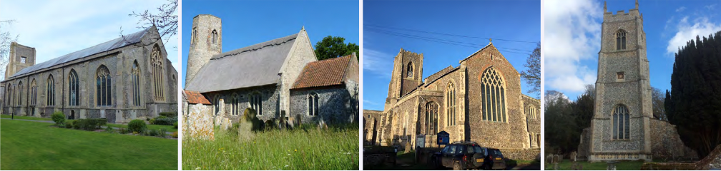

N.E.W.
North Walsham
Edingthorpe
Worstead and Westwick
NEWS
The Magazine for the North Walsham Benefice November 2026 40p
Transformed by Christ: Prayerful, Pastoral, Prophetic

Editor’s Bit

Contents in this issue:
- Vicar’s Page
- From the assistant curate
- Dates from the Diary
- November service Dates
- Upcoming Events
We hope to see you at our services, you are all welcome.

Please note the date for items to go in the December/January edition of NEWS needs to be at the Parish office by November 18th latest.

Financial Information

Please may we remind you, that if you are giving us a cheque for any of the Churches, they need to be made payable to the following:
St Nicholas’ Church – North Walsham PCC
All Saints’ – Edingthorpe PCC
St Mary’s – Worstead PCC
St Botolph’s – Diocesan Churches Trust

Please may we ask if you are sending any payments to us via an online service that you put a meaningful reference on the payment to ensure we know where the payment should go to.

Live-streamed services are available on YouTube - please search St Nicholas North Walsham. Do you participate in our live-streamed services - we would love to hear your feedback: contact David on 07506 723946 or davidnorthwalsham@gmail.com

If you are considering a change to your Committed Giving for St. Nicholas, please inform Chris Sherman (Committed Giving Officer)
Please support St. Nicholas Church, North Walsham on #easyfundraising, you can raise FREE donations when you shop online with over 5,000 retailers. It is simple and only takes 2 minutes to sign up! Plus, once you have raised your first £15, easy fundraising will match it!
Sign up now: https://www.easyfundraising.org.uk/causes/stnicholaschurchnw/

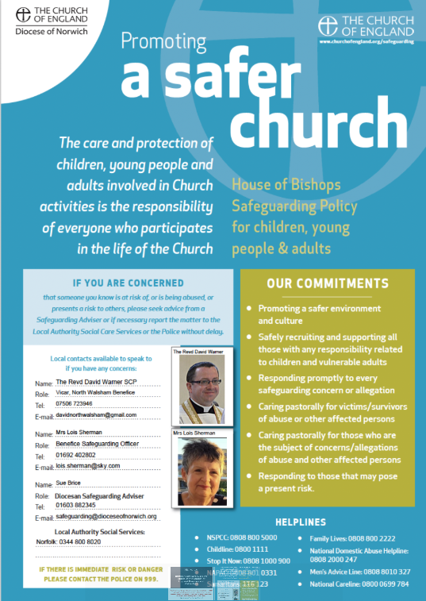
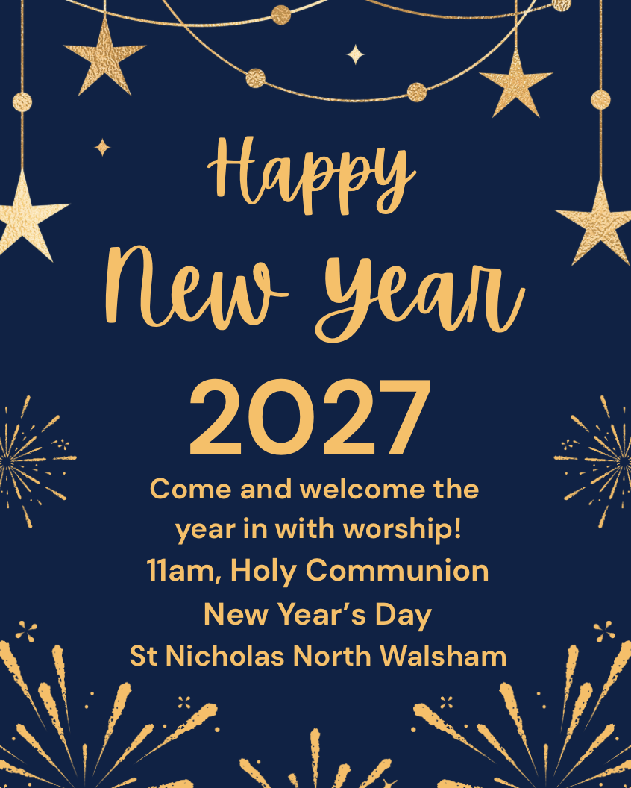

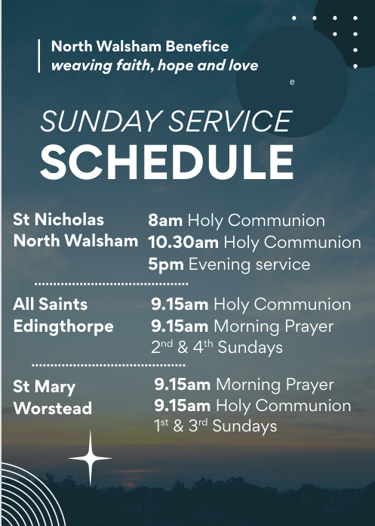

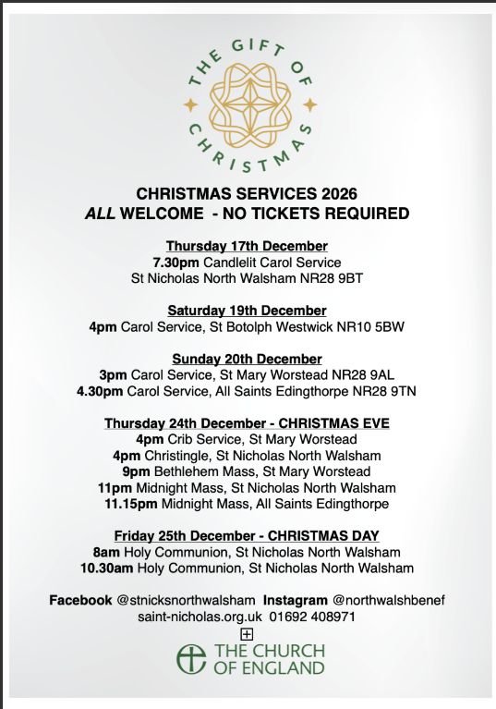
The Vicar’s page:
The Feast of Christ the King, which falls this year on 22nd November is the end of the church year – the new liturgical year begins a week later on Advent Sunday.
The feast is very modern, having been established by Pope Pius XI in 1925, under its full title, the feast of Our Lord Jesus Christ, King of the Universe. It was moved to the last Sunday in Ordinary time in 1969 and adopted by Anglicans and many other Christian denominations.
What moved the Pope to create such a feast, and other parts of the church to adopt it? 1925 was a time of political upheaval and instability, of uprisings and an increase in both aggressive nationalism and secularism. The idea was to reinforce and re-establish the sovereignty of Christ, and to give renewed focus for people’s allegiance, far above the squabbling and violence of political upheaval in Europe.
For much longer, the last Sunday before Advent has been known informally in Anglican churches as Stir-up Sunday – the traditional day when families stirred up the mix for Christmas puddings, to await the feast to be celebrated at the end of Advent. So deep does our Anglican attachment to this concept go, that the Collect (the special prayer for the day, see end of article) has been retained as the post-communion prayer for the feast of Christ the King, so all that has been celebrated and recalled can still be prayed for and remembered.
November brings the days when we remember and recall the fallen of the nations, and the departed of our own families and communities, and give thanks for all those who have given so much for us. As we stir the pudding with family, as we gather to worship and to remember and make real the memory of those we have loved and lost we can give thanks for all who support us in our daily lives. As we celebrate the feast of Christ the King we can give thanks that in Jesus all is held together, and that he is the one eternally begotten of the Father, the one from whom all real authority and power, all allegiance and worship comes.
Stir up, O Lord the wills of your faithful people:
that they, plenteously bringing forth the fruit of good works,
may by you be plenteously rewarded;
through Jesus Christ our Lord. Amen.

Post–communion prayer for Christ the King

David

The Curate’s Page
By the time you read this article, the Field of Remembrance in our Memorial Park will be open, poppies at St Nick’s will dazzle you with the crimson red colour, and we will be in full swing with preparations for our Remembrance commemorations.
11th November is always a very special day for me, because I will not only give thanks for the end of the First and Second World Wars and remember in my prayers all those who died in those conflicts, both in service and civilians, but also celebrate Polish Independence Day.
In 1918, after 123 years of nonexistence as a country, Poland gained her independence. Ever since then, there is an Eternal Flame burning at the grave of the unknown warrior in Warsaw’s Piłsudski Square. Remembrance should always be first and foremost just that: remembering the terrible bloodshed, lives lost, hopes and dreams crushed, freedom restored at a heavy price.
Each year, there are fewer and fewer veterans at the parade in Central London on Remembrance Sunday. The big national celebration of remembrance and thanksgiving is overshadowed by the Halloween preparations and Christmas shopping. It is down to us and our children to remember the terrible past and make sure that this will NEVER happen again.
Whatever our political view, whatever our personal feelings on war and conflict, let us come together, first for Remembrance Sunday and then on the 11th of November, to stand in silence, to honour those who died, to pray for a better future and peace around the world. Let us make sure that, when all the veterans and survivors are gone, we and our children will continue to honour their memory, continue to pray for peace and work together for the better tomorrow.
In Poland, we do not wear poppies, but we have a very famous song which speaks about the poppies of Monte Cassino:
‘Red poppies on Monte Cassino, instead of dew drank Polish blood.
Through these poppies went soldier and died, but anger was stronger
than death. Years and centuries will pass, the marks of the old days will
remain, and only poppies on Monte Cassino will be redder, because out
of Polish blood these will grow.’
Dan

Edingthorpe Village news for October
All Saints Church, Edingthorpe
Services
1st November. 4pm. All Saints Patronal Choral Evensong.

8th November. 10.55am. Remembrance Service (Note time) Holy Communion

22nd November. 9.15 am. Morning Prayer

The Church looked lovely for the Harvest Floral Day, Photographic and Produce Display. There were several old tractors on display from the Vintage Tractor Club and local residents. Representatives from various Conservation organisations were also present and they created much interest from the many visitors. There was a great attendance for the Harvest Service. Alison Ritchie gave an interesting talk about the Charity YANA (you are not alone) which was founded to help people in the agricultural industry. Donations from this service were for YANA. Thanks must go to Margaret and all her team for the wonderful display of floral arrangements. Thanks also to all who brought their tractors for display and those who helped with the refreshments and cakes. It was a long day but was great to see so many people coming to make it such an enjoyable day.

On 1st November there is All Saints Patronal Choral Evensong at 4pm followed by refreshments. We will be joined by the Choir from St. Nicholas Church for this service. Do join us.

Our Christmas Coffee Morning is being held on Thursday 10th December in St Benet’s Hall, North Walsham from 9.00am to 12 noon. There will be many stalls including cakes and preserves, bric a brac, tombola, Christmas decorations, Christmas raffle and many more. Tea, coffee and mince pies will be served. Please come along and join us. All proceeds to the Church.

Looking further ahead our Carol Service will be on 20th December at 4.30pm. We are having a Midnight Mass Service at 11.15pm on Christmas Eve. All welcome. This was very popular last year.
All events about the Church are on https://www.achurchnearyou.com/church/10076/ or the village website www.edingthorpe.village.org.uk
ST MARY’S - WORSTEAD
With the approach of Winter, our schedule begins to step up a gear.
We hope that as many of you as possible will be able to join us for our annual Service of Remembrance on Sunday, November 8th at 10.45 am. Always a poignant occasion, and something special.
Our current “work in progress” is the planned renewal of the Main Entrance Porch Roof. As with all things, we are obliged to seek the necessary permission from the Norwich Diocese to proceed. This necessitates the preparation of detailed Architect’s drawings together with the appropriate Contractor’s quotation as to the likely cost. No doubt eye-watering!
The next event in our calendar will be the Worstead Craft Fair on Saturday, November 21st from 10.00 am until 3.00 pm. An annual event and a firm favourite with many. As ever, there will be much to see with the opportunity to browse all sorts of locally-made items of unique design and quality. For the weary shoppers, there will be the usual light refreshments to keep them, and no doubt the Stallholders, going.
On Thursday, November 26th, we’ll be holding a Coffee Morning in St Nicholas Rooms, North Walsham, from 9.00 am to 11.45 am. Do join us for coffee and a chat with friends. All monies raised will be for the benefit of St Mary’s.

Diary Dates
Sunday, 8th November – Remembrance Service – 10.45 am
Saturday, 21st November – Worstead Craft Fair – from 10.00 am
Sunday, 20th December – Carol Service – 3.00 pm
Thursday, 24th December – Crib Service – 4.00 pm
Midnight Mass – 9.00 pm (Midnight in Bethlehem)

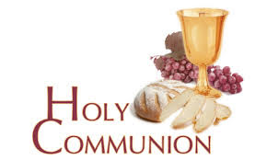
You may have read items in the press relating to the use of 'gluten free' wafers at Holy Communion - for those who require them, we use wafers which are approved and recommended for use by Coeliac UK - more information here. If you need a gluten free wafer, please advise the churchwardens/welcomers when you arrive for the service, and please indicate to the clergy distributing Holy Communion.
The Church teaches that receiving Holy Communion in both kinds (wafer and wine), or in one kind (the wafer or the wine) are acceptable and contain the fulness of the Sacrament. There are many reasons why this will be the case at different times in our lives, and there will be times when we cannot physically receive but join in an Act of Spiritual Communion (as those who watch online do - see below).

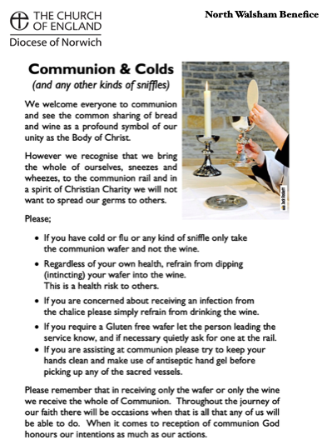
​Intinction (that is, dipping your wafer into the wine) is not permitted, both for hygiene reasons and because it might introduce gluten to the wine, which could be consumed by someone who is allergic to it.
If you wish to discuss any of this, please speak to David.

An Act of Spiritual Communion
In union, O Lord, with the faithful at every altar of your Church, where the Holy Eucharist is celebrated, I desire to offer you praise and thanksgiving. I present to you my soul and body with the earnest wish that I may always be united to you. And since I cannot now receive you sacramentally, I ask you to come spiritually into my heart.
I unite myself to you and embrace you with all the affections of my soul. Let nothing ever separate you from me. May I live and die in your love. Amen.

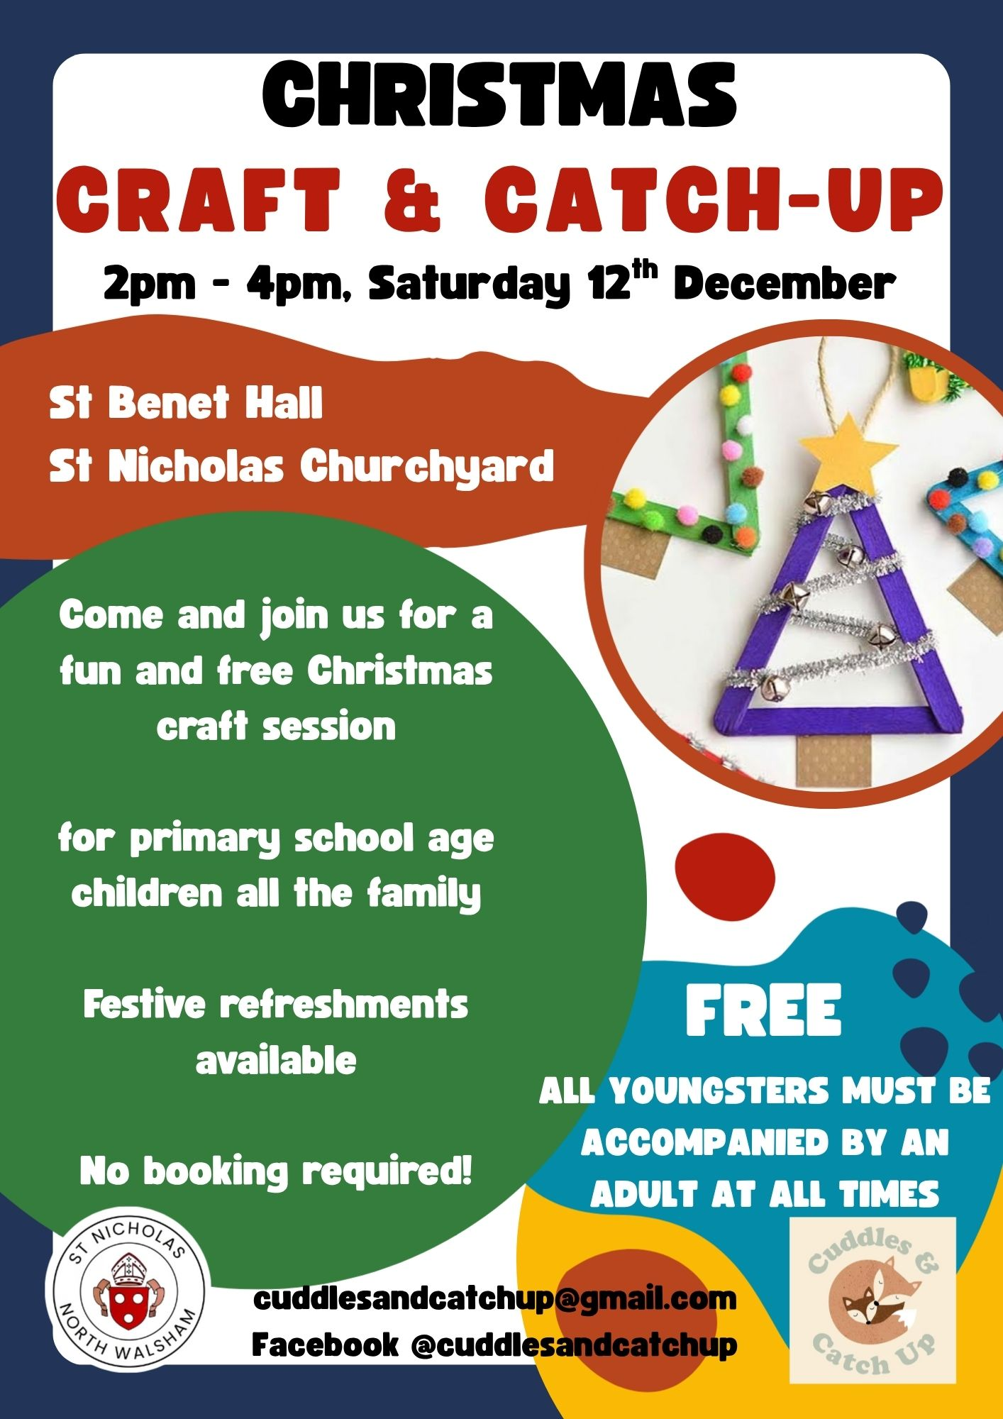



Why not come along to Sunday Kids and find out how to learn about what we do? We meet on the 1st and 3rd Sunday of the month at St Nicholas Church during the 10.30am service. You are most welcome.

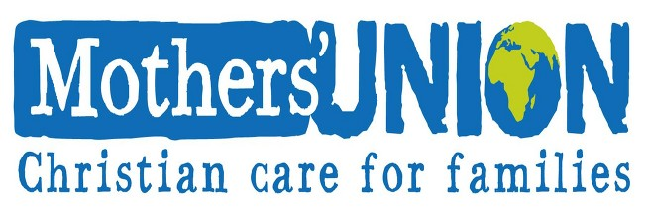

North Walsham Mothers’ Union. We meet in St Nicholas Room on the second Tuesday of the month at 2.00 p.m. Following a short act of worship and a few notices our speaker then takes the floor, after which, over tea and biscuits, there is an opportunity to ask questions and socialise. We usually finish about 3.30 pm.

North Walsham Churches Together Christmas Day Lunch

This has been an event in town for over thirty years. Its aim is to ensure that no resident of our town has a lonely Christmas Day but can join with others in a welcoming space for a traditional meal.
Since the friendly welcome is as important as the food volunteers for all sorts of roles are needed. Collect and drive guests, welcome and chat, help lay tables and arrange the big room, prepare, cook the food and serve the food and drink and finally clear up. The guests arrive from 12:15pm. The meal is at 1pm. Tea/coffee is served in time for His Majesty The King’s broadcast at 3pm before the party ends. Hopefully everyone (including the clearing up team) is safely home before dark. The event is free and the organisers are very grateful for many individual, shop and group donations, and a wonderful grant from The NW Community Shop not to mention the Community Centre who give us free use of the building.
The guests who booked to come in previous years will be contacted in good time to be invited again. If you, or someone you know living in town has not been before and this year will be alone without any company on Christmas Day and would like an invitation please request an invitation by posting a note with their name, address and a contact email or phone number to
CTNW Christmas Meal
32 Youngmans Close
North Walsham
NR28 9JQ
Email address: ctnw.christmas@gmail.com

All volunteers from previous years will be asked if they are able ( but not pressured) to help again. New people offering to help please make contact with a note to:
The Parish Church of St Nicholas,
Market Place,
North Walsham NR28 9BT
The church letter box is in the door at the base of the remaining tower.
Or volunteers email: nwchristmaslunch@gmail.com

Coordinating this event is no small task and this year the organisers aim to have the guest lists completed by 1st December and all the Volunteers allocated roles by 1st November. It’s such a busy time of year and forward planning can make the festivities so much more enjoyable for all volunteers and guests can look forward to their day out with confidence when they all know their arrangements are complete.
So please, any questions do contact us now before the summer is ended.
Benefice Prayer Cycle

Every day we pray for our community - today we’re especially praying for…

1. Bishops of Norwich, Thetford and Lynn and their families and PAs
2. Archdeacons of Norwich, Norfolk and Lynn and their families and PAs
3. Cathedral, the Dean and Canons, staff and community
4. Parish Support Team
5. Deanery
6. Vicar & Assistant Curate: David and Dan and their families
7. Assistant clergy: Nigel, Maggie, Penny and their families
8. Authorised Pastoral Assistants: Felicity, Lois, Chris, Elizabeth, Sue
9. North Walsham Churchwardens, PCC & congregations
10. Worstead Churchwardens (Michael & Susan), PCC & congregations
11. Edingthorpe Churchwardens (Chris), PCC & congregations
12. Westwick
13. Diocesan Safeguarding Team (Sue & Peter) and Benefice Safeguarding Officer (Lois)
14. PCC Treasurers (Sam, Erica, Michael)
15. Musicians (Tim, Matthew) and choirs
16. Servers, welcomers and coffee teams
17. Flower arrangers, cleaners, polishers
18. Funeral directors, crematorium and cemetery staff
19. Baptism, wedding and funeral families
20. Churches Together in North Walsham
21. Veterans Organisations: RBL, RAFA
22. Schools: Paston, NW High, Millfield, North Walsham, Worstead
23. Nurseries, Cuddles and Catch-up, Sunday Kids
24. Hospitals, Hospices and Dr’s Surgeries, Hospital Chaplains
25. Emergency services: Police, Ambulance, Fire, Coastguard, RNLI, Air Ambulance
26. Care homes, home communicants, all we visit
27. Online worshippers
28. Church hall users, Foodbank and Community resources
29. Town, Parish, District and County Councils and MP, public services
30. Businesses
31. Charities

If the month doesn’t have enough days, all the remaining petitions are made on the last day of the month

Services for November
Sunday 1st November – All Saints
8am Holy Communion (1662) at North Walsham
9.15am Holy Communion at Worstead
10.30am Holy Communion at North Walsham
4pm Patronal Choral Evensong at Edingthorpe followed by refreshments
Monday 2nd November – All Souls’
9.30am Holy Communion at North Walsham
10am Knitting Group in North Walsham Church Hall

Wednesday 4th November
10am Worstead Wednesday coffee morning at the Village Hall

Thursday 5th November
9.30am Market Day coffee morning in the St Nicholas Room
9.30am Quiet Prayer at North Walsham
10.30am Holy Communion at North Walsham
Friday 6th November
9am Morning Prayer at North Walsham
9.30am Cuddles and catch-up at North Walsham
Sunday 8th November - Remembrance Sunday
8am Holy Communion (1662) at North Walsham
10.45am Remembrance Morning Prayer at Worstead
10.55am Remembrance Holy Communion at Edingthorpe
10.55am Remembrance Holy Communion at North Walsham
2.15pm Civic Remembrance Parade in the Memorial Park, North Walsham
3pm Civic Service at North Walsham
Monday 9th November
9am Morning Prayer at North Walsham
Tuesday 10th November
9am Morning Prayer at North Walsham
2pm Mothers' Union meet in St Nicholas Room

Wednesday 11th November – Armistice Day
9am Morning Prayer at North Walsham
10am Worstead Wednesday coffee morning at the Village Hall
10.55am Act of Remembrance in the Market Place, North Walsham
10.55am Act of Remembrance at North Walsham Hospital
Thursday 12th November
9am Morning Prayer at North Walsham
9.30am Market Day coffee morning in the St Nicholas Room
9.30am Quiet Prayer at North Walsham
10.30am Holy Communion at North Walsham
Friday 13th November
9am Morning Prayer at North Walsham
9.30am Cuddles and catch-up at North Walsham

Sunday 15th November - 2nd before Advent
8am Holy Communion (1662) at North Walsham
9.15am Holy Communion at Worstead
10.30am Holy Communion at North Walsham
5pm Evening Prayer at North Walsham
Monday 16th November
9am Morning Prayer at North Walsham
10am Knitting Group in North Walsham Church Hall
Tuesday 17th November
9am Morning Prayer at North Walsham
Wednesday 18th November
9am Morning Prayer at North Walsham
10am Worstead Wednesday coffee morning at the Village Hall
Thursday 19th November
9am Morning Prayer at North Walsham
9.30am Quiet Prayer at North Walsham
9.30am Market Day coffee morning in the St Nicholas Room
10.30am Holy Communion at North Walsham
Friday 20th November
9am Morning Prayer at North Walsham
9.30am Cuddles and catch-up at North Walsham

Sunday 22nd November - Christ the King
8am Holy Communion (1662) at North Walsham
9.15am Morning Prayer at Edingthorpe
10.30am Holy Communion at North Walsham
5pm Choral Evensong at North Walsham
Monday 23rdh November
9am Morning Prayer at North Walsham
Tuesday 24th November
9am Morning Prayer at North Walsham
Wednesday 25th November
9am Morning Prayer at North Walsham
10am Worstead Wednesday coffee morning at the Village Hall
Thursday 26th November
9am Morning Prayer at North Walsham
9.30am Quiet Prayer at North Walsham
9.30am Market Day coffee morning in the St Nicholas Room
10.30am Holy Communion at North Walsham
Friday 27th November
9am Morning Prayer at North Walsham
9.30am Cuddles and catch-up at North Walsham

Saturday 28th November
Christmas Lights Switch on in North Walsham
Sunday 29th November - Advent Sunday
8am Holy Communion (1662) at North Walsham
10.30am Holy Communion at North Walsham
5pm Advent Carol Service at North Walsham
Monday 30th November – St Andrew
9am Holy Communion at North Walsham
Tuesday 1st December
9am Morning Prayer at North Walsham
Wednesday 2nd December
9am Morning Prayer at North Walsham
10am Worstead Wednesday coffee morning at the Village Hall
Thursday 3rd December
9am Morning Prayer at North Walsham
9.30am Quiet Prayer at North Walsham
9.30am Market Day coffee morning in the St Nicholas Room
10.30am Holy Communion at North Walsham
Friday 4th December
9am Morning Prayer at North Walsham
9.30am Cuddles and catch-up at North Walsham
Sunday 6th December - St Nicholas
8am Holy Communion (1662) at North Walsham
10.30am Patronal Holy Communion at North Walsham
5pm Choral Evensong at North Walsham

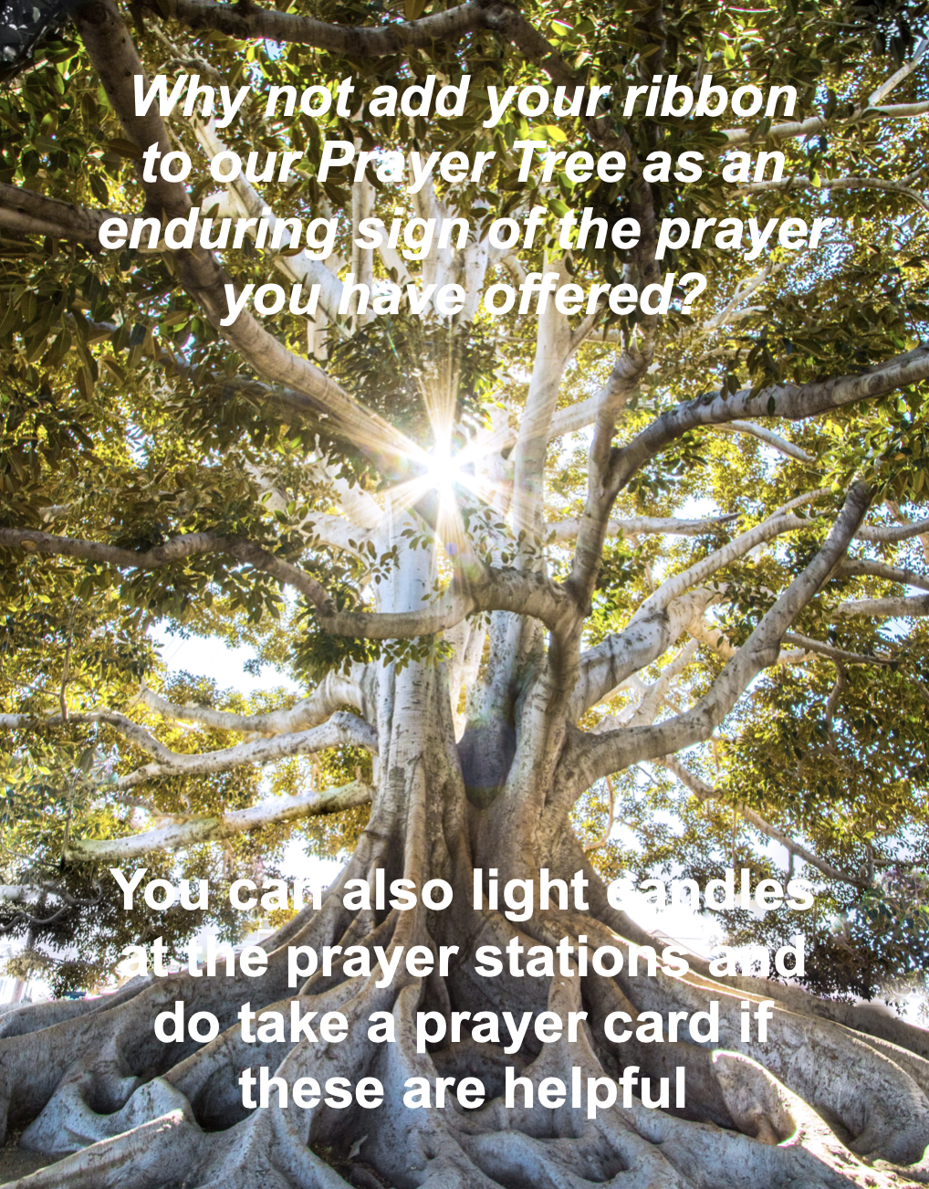

We are privileged to hold special
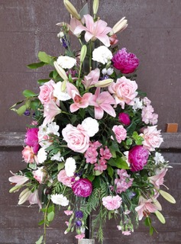
services at any of our churches
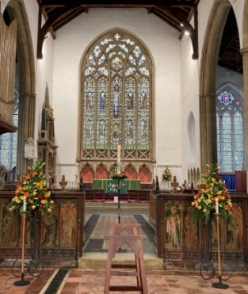
All who live in the benefice are entitled to a baptism, wedding or funeral service in church, and our clergy can officiate at the crematorium and cemeteries too. The church is here for you, through every moment of life.

From the Diary

Baptism
Penny Hinton

Wedding
Lyle Kallis & Wendy Fenwick

Funeral
Evelyn Harris
Jean Millar
Anne Allen

Please hold those above and their families in your prayers.




Our weekly coffee mornings at North Walsham and Worstead are now registered with Warm Welcome Spaces
North Walsham Market Day Coffee Morning
Thursdays 9.30 – 12.00noon
The space is open to all (and their well-behaved dogs on leads), every Thursday! A warm welcome and refreshments available

Thank you to everyone for raising donations for St. Nicholas Church, North Walsham with #easyfundraising! If you have not signed up yet, it is easy and completely FREE. 8,100 brands will donate to us when you use easy fundraising to do your everyday online shopping - at no extra cost to you! Every donation you raise makes a difference to us so please sign up & share today. https://join.easyfundraising.org.uk/stnicholaschurchnw/XT7MPH/at/TSX8RX7z/RTND2/facebook/
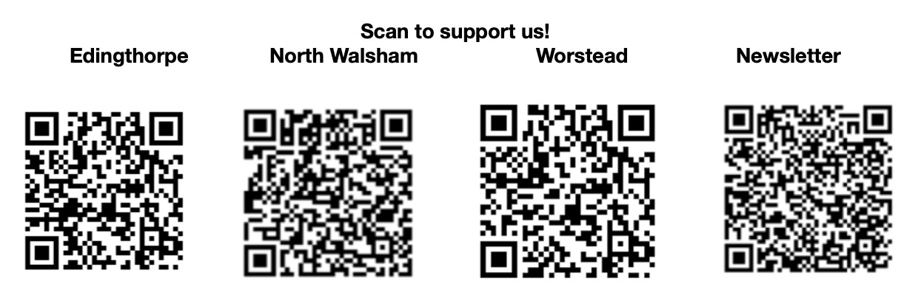


Please support the work of our Churches, by using the contactless giving point at St Nicholas or St Mary’s, leaving your gift on the offering plates or in the wall safes, or through these QR codes. Thank you.

Do you have a Business you would like to advertise in this magazine?
Whole, half or quarter page space is available.
Full Page £ 150.00
Half Page £ 75.00
Quarter Page £ 50.00
Please contact the Benefice office on 01692 408971
or email saintnicholasnw@gmail.com
for details and prices

Church Postcodes
Edingthorpe NR28 9TN, North Walsham NR28 9BT, Worstead NR28 9AL, Westwick NR10 5BW

Benefice dates

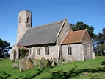
All Saints’ Edingthorpe
1st November Patronal Evensong 4 p.m.
8th November Holy Communion 9.15am
22nd November Morning Prayer 9.15am

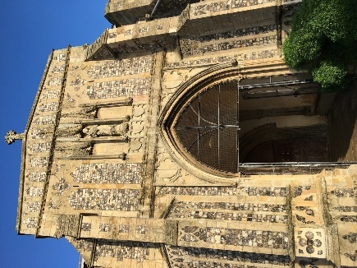
St. Mary’s, Worstead
Sunday, 1st November – Morning Prayer – 9.15 am
Sunday, 8th November – Service of Remembrance –
10.45 am
Sunday, 15th Novembber – Holy Communion – 9.15 am

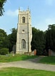
St Botolph’s Westwick

No service in November

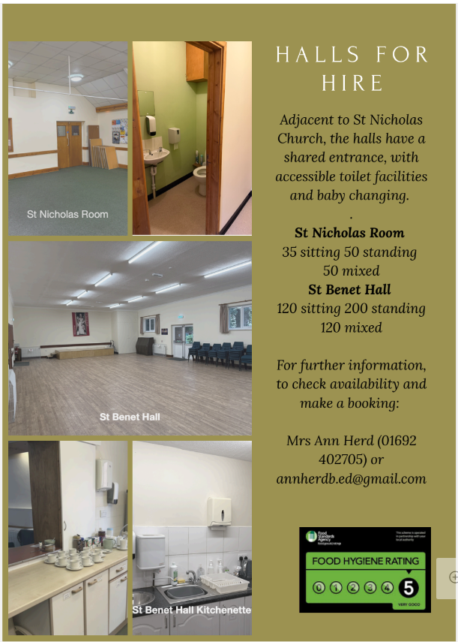

Ready to tick off your list – Will Made?
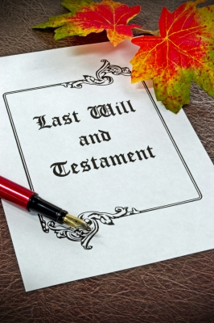
"The Church of England have teamed up with Farewills to provide a free will writing service: Online Will Writing Service | Legal Will In 15 Minutes . Anyone can use this service and it is not compulsory to leave something to your church, but it would be nice if you did. It is important for each one of us to leave our earthly matters in good order so why not take advantage of this opportunity now? It is good to remember a gift in your will to a charity is tax free. If you already have a will, you could consider leaving a legacy to the church by adding a codicil. https://farewill.com/norwich-diocese

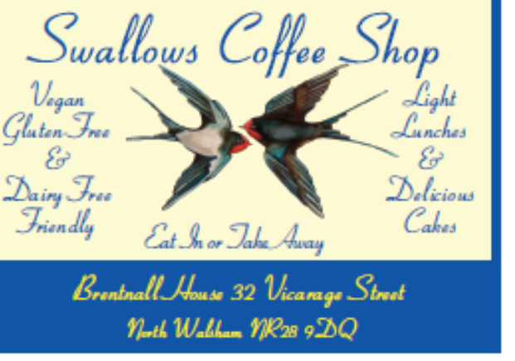

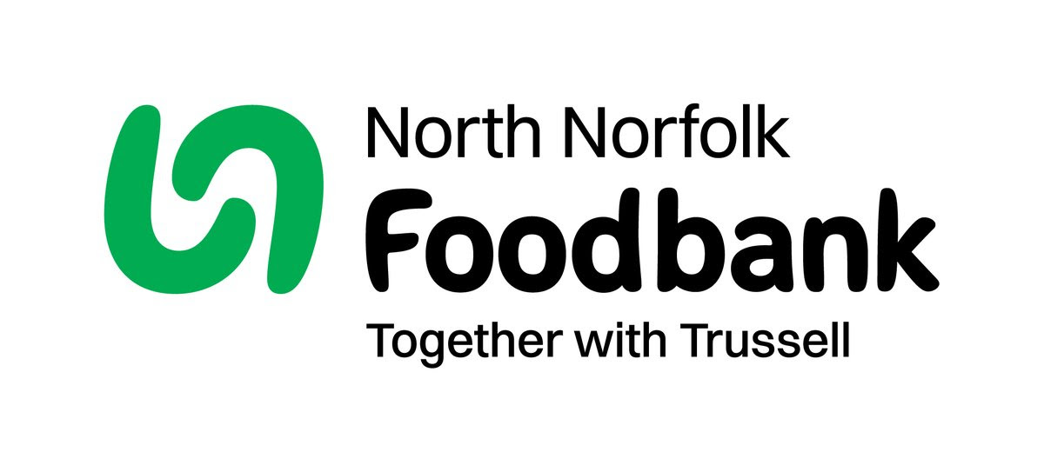
Dear Foodbank supporter,
Thank you for your donation from
St Nicholas Church, North Walsham
last month of 41.30kg.
As a small charity we rely on food and financial donations to operate, and we are extremely grateful when people choose to support us.
Whilst Trussell campaigns to end the need for foodbanks, we will be here helping those who need us right now. But that can only be done with kind donations from our supporters.
To see what we need most right now, our wish list is published on our website and social media, and the list gets updated throughout the month on our donation page https://northnorfolk.foodbank.org.uk/give-help/donate-food/
Thank you for thinking of us and enabling us to serve the people facing hardship across our district.
Kind regards
Julie and the Foodbank team
North Norfolk Foodbank
Cromer Methodist Church Hall, West Street, Cromer, NR27 9DT
07826 376343
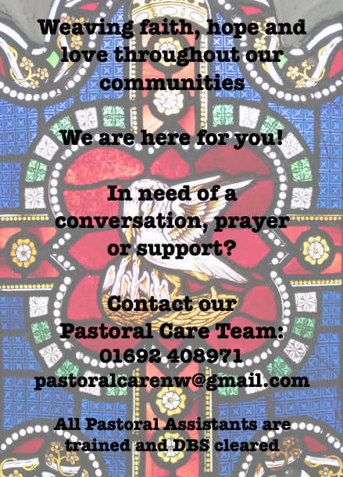

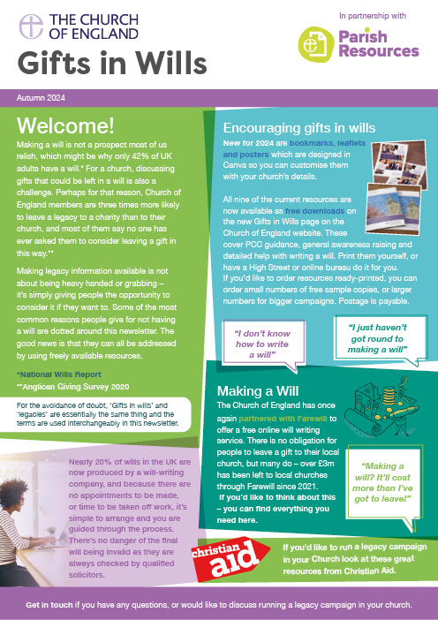
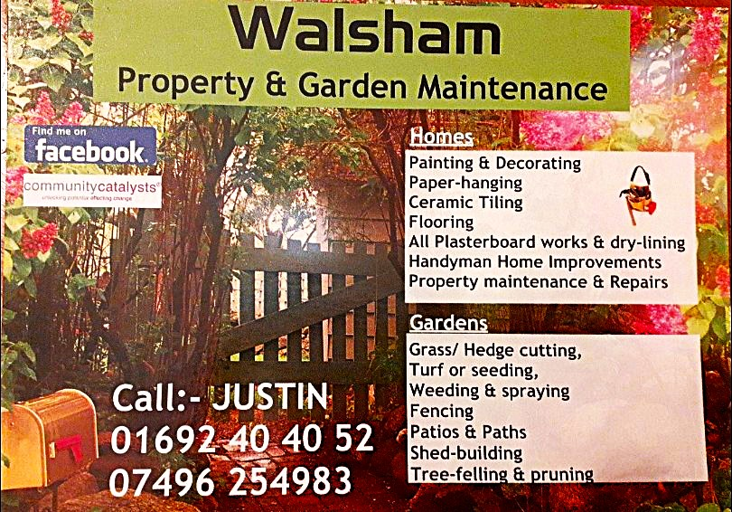

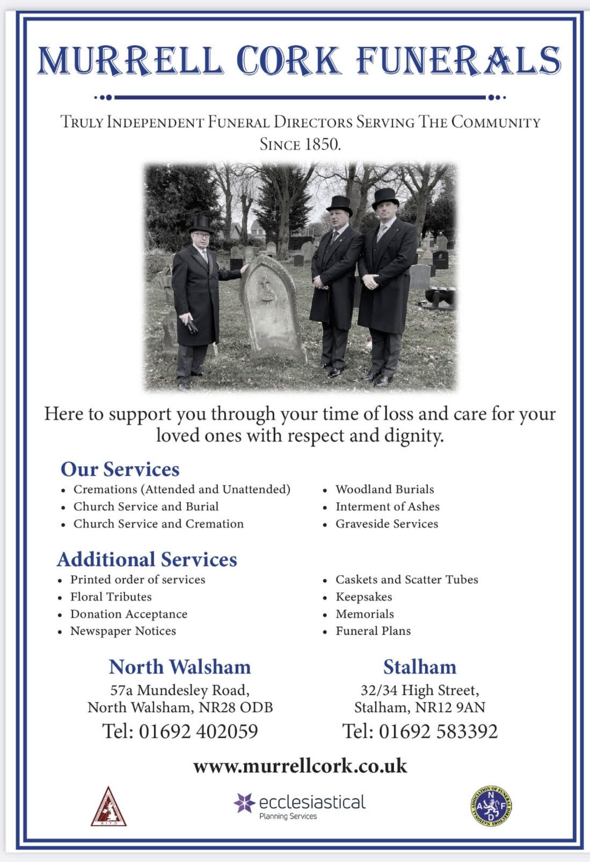
r Sale and Wants Page




Money Matters …
A regular report for our readers written by James Reginald Drake at ClearView Financial Consultants
Burgh Road, Aylsham - 01263 734859, Station Road, Hoveton - 01603 273590 and North Walsham 07773 626662

Lasting Powers of Attorney – Why are they so Important?
Lasting Powers of Attorney (LPA’s) are documents that give an individual you trust (your attorney) the legal authority to make decisions on your behalf should you either lose the mental capacity to make them, or you no longer wish to make these decisions yourself. Lasting Powers of Attorney come in 2 forms, these coming under the heading of ‘Property & Financial Affairs’ and ‘Health & Welfare’
So, how can they help?
The Property & Financial Affairs LPA covers things such as running your bank and savings accounts, making or selling investments, paying bills, buying or selling property and applying for benefits.
The Health & Welfare LPA covers things such as the type of health care and medical treatment you receive (including decisions on life sustaining treatment), where you live, as well as the type of care that you receive in areas such as diet and daily routine.
Given the wide range of areas that these documents cover, it becomes quite obvious as to why they are so important. However, according to ‘The Office of the Public Guardian’ via an article produced in 2022, less than 1% of the UK population have a Lasting Powers of Attorney in place.
So, why do so few people have them in place? One of the most commonly mentioned reasons is that people assume that their spouse will automatically have the right to make decisions for them should they ever reach the stage where they are unable to. This however is a common misconception and it is very often discovered far too late that they actually have no legal authority at all. Cost is another reason people put it off, I can assure you are costs for this type of work are minimal, in the hope this is not a reason to delay.
What should you do?
Well, the answer to this one is quite simple……. get on and set up both types of LPA as soon as you can. It is never too soon to set one up, but it certainly can be too late. By law, once your mental capacity has gone, so has your opportunity to appoint attorneys to act on your behalf. At this point your loved ones will be required to go down a different route and apply to the Court of Protection for a Deputyship order. This requires more forms, more cost and more time, which can all be easily avoided with a bit of forward planning.
So, if setting up Lasting Powers of Attorney(s) is something that you think would benefit you and your loved ones, please feel free to contact me and we can discuss how they can be put in place in a way that is best suited to your own personal requirements.
This short article in no way should be taken by readers as advice.
James can be contacted on either of the above landline numbers or via email at support@smithifa.co.uk
ClearView Financial Consultants is a trading name of Martin Smith Independent Financial Adviser Ltd, a company registered in England
under number 11439150 and authorised and regulated by the Financial Conduct Authority under number 944677.


