Who to contact at St Helen’s Church:  If you wish to have an inscription in the Memorial Book and your loved ones name to be read out in church, it is £25. Please see John Sparkhall. (PCC Treasurer)    If you wish to donate to the Heritage of Sefton Church, details are as follows: Sefton Church. RBS Account Number 10047948. Sort Code. 16-24-06 or use this QR code:  For wedding and graveyard information:  Jane Cave jane_k_cave@yahoo.co.uk  For Bell Ringers: Janet Hopwood 07736423365  For website enquiries/events = Angela Rushton  07977344169 rushtonangela@hotmail.com  For information regarding opening times, events and services etc please see our www.achurchnearyou.com website. |  |  | 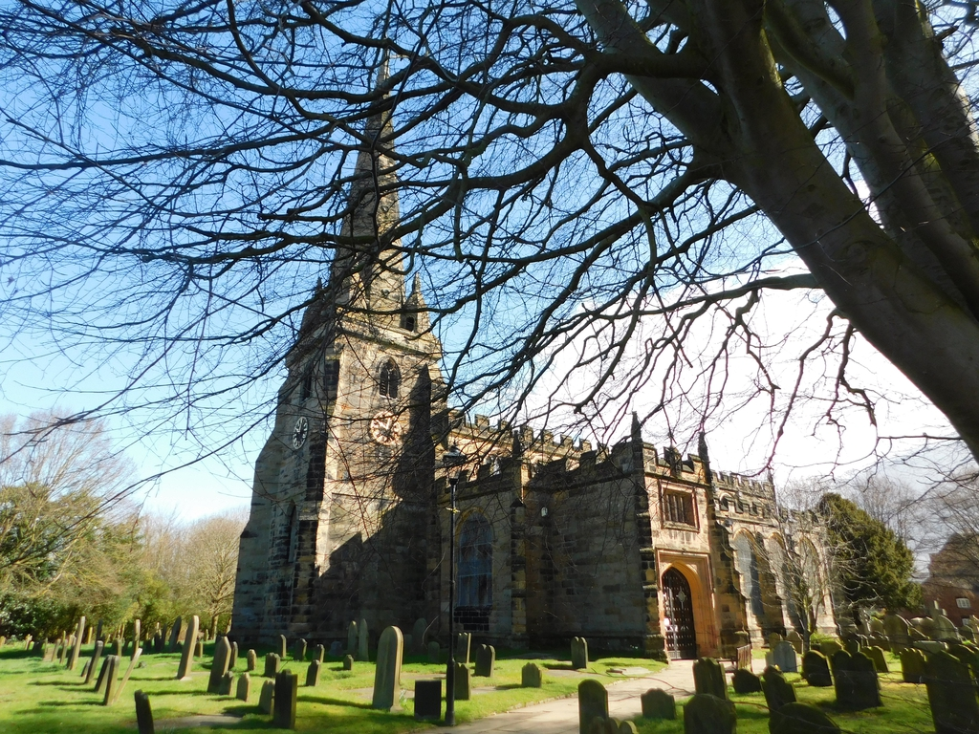  Sefton Parish Church Newsletter  OCTOBER 2026  Church Services at 11am:  4th Harvest Praise (and Bring and Share Lunch)  11th Morning Prayer.  18th Holy Communion.  25th Baptism.  Church Floodlighting in October:  21.10.26 Jack’s Birthday  27.10.26 Birthday Remembrance Richard Slater  From our Church Register:  Baptisms:  27.9.26. Leonardo Glynron Caldwell  27.9.26. Luca Daniel Sole  27.9.26. Zara Sole  Burial Of Ashes:  9.9.26. Elianne Nicolai  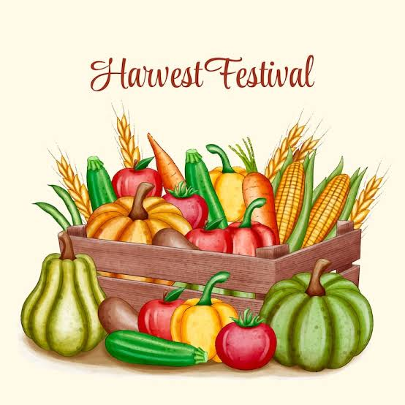  Harvest Festival Sunday 4th October  We will be holding our Harvest Festival Service with a “Bring and Share” lunch. There is a sign-up sheet for our bring and share lunch at the back of church. We will be decorating the church on Saturday 3rd October at 10am.
Clergy Contact Details
Associate Vicar:
Rev Jackie Parry: 07803468870 rev.jackie@nschurches.uk
Ministry Team:
Rev Penny Leeman (Retired Priest)
Mr Ray Glenn and Mrs Polly Glenn (Readers)
Churchwardens Contact Details
Mrs Jane Cave: 07426 880690 jane_k_cave@yahoo.co.uk
Mr Darren Charnock: 07518 738364 darren.seftonchurch@gmail.com

Events and News from Sefton
Scouse Supper and Organ Concert - Friday 16th October  There are still some tickets left for this event. Please support this fundraising event and see Ange by Friday 2nd October as we have to inform the caterers for the numbers. £15 a ticket. Bring your own drinks.    “A Cuppa and a Chat”  Please come and join us at Sefton Meadows Coffee Shop “Rosies” on the 14th October from 10am – 12pm. This is a monthly event  with the following dates for 2026: 11th November and 9th December (with a Christmas Quiz).  All are welcome – bring a friend.  Heritage Open Days  Thank you so much to all the volunteers who gave their time over these two weekends to make our Heritage Open Days such a success. We had 368 visitors and raised a superb total of £951.78 from donations, the shop and café.  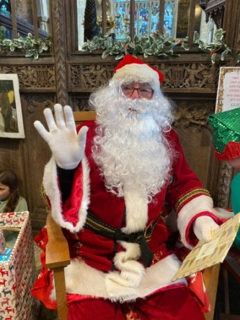  Saturday 28th November – Dickensian Fayre –There will be a meeting on Monday 19th October at 10am to discuss ideas. If you have any ideas for new stalls, we would be grateful. The boxes for any stall donations will be at the back of church after the meeting.  Harvest Decoration of Church: We are desperate for cash donations to buy foodstuffs for our Harvest display. All food is taken to the local Foodbank after our Harvest service. Please see Ailsa or put in the box at the back of church. Thank you. |  |  | Emmaus, Merseyside    Emmaus Merseyside is a community-based charity which provides housing, work opportunities, training and a chance to get back on their feet for 28 people who have faced homelessness and addiction. It is situated behind Seaforth and Litherland Station.  Linda Adkins and I have been involved with the (large) garden attached to the house for some 6 years now, it provides seasonal vegetables for them and plants to sell.  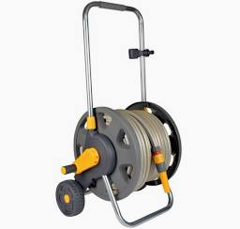  We are struggling at the moment with our hosepipe which is now past its sell by date, the trolley now has only one wheel, the hosepipe itself has lots of holes in it, so that when we use it, we get more water on us than the plants!!  The hosepipe itself, the garden being quite big, needs to be a fairly long one, over 90 meters, with a trolley. We were wondering, therefore, if you could help us out with cost of this item? It will provide Emmaus with an essential piece of equipment to keep the garden at its best and us with the difficult job of watering the 3 polytunnels where we nurture next years plants and seedlings. Thank you for taking the time to read this. Please see Janet Hopwood, Tower Captain (Bell Ringers) if you are able to donate.

