Psalm Psalm 78:1-4, 12-16

Please stand, if able, and join in with the verses in bold italics

Give ear, O my people, to my teaching;
incline your ears to the words of my mouth.
I will open my mouth in a parable;
I will utter dark sayings from of old,
things that we have heard and known,
that our ancestors have told us.
We will not hide them from their children;
we will tell to the coming generation
the glorious deeds of the Lord, and his might,
and the wonders that he has done.

In the sight of their ancestors he worked marvels
in the land of Egypt, in the fields of Zoan.
He divided the sea and let them pass through it,
and made the waters stand like a heap.
In the daytime he led them with a cloud,
and all night long with a fiery light.
He split rocks open in the wilderness,
and gave them drink abundantly as from the deep.
He made streams come out of the rock,
and caused waters to flow down like rivers.

Glory be to the Father and to the Son and to the Holy Spirit,
as it was in the beginning, is now and ever shall be,
world without end. Amen
Evening Services
From Sunday 25th October the evening services will be back to 4pm and we will be meeting to worship in Friendship House.

Rev’d Ailsa’s moving on… to Marlpool. Ailsa will be taking a monthly Sunday service at Marlpool church for the next couple of months then transferring full time after Christmas to complete her curacy at All Saints Church. Please hold her and the family in your prayers.
Harvest Meal
Thank you to everyone who came, helped and supported the Harvest Meal – together we raised £435.39!

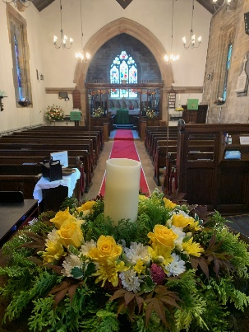

In our weekly prayers for our parish
This week we pray for God’s blessing on Longfield Lane, Lower Stanton Road and Macdonald Square.

All Saints Church
Distribution of Communion –new arrangements!
Thank you to everyone who fed back about communion distribution, especially about the wine. We will now have at the altar two chalices, one where the priest will continue to dip the wafer into the wine and a separate chalice for those who want to sip the wine.

Please help us by letting us know what you prefer, and be gracious as it takes a little longer at the altar rail.
Refreshments After the Morning Service
Please stay seated after the service and a hot drink will be brought to you in the pews. Do not get up and head to the back of church, it is becoming a hazard, and a risk as trays of hot drinks could be knocked over.
Church contact information
Contact: Rev’d Christine - revchristine@outlook.com
The Rectory, The Village, West Hallam, DE7 6GR
Landline 0115 646 1497
Rev’d Ailsa -revailsahunt@gmail.com
Tel - 07356064856

Churchwardens – Mrs Janet Wheeldon, -Tel: 0115 8771593
Mrs Linda Gregory – linda.gregory3@icloud.com
https://www.achurchnearyou.com/church/13402/
https://www.facebook.com/allsaintskirkhallam
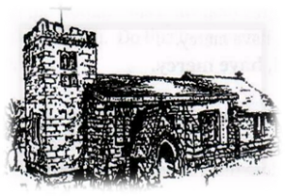
Kirk Hallam
Disabled Toilet in Friendship House.
Disabled Toilet in Friendship House.

Working with God to transform lives & communities.
Please can you ensure your mobile is on silence, or off during the service, it is affecting people with hearing aids and the loop system.

27th September – Seventeenth Sunday After Trinity
10.00am CW Communion Service with Rev’d Ailsa & Eileen
6.00pm BCP Evening Prayer with Rev’d Christine

Forthcoming Events
Tues 29th 6.30pm Home Group in Friendship House
Weds 30th 9.30am Morning Prayer at UCAS
Fri 2nd 6.00pm Choir in Friendship House
Sat 3rd 10.00am Prayer Meeting in Friendship House

4th October – Eighteenth Sunday After Trinity
10.00am CW Communion Service with Fr Bob Boyle
1.30pm Baptism of Zara Jayne Hyde with Rev’d Christine
6.00pm BCP Evening Prayer with Rev’d Ailsa
It’s Good to Talk! If you spot that someone is missing, please pop a news sheet through their door, & if you’ve time, call for a chat - just to check they’re OK & to let them know that they are not forgotten!

‘Love the Lord your God, with all your heart and with all your soul and with all your strength’ Deuteronomy 6:5

