Music for Sunday 6th September
(Dark Green Service Booklets)

Music before the service Air from Water Music

Processional 617 Stand up stand up for Jesus

Gloria Anderson (Dark Green)

Gradual 69 Be thou my guardian and my guide T. Abridge

Offertory 755 Ye holy angels bright
T. Darwells 148th

Choir Anthem 622 Sweet sacrament divine

Communion 576 Put thou thy trust in God

Final 689 Thou hand O God has guided
T. Thornbury

What’s on this week

Monday 7th September
1-4pm Community Hub

Tuesday 8th September
9-12 midday Babies and Toddler

Wednesday 9th September
1-4pm Community Hub

Thursday 10th September
10am Morning Prayer
10.30 – 12 midday Coffee and chat

Friday 11thSeptember
10am – 12 midday Church Office Open

Saturday 12th September
11.30am Choir Practice

Sunday 13th September
10am Parish Communion

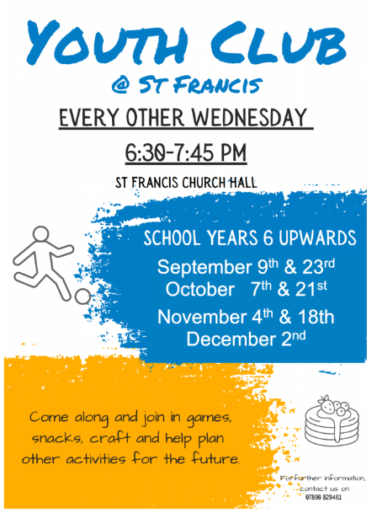

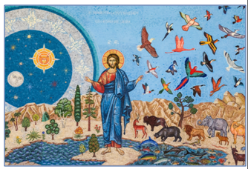

6th September First Sunday of September is now designated as Festival of Creation in Christ’. This designation is one of the fruits of a growing ecumenical movement across churches worldwide and offers an opportunity for Christians to give thanks for God's creation and redemption of the world, reflect on humanity's responsibility to care for the natural world and pray for its renewal.

The title "Creation in Christ" emphasises that creation is understood through the person and work of Jesus Christ: created through him, sustained in him and destined for renewal in him.

Contact. Erica on Stfrancissaxongreen1@gmail.com or Tel: 07890 829461
For Hall bookings Tel: 07557 520338

