St James’ Church Church
Church Door Diary September 2026

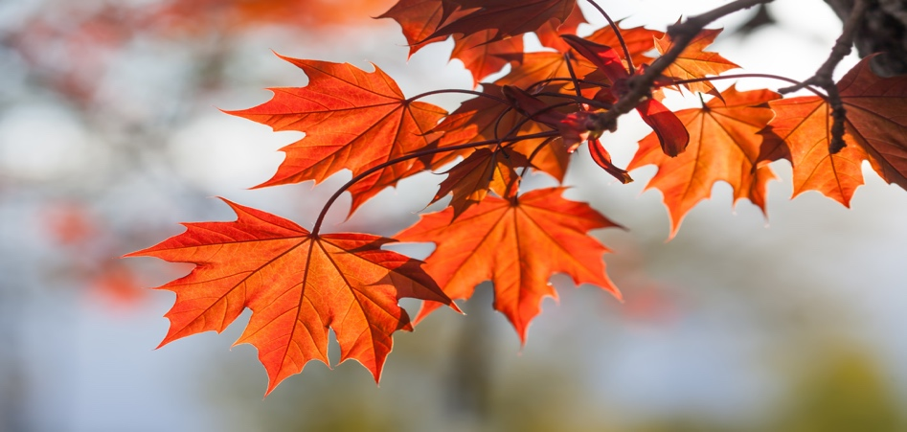
Well, Autumn seems to be here! Enjoy the season!
Wednesday September 2nd: Church open for admin, a chat and coffee 10am – 12 noon
Sunday September 5th: 10am Holy Communion at 10am
Wednesday September 9th: Church open for coffee/admin
Saturday September 12^{th: :}Open Door coffee as usual BUT The Waingroves Show is on today
Sunday September 13^{h}: No church service here. We are worshipping on the school field at Waingroves at 10am. Please join us!
Wednesday September 16th: Church open for coffee/admin
Sunday September 20th: Café Church 10am – all welcome! A very casual and “easy” service
Wednesday September 23rd: Church open for coffee/admin
Saturday September 26th: Open Door coffee Morning
Wednesday September 30th: Chuch open for admin/coffee
This is your church. Feel free to visit, pop in, look around and find peace!

