Who to contact at St Helen’s Church:  If you wish to have an inscription in the Memorial Book and your loved ones name to be read out in church, it is £25. Please see John Sparkhall. (PCC Treasurer)    If you wish to donate to the Heritage of Sefton Church, details are as follows: Sefton Church. RBS Account Number 10047948. Sort Code. 16-24-06 or use this QR code:  For wedding and graveyard information:  Jane Cave jane_k_cave@yahoo.co.uk  For Choir: Andy Freeman – 0151 292 1763  For website enquiries/events = Angela Rushton  07977344169 rushtonangela@hotmail.com  For information regarding opening times, events and services etc please see our www.achurchnearyou.com website. |  |  |   Sefton Parish Church Newsletter  AUGUST 2026  Church Services at 11am:  2nd Holy Communion  9th. Morning Prayer. Refreshments after service.  16th Holy Communion  23rd All Age Service. Refreshments after service.  30^{th.} Holy Communion  Church Floodlighting in August:  1st Sarah and Richards’ Wedding Anniversary  1^{st.} Birthday Remembrance Edie Wilson  3^{rd.} Peter and Janet’s Wedding Anniversary  8^{th.} Cate and Scott’s Wedding Anniversary  10th Birthday Remembrance Florence Margaret Bridgens  16th Birthday Remembrance Albert Hale  20^{th.} In memory of Albert Hale  29th David Prices’s Birthday  29th In memory of Eva Lee  From our Church Register:  Baptisms:  26.7.26 Eloise Rose Somerville  Weddings:  25.7.26. Elin Williams and Steven Daniels
Clergy Contact Details
Associate Vicar:
Rev Jackie Parry: 07803468870 rev.jackie@nschurches.uk
Ministry Team:
Rev Penny Leeman (Retired Priest)
Mr Ray Glenn and Mrs Polly Glenn (Readers)
Churchwardens Contact Details
Mrs Jane Cave: 07426 880690 jane_k_cave@yahoo.co.uk
Mr Darren Charnock: 07518 738364 darren.seftonchurch@gmail.com

Events and News from Sefton
  “A Cuppa and a Chat”  Please come and join us at Sefton Meadows Coffee Shop “Rosies” on the 12th August from 10am – 12pm. Due to the popularity of this event we have now decided to make this a monthly occasion with the following dates: 9th September, 14th October, 11th November and 9th December! All are welcome – bring a friend.    Heritage Open Days – 11th – 13th and 18th - 20th September.  Please return your Volunteer sheets to Ange asap. There are spare copies available. If you feel able to give just a small bit of your spare time to help out, I would be very grateful particularly when St Oswalds children are here on the morning of Friday 11th. Once I have all the forms back you will then have your jobs confirmed. Please also distribute fliers which are at the back of church.  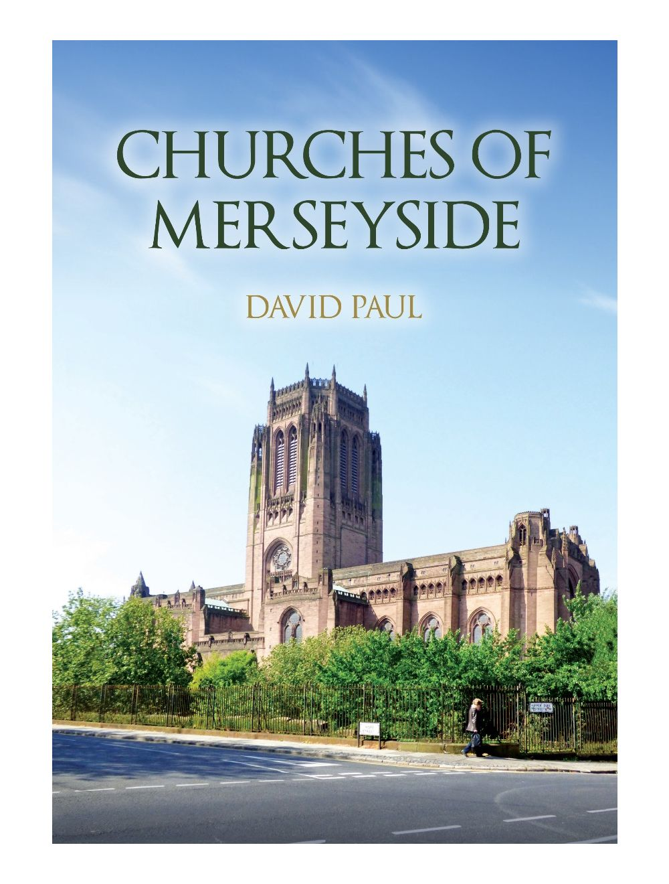  “Churches of Merseyside” Book A new Book has just been published called Churches of Merseyside which features 21 churches of historical, religious interest, and Sefton Church is included. Written by a local historian David Paul, his new book highlights the variety of historic church buildings in Liverpool and the wider Merseyside area. The book is now available in local booksellers and on-line (£15). |  |  | Friday 16th October Organist Concert  This event is still taking place but due to unforeseen circumstances, we are unable to follow the original plan for the evening. A big thank you to the 17 people who had actually offered to sing in our choir. Please see the new information below. Tickets are now on sale from Ange until Friday 2nd October. Please note that there are no reductions for children or just for the concert only. Vegetarian option can be booked.  Stewart Whillis – Guest Organist  Presents:  “An Evening of Musical Entertainment”  On: Friday 16th October  At: 7.30pm  At: Sefton Parish Church  Tickets: £15 (including a delicious Scouse Supper with accompaniments, Apple Pie & Cream from “Scrummies” Caterers)  Please bring your own drinks.  Entrance by ticket only. Raffle.  “SWIM IT” - Fundraising for Macmillan Cancer Appeal  Polly Glen (our Lay Reader) has already completed her first 21 miles for this worthwhile cause. She has now started on her next 21 miles! If you feel you can support her, then please sign the sponsor sheet at the back of church and when completed Ange will collect the donations and give to Polly for the Appeal.

