SUNDAY MORNING READING SHEET 27th September 17th Sunday after Trinity
A Reading from Paul’s Letter to the Philippians

If then there is any encouragement in Christ, any consolation from love, any sharing in the Spirit, any compassion and sympathy, make my joy complete: be of the same mind, having the same love, being in full accord and of one mind. Do nothing from selfish ambition or conceit, but in humility regard others as better than yourselves. Let each of you look not to your own interests, but to the interests of others. Let the same mind be in you that was in Christ Jesus,
who, though he was in the form of God, did not regard equality with God as something to be exploited, but emptied himself, taking the form of a slave, being born in human likeness. And being found in human form, he humbled himself and became obedient to the point of death— even death on a cross. Therefore God also highly exalted him and gave him the name that is above every name,
so that at the name of Jesus every knee should bend, in heaven and on earth and under the earth, and every tongue should confess that Jesus Christ is Lord, to the glory of God the Father. Therefore, my beloved, just as you have always obeyed me, not only in my presence, but much more now in my absence, work out your own salvation with fear and trembling; for it is God who is at work in you, enabling you both to will and to work for his good pleasure. Philippians 2:1-13

GOSPEL

When Jesus entered the temple, the chief priests and the elders of the people came to him as he was teaching, and said, ‘By what authority are you doing these things, and who gave you this authority?’ Jesus said to them, ‘I will also ask you one question; if you tell me the answer, then I will also tell you by what authority I do these things. Did the baptism of John come from heaven, or was it of human origin?’ And they argued with one another, ‘If we say, “From heaven”, he will say to us, “Why then did you not believe him?” But if we say, “Of human origin”, we are afraid of the crowd; for all regard John as a prophet.’ So they answered Jesus, ‘We do not know.’ And he said to them, ‘Neither will I tell you by what authority I am doing these things.
‘What do you think? A man had two sons; he went to the first and said, “Son, go and work in the vineyard today.” He answered, “I will not”; but later he changed his mind and went. The father went to the second and said the same; and he answered, “I go, sir”; but he did not go. Which of the two did the will of his father?’ They said, ‘The first.’ Jesus said to them, ‘Truly I tell you, the tax-collectors and the prostitutes are going into the kingdom of God ahead of you. For John came to you in the way of righteousness and you did not believe him, but the tax-collectors and the prostitutes believed him; and even after you saw it, you did not change your minds and believe him. Matthew 21:23-32


If you wish to make a donation to the church, then please hold Your phone’s camera over this image then touch the link that appears:

Royston Parish Church
Where all are welcome and God’s love is shared
Sunday 27TH September 2026 –17th Sunday after Trinity
If you would like regular copies of the Notice Sheet emailed to you please email the
Parish Office at admin@roystonparishchurch.org.uk
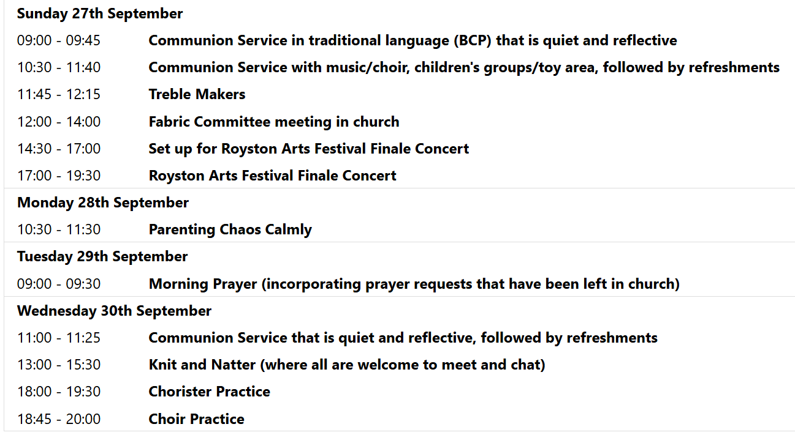
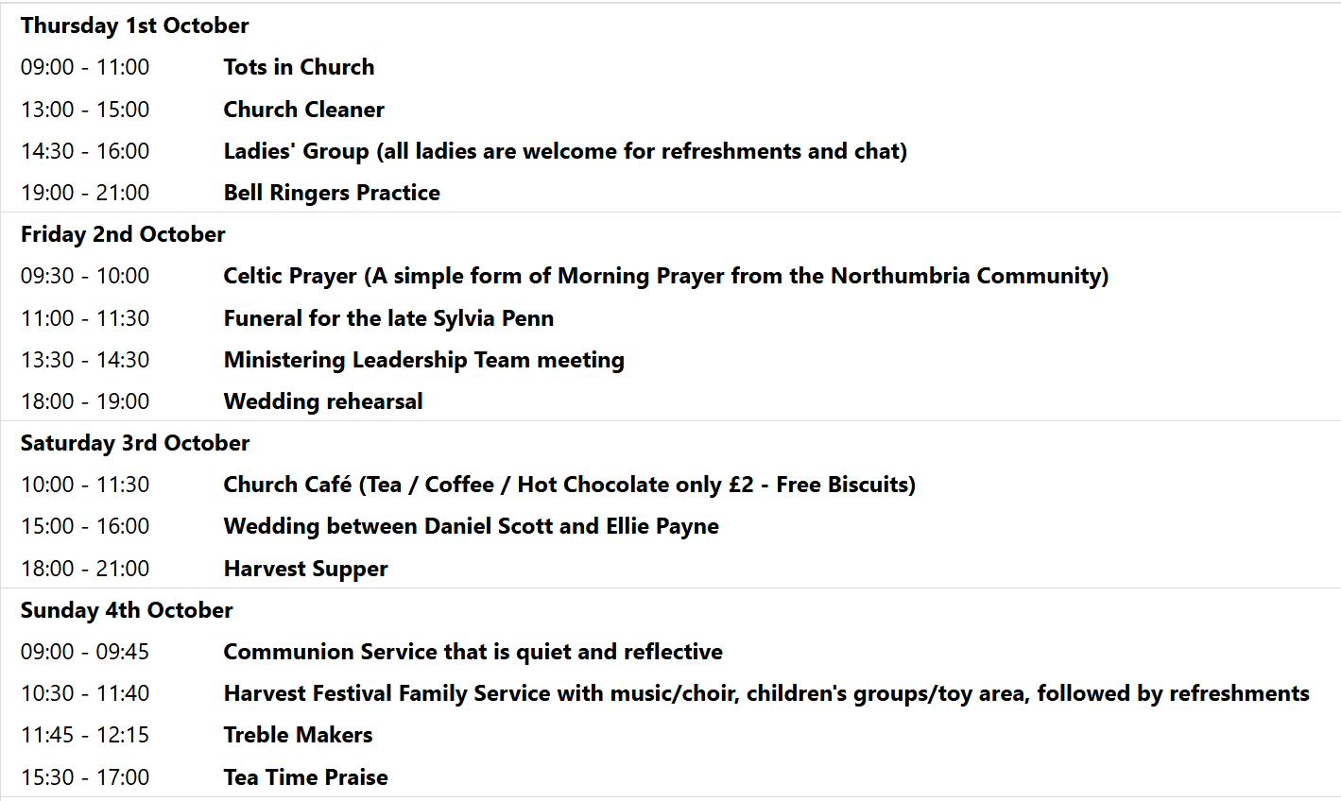
We pray for all Christians worldwide:
For all Christians in Bolivia, Brazil, Chile, Peru
For all who worship at Royston Catholic Church: Fr. Philip Knights
For the work of our mission partners: Church Mission Society (CMS)
Pray for the community of Royston:
For our local health centres
For all who work on our Market Stalls
We pray for our world and ECO projects:
We pray that we may think more about the producers of products; we pray for the success of Fair Trade Fortnight from 22nd September - 5th October 2026

We pray for the Rt. Revd Andrew Rumsey installed on the 19th September as the 11th Bishop of St Albans
We pray for all who may be considering applying for our Minister of Music.

We pray for the sick and suffering:
6th September | 13th Sept | 20th Sept | 27th Sept
Emma Thompson | Pat Tidey | Val Brown | Peter Coates
Jackson Herbert | Mike Brown | Angie & Ken Rushall | Peggy Dawes
Marion | Clare Rice | Paula Walker | Chris Stratton
Barbara Goy | Max Elliott | Sandra Landels  (nee Cornwell) | Keith & Elaine Edwards

We pray for those who have died in the faith of Christ:
Deceased Bereaved
Sylvia Penn Ritchie, family and friends
Kazimierz Nowak (pronounced Novak) Lucas, family and friends

We pray for those whose anniversaries fall at this time:
Ena Saunders

NOTICES

THE INSTALLATION OF THE RT REVD ANDREW RUMSEY AS THE 11TH BISHOP OF ST ALBANS took place on Saturday 19th September at 2pm. If you would like to watch a recording of this, then you can watch it through here link: https://www.youtube.com/watch?v=A81P_yOK9vU

HELP WANTED TO HOST SOME PEOPLE: We have our town's twinning exchange coming up soon and I would to have some help please in hosting some people. They are due to arrive on the morning of Friday 9th October and will be leaving following the 10.30am service on Sunday 11th October. If you feel you could put up any of the following people for the two nights and host them whilst they are with us then please could you let me know (my email address is: vicar@roystonparishchurch.org.uk). If you are willing to do this but cannot commit to some of the time such as you are at work on the Friday or you have something on for part of the Saturday then please still let me know as I or others may be able to cover that. There are the people who need hosts:
Sivia is 62 and enjoys swimming, reading, gardening and travelling.
Regina Lui is 68 and enjoys singing, gardening and church life.
Please be aware that she requires her own room due to medical reasons.
Anja zur Nieden who is 60 and likes dogs, travelling, music and football
Anja & Regina could be hosted together if helpful.
Jurgen is 71 and enjoys sport, walking, music, dancing, travelling and politics.
Lara is 24 and enjoys walking, shopping, games and events.
Thank you Steven

SATURDAY 26TH SEPTEMBER 10 AM TO 4 PM, ARTS FESTIVAL BOOK FAYRE: in Church,

HELP WANTED! We have events coming up during September, for which we'd like donations of cakes, and help to serve refreshments. We have the Arts Festival running a book fayre in our church building on Saturday 26th, during which we'll be selling refreshments, the proceeds of which will go to church funds. If you're able to spare an hour or more to help, or can make a cake or batch of scones for either event, please can you sign up on the sheets at the back of church. Thank you from the Events Committee.

BIBLE SOCIETY MEETING: Thursday 12th November 7.30 pm for 7.45 pm. Venue: Christ Church Royston (formerly Evangelical Church) SG8 5HJ. Guest speaker Neil Rees.

