Who to contact at St Helen’s Church:  If you wish to have an inscription in the Memorial Book and your loved ones name to be read out in church, it is £25. Please see John Sparkhall. (PCC Treasurer)    If you wish to donate to the Heritage of Sefton Church, details are as follows: Sefton Church. RBS Account Number 10047948. Sort Code. 16-24-06 or use this QR code:  For wedding and graveyard information:  Jane Cave jane_k_cave@yahoo.co.uk  For Choir: Andy Freeman – 0151 292 1763  For website enquiries/events = Angela Rushton  07977344169 rushtonangela@hotmail.com  For information regarding opening times, events and services etc please see our www.achurchnearyou.com website. |  |  | 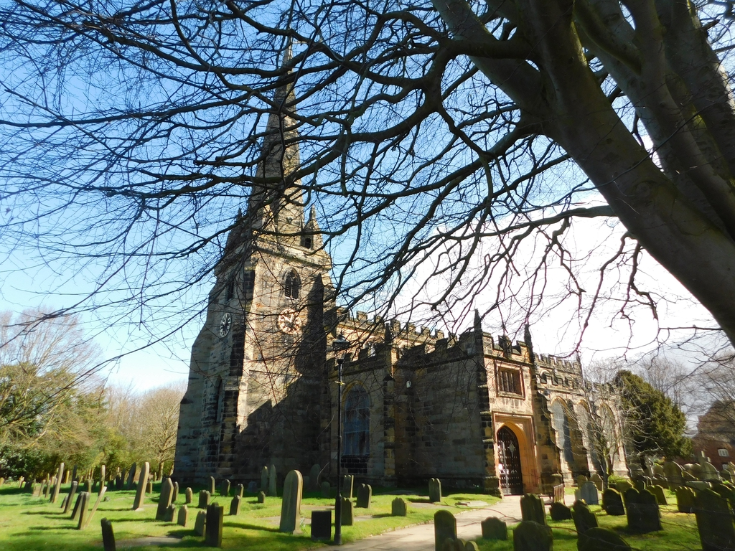  Sefton Parish Church Newsletter  SEPTEMBER 2026  Church Services at 11am:  6th Holy Communion  13th Morning Prayer.  20th Holy Communion.  27th Baptism.  Church Floodlighting in September:  24th Birthday Remembrance Sybil Thomas  From our Church Register:  Baptisms:  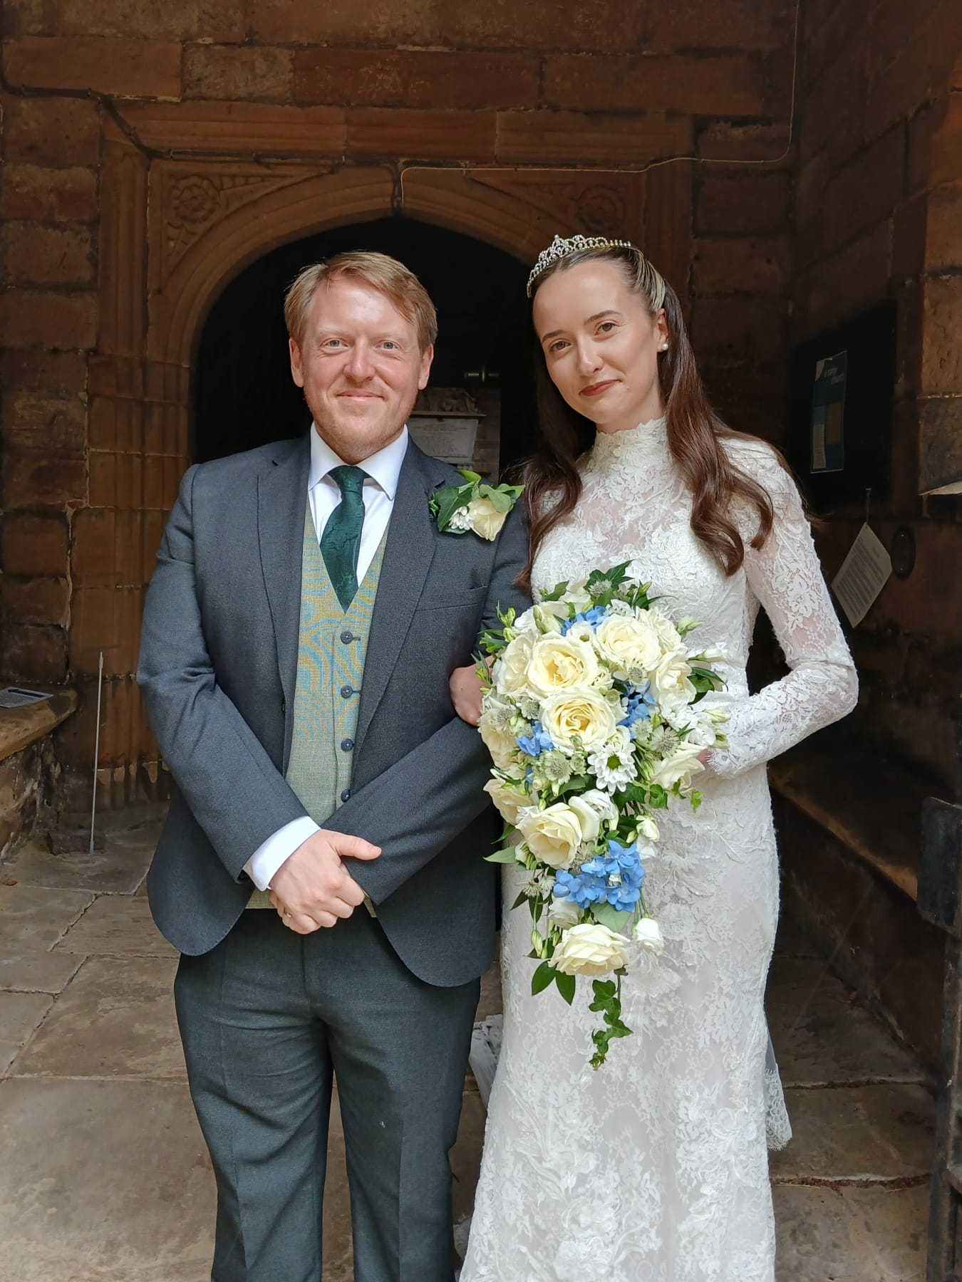  23.8.26. William Hopkinson  Weddings:  25.7.26. Elin Williams and Steven Daniels
Clergy Contact Details
Associate Vicar:
Rev Jackie Parry: 07803468870 rev.jackie@nschurches.uk
Ministry Team:
Rev Penny Leeman (Retired Priest)
Mr Ray Glenn and Mrs Polly Glenn (Readers)
Churchwardens Contact Details
Mrs Jane Cave: 07426 880690 jane_k_cave@yahoo.co.uk
Mr Darren Charnock: 07518 738364 darren.seftonchurch@gmail.com

Events and News from Sefton
  “A Cuppa and a Chat”  Please come and join us at Sefton Meadows Coffee Shop “Rosies” on the 9th September from 10am – 12pm. Due to the popularity of this event we have now decided to make this a monthly occasion with the following dates: 14th October, 11th November and 9th December! All are welcome – bring a friend.  Heritage Open Days – 11th – 13th and 18th - 20th September.  Thank you so much to all the volunteers who have offered their time over these two weekends to make our Heritage Open Days a success. If there are any problems then please see Ange.  Fliers regarding FREE Tudor Blackwork Embroidery Sessions on Sat 12th are at the back of church. Please see Ange if interested asap.    Bell-ringing Saturday 19th between 12pm and 3pm - why not come and try bell ringing - with guidance from our Sefton Bell Ringers. Please note the minimum age to ring is 10, with an ability to follow instructions and count to 8.    Harvest Festival Sunday 4th October – We will be holding our Harvest Festival Service with a “Bring and Share” lunch. There is a sign-up sheet for our lunch at the back of church. We will be decorating the church on Friday 2nd October at 10am. If you are able, please put any contributions in the Flower Money box at the back of church or see Ailsa. All the food we purchase will be used for our Harvest display and will be donated to our local Foodbank afterwards. |  |  | Stewart Whillis – Guest Organist  Presents:  “An Evening of Musical Entertainment”  On: Friday 16th October  At: 7.30pm  At: Sefton Parish Church  Tickets: £15 (including a delicious Scouse Supper with accompaniments, Apple Pie & Cream from “Scrummies” Caterers)  Please bring your own drinks.  Entrance by ticket only. Raffle.  Tickets are now on sale from Ange until Friday 2nd October. Please note that there are no reductions for children or just for the concert only. Vegetarian option can be booked. Fliers are at the back of church for distribution.  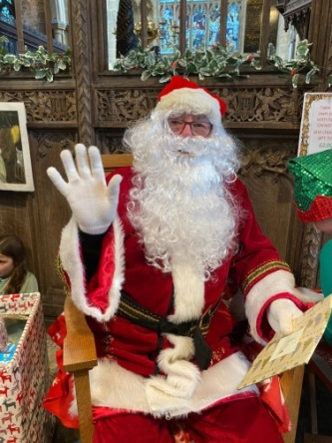  “Saturday 28th November – Dickensian Fayre – It may seem too soon to start thinking about Christmas but it will soon be here! Please let us know if you have any ideas for new ways to bring people through our doors to make this day a huge success again. There will be a meeting on Monday 19th October at 10am to discuss ideas. It is important that one representative from each stall attends. The boxes for any stall donations will be at the back of church after the meeting.

