
SPIRE & LIGHT United Churches
United Benefice of St Keverne, St Ruan with St Grade & St.Wynwallow (The Lizard)

*If you do not wish to receive these notices, please let your Churchwarden know*

13th September 2026

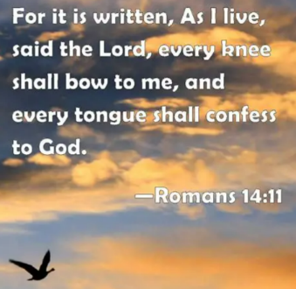
Readings
Genesis 50:15-21
Psalm 103:1-13
Romans 14:1-12
Matthew 18:21-35

9.30am – Morning Prayer - St.Peter’s, Coverack
9.30am – Holy Communion - St.Ruan, Ruan Minor
11am – Holy Communion - St.Keverne
11.15am – Café Church – St.Wynwallow, The Lizard
6pm – Evensong – St.Grade

Next week – Sept.20th
9.30am – Holy Communion - St.Peter’s, Coverack
9.30am – Morning Prayer - St.Wynwallow, The Lizard
11am – Creation Sunday - St.Keverne
11.15am – Family Service – St.Ruan, Ruan Minor


St Keverne & St Peter's Coverack Harvest supper celebrations Friday 25th September
Service in Church 7pm followed by Harvest Supper in Hall 8pm.
Tickets £5.
Available in advance from Kathy Ough tel: 01326281079


The Prayer Spot

The Diocese of Truro’s Prayer Diary for this week

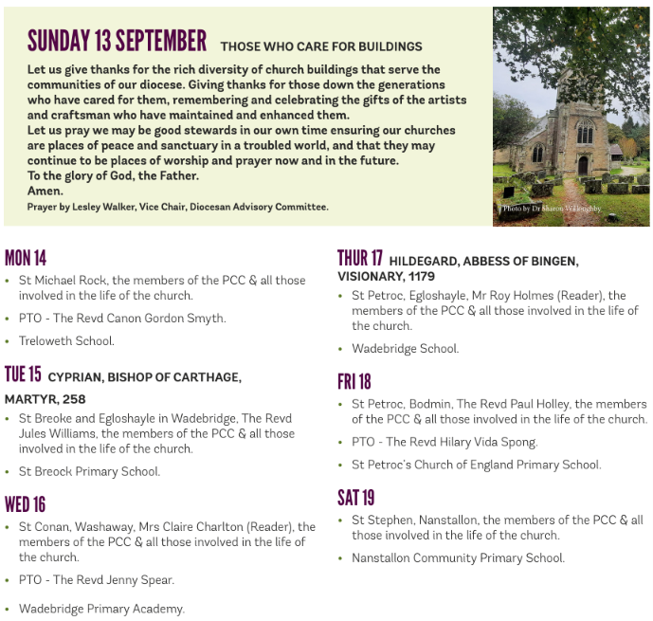

We pray for the Deanery that we belong to and we thank you for the faithful people you have brought together here. Remind us that we have each been brought to faith by Our Saviour Jesus Christ.
Lord Jesus, we thank you for your presence in our lives and the love you give us to share with others. Keep us strong in our faith and close to you.
Help us to be always there for others in their time of need, you have given us each gifts to use to reach out to others and to give comfort to those around us.
Heavenly Father we live in a world slowly destroying itself, through greed, hatred, and with no concern for others. Remind us that we can bring love, care and understanding into the world, by reaching out into our communities and showing your love to all we meet. Loving God, be with us always. Remind us that we are brothers and sisters in Christ Jesus, that God is ever present in our lives, through his wonderful Holy Spirit that he has given to you as a free gift to us all.
Mighty God, everything you do reveals your Majesty. Open our eyes to see what you are doing in our lives. Let us marvel at your good gifts and your wise provision. Your acts are amazing Lord. We cannot comprehend the number of blessings you pour out to us from day to day. As we gather today around your name, we pray that you will fill our hearts, our minds and our souls. Transform us Lord and make us more like you. Through Jesus Christ our Lord. Amen
God bless you all. Samuel Buchanan

On the Way Prayers

Prayers for Creationtide – September 1st – October 4th

Through our love of the countryside, through our care for commuters and farmers, through our care for animals and wildlife, through our respect for property and tools;
Father, hallowed be your name.
On our farms and in our homes, in our colleges and schools, where machinery is made, and where policy is planned: Father, your kingdom come.
By our seeking your guidance, by our keeping your commandments, by our living true to our consciences: Father, your will be done.
For the millions who live in poverty and hunger, for our own needs, and the requirements of our neighbours, by cooperation, sympathy and generosity: give us today our daily bread.
Because we have broken your commandments, doing what we ought not to do and failing as good stewards of your creation: forgive us our sins.
If any have injured us by injustice, double dealing or exploitation;
we forgive those who sin against us.
When prosperity lulls us to false security, or hard times prompt us to despair, when success makes us boastful, or failure makes us bitter:
lead us not into temptation, but deliver us from evil.
In the assurance of faith, in the confidence of hope, in the will to serve, help us to love Christ as Lord and our neighbour as ourselves.
For the kingdom, the power and the glory are yours, now and for ever. Amen

Holy God, earth and air and water are your creation, and every living thing belongs to you;
have mercy on us as climate change confronts us.
Give us the will and the courage to simplify the way we live, to reduce the energy we use, to share the resources you provide and to bear the cost of change.
Forgive our past mistakes and send us your Spirit, with wisdom in present controversies and vision for the future to which you call us in Jesus Christ our Lord.

Let’s now take a minute to pray for those places which mean the most to us in this wonderful part of your creation – our coves, harbours, coasts, our beautiful beaches, hills, cliffs, woods and streams, our towns and villages, our communities and our congregations. Lord we give you thanks that we are blessed to live in this wonderful place – help us and our churches to care for it. Let’s give thanks for our rubbish and recycling collectors, who in all weathers have to deal with our waste, for those who clear our beaches, and litter pick our streets. Help us to help them.

And now we pray for anything or anyone who needs to the power of our collective prayers right now.
Before the ending of the day, Creator of the world, we pray,
Your grace and peace to us allow and be our guard and keeper now.
From all ill dreams defend our eyes, from nightly fears and fantasies;
Tread underfoot our ghostly foe, that no pollution we may know.
O Father, that we ask be done, through Jesus Christ, thine only Son
Who with the Holy Ghost and thee, doth live and reign eternally. Amen.

