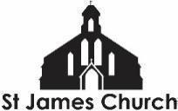
What’s On at St. James Church and in our local community from 4th September 2026 onwards
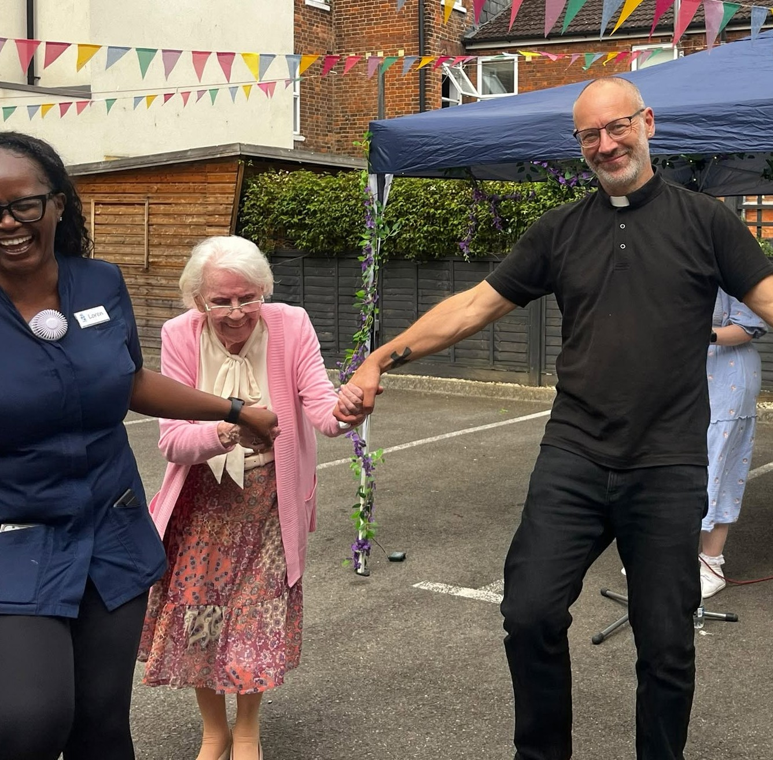
I hope you and your loved ones are doing well this week. Here is “What’s On” at St. James Church and some highlights from within our community this week.

Saturday 5th September is Gloucester Day.
There is a Service of Thanksgiving at St Mary de Crypt Church at 12noon. - All are welcome.

Sunday 6th September
9am Taize Holy Communion Service - We have developed our 9am Holy Communion so it now includes several well known chants from the Taize community in France. This service is on the 1st and 3rd Sundays of the month. All are welcome before…
10am Coffee and conversation in the church. A chance to meet and spend time with one another before or after worship
11am Back To School All Age Service. During the service there will be a chance to bring up your school bags, books, uniform etc. for a special blessing and gift for the year ahead. We will also pray for all of our young people at nurseries, schools, colleges, and universities, as well as for our adults who work in these places. Come and sing, worship, pray, learn, and have fun together.
3pm Installation of new Archdeacon of Gloucester at the Cathedral

Monday 7th September
Monday to Friday at 8.30am and 6pm: Morning and Evening Prayer on ZOOM

Tuesday 8th September
9.15am St James School - New School Year Service for pupils and staff
11am Holy Communion service at Park View Care Home (where I am pictured dancing over the summer!)
7pm Church PCC meeting at the vicarage

Wednesday 9th September
9.15-10.45am English Corner - English language conversation class
1 - 2.30pm Art4Life group in church
6.30 - 7.30pm Youth Choir - Young people between Years 5 and 10 are invited to come and learn a range of new songs for Autumn, in a fun and friendly choir. Free.

Thursday 10th September
Youth Club 6 - 8pm - Unfortunately, attendance is temporarily limited to young people who are invited (you know who you are!) whilst we build up our leadership and volunteer team.

More Community What’s On
The Fair Shares Allotments, Upton Street, are open on Monday, Wednesday and Thursday from 10am - 4pm - You can pick up some freshly picked vegetables, help to look after the crops, and find activities for children. As well as a cup of tea and a sit down! Everyone is welcome to go along.
St James City Farm - Do pop along and say hello to the animals on any day of the week with special events on many days inc.
Gloucester FM (GFM 86.6) has a new DJ on Wednesday evenings 6-7pm during September. Listen Live, or catch up online, to hear Rev Steve hosting the much loved tea time show on Gloucester’s favourite radio station. I MIGHT NOT BE ON AIR THIS COMING WEDNESDAY (9TH) - APOLOGIES.

In other news…
We are looking to employ a youth worker for our Friday evening youth group. If you know of anyone who might be interested in this then please ask them to contact me.
In addition, we are looking for someone to help with our pre-school children on a Sunday morning. If you know of anyone who might like to serve in this way then please let me or Fola know.
We are planning a Global garden - 4 raised beds growing food from Jamaica, Nigeria, Sri Lanka, and the UK. Would you be interested in being a part of this - helping to plan, plant, and nurture one of the beds? Speak to me or Chioma for more information.

Further ahead
Saturday 19th September
A celebration of lay ministry at the Cathedral.
1.15pm-2.45pm: Stalls set up in the Cathedral Cloisters highlighting some of the lay ministries exercised across the Diocese.
3pm Service celebrating all those who exercise a lay ministry in our church.
All may attend and support and there are some specific invitations in church as well.

As always, if you would like me to pray for, or have a conversation about anything then do get in touch. I am available to listen and share in whatever might be arising for you at this time.

God Bless, Rev Steve 07503164309

