Who to contact at St Helen’s Church:  - To sponsor floodlighting of the church at £5 per night please see the John Sparkhall. (PCC Treasurer)  - If you wish to have an inscription in the Memorial Book and your loved ones name to be read out in church, it is £25. Please see John Sparkhall. (PCC Treasurer)  - If you wish to donate to the Heritage of Sefton Church, details are as follows: Sefton Church.  RBS Account Number 10047948. Sort Code. 16-24-06  - For wedding and graveyard information contact Jane Cave  jane_k_cave@yahoo.co.uk  - For Choir: Andy Freeman – 0151 292 1763  - For website enquiries/events = Angela Rushton  07977344169 rushtonangela@hotmail.com  For information regarding opening times, events and services etc please see our www.achurchnearyou.com website. |  |  | 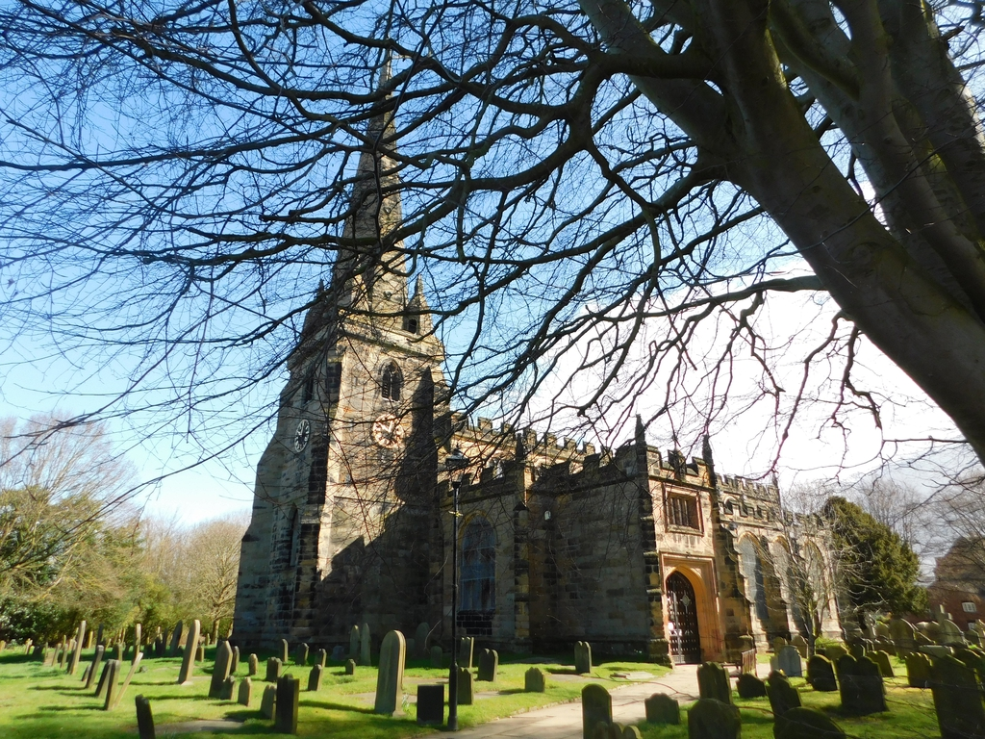  Sefton Parish Church Newsletter  JULY 2026  Church Services at 11am unless noted:  5th Holy Communion  12th Sea Sunday. Fire Drill at the end of the Service.  19th Holy Communion  26th Baptism. Refreshments after the service.  Church Floodlighting in July:  1st Jacob’s Birthday  2nd Birthday Remembrance Lesley Snook  14th Alfie’s Birthday  15th In Memory of Ann Price  16th Birthday Remembrance Ann Price  18^{th.} In Memory of John Ashton  24th Birthday Remembrance Blanche Halley  27th Janet’s Birthday  28th In Memory of George Rushton  30th In Memory of my friend Jacque  From our Church Register:  Funerals:  4.6.26 Barbara Dickinson  15.6.26 David Price  Baptisms:  28.6.26. Logan Jameson-Foster  28.6.26 Kelsey Blackhurst  28.6.26. Joel Blackhurst  Confirmation:  7.6.26 Elin Williams
Clergy Contact Details
Associate Vicar:
Rev Jackie Parry: 07803468870 rev.jackie@nschurches.uk
Ministry Team:
Rev Penny Leeman (Retired Priest)
Mr Ray Glenn and Mrs Polly Glenn (Readers)
Churchwardens Contact Details
Mrs Jane Cave: 07426 880690 jane_k_cave@yahoo.co.uk
Mr Darren Charnock: 07518 738364 darren.seftonchurch@gmail.com

Events and News from Sefton
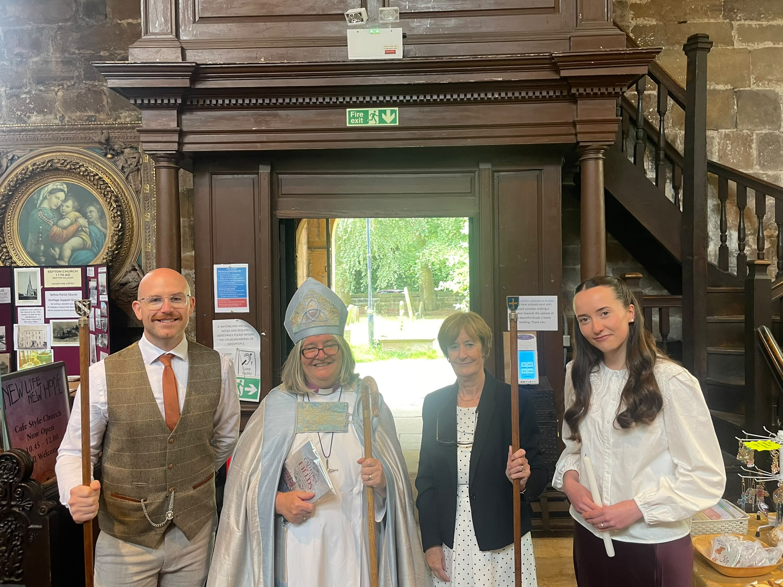  Sunday 7th June  We were delighted that Bishop Ruth presided at our recent Confirmation and Holy Communion service. The candidate confirmed was  Elin Williams shown in the picture with Bishop Ruth and our 2 new Churchwardens, Darren Charnock and Jane Cave.    Sunday.14th June - Blessing of the Animals Service. Our service was well attended with a variety of pets being present to be blessed by our Lay Readers Ray and Polly Glenn.  All the animals were well behaved! We managed to raise £158.00  for Freshfield Animal Rescue Centre. Photos of the animals being blessed will shortly be at the back of church on the noticeboard.  MADUkes Concert – Friday 26th June  This proved to be another successful evening full of fun and great entertainment. Just over 110 people attended (including the Ukelele band). We raised £700.35 for church funds. Our grateful thanks go to Hannah and Mark for yet again providing a great Burger BBQ and to the few (but dedicated) volunteers who helped to set up, man the door, sell raffle tickets etc and clear away – thank you. It is very much appreciated. |  |  |   First Aid Course  A First Aid Course led by Safe Haven Training took place in the Vestry on Tuesday 23rd June. A total of 8 people attended and by the end of the day they all passed their qualification. By all accounts an interesting hands-on day was had by all the First Aiders. Thank you to all the participants from Sefton and St Oswalds who gave their time so freely. It is much appreciated. Our First Aiders at Sefton are: Terry Cave, Joan Wolfenden, Rev Jackie, Darren Charnock, Janet Hopwood, James Parry and Ray Glenn (for both churches) and Fred Pilgrim from St Oswalds.  Heritage Open Days – 11th – 20th September.    St Oswalds School Year 6 pupils are again coming to spend the morning with us at Sefton Church on Friday 11th September between 9.30am and 11.30am.  I will be distributing the usual Volunteer sheets very soon and if you feel able to give just a small bit of your spare time to help out, I would be very grateful. This is particularly needed when the children are here. There are already fliers at the back of church with further details of the 6 days we are open.  Cards for our Congregation  Caroline Heaps has kindly offered to take over the role of sending cards to our congregation for “special” birthdays and anniversaries, get well and sympathy. If you hear of anyone in need of a special card please let Caroline know in plenty of time. Thank you.

