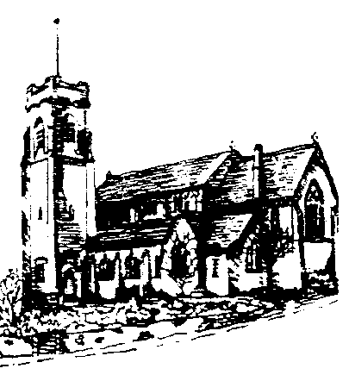
ST. ANN’S, BELFIELD NEWS LETTER
WORSHIP

St Ann’s is open for public worship Sundays and Wednesdays at 10.30am
Streamed LIVE on our Twitch TV channel twitch.tv/revdgill and on our Facebook page. – facebook.com/christchurchhealey
And to view on both after the broadcast Downloads on request.

Prayers for the sick
Ghislaine Glover, Cath Boon, Roger, Lilian, Letty and children, Derek.

Prayers for home members
Bob (in Mona Cliffe Care Home), Dorothy (in Braeside)

The anniversary of the dearly departed
Clara Elsdon, Frank Taylor, Charles Pointing, Alan Fielden, Doris Almond and Alice Buckley.

Scan this with your phone to contribute to St Ann’s mission and ministry

Benefice Motto, 2026
“In everything by prayer and supplication… let your requests be made known to God. And the peace of God which surpasses all understanding, will guard your hearts and your minds in Christ Jesus.”

Quiz Night
Friday 16th October 2026 7pm for 7.30pm start. Strictly teams of 6. £10 per person inc potato pie or cheese and onion supper. Free raffle with additional tickets to be bought on the night. Bring your own booze and nibbles. Please see Annette, Kim or Carolyn to order tickets. Hamper items gratefully received for raffle prize.

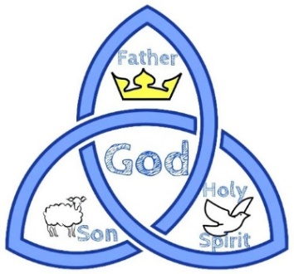

Fourteenth Sunday after Trinity
6th September 2026
Eucharist Rev. Debs Crossland

Hymns All H&W
18 As we are gathered. 83 God is working his purpose out. 246 Take my life and let it be. 32 Broken for me, broken for you. 173 Make me a channel of your peace
NOTICES
Country and Western Night
Friday 11th September, Christ Church Community Hall, ticket only, 7pm.

Quiet Communion
Christ Church, Sunday 13th September, 2pm.

Breathe
Quiet, contemporary worship, 13th September, St George’s, Oakenrod, 7.30pm

Manchester Pride in Place Scheme

Residents' input into the best use of £20m from GM City Council is sought. Opportunity to discuss and have your say – light lunch provided, Wed 2nd and 9th Sept. 12.30 – 2.00. Please share this invitation.
Hurstead, Smallbridge and Belfield Pride in Place Questionnaire - Page 1 of 8 - Rochdale Borough Council - Citizen Space

