Psalm 145: 1 to 8
Please stand, if able, and join in with the verses in bold italics

I will extol you, my God and King,
and bless your name for ever and ever.
Every day I will bless you,
and praise your name for ever and ever.
Great is the Lord, and greatly to be praised;
his greatness is unsearchable.

One generation shall laud your works to another,
and shall declare your mighty acts.
On the glorious splendour of your majesty,
and on your wondrous works, I will meditate.
The might of your awesome deeds shall be proclaimed,
and I will declare your greatness.
They shall celebrate the fame of your abundant goodness,
and shall sing aloud of your righteousness.

The Lord is gracious and merciful,
slow to anger and abounding in steadfast love.

Glory be to the Father and to the Son and to the Holy Spirit,
as it was in the beginning, is now and ever shall be,
world without end. Amen

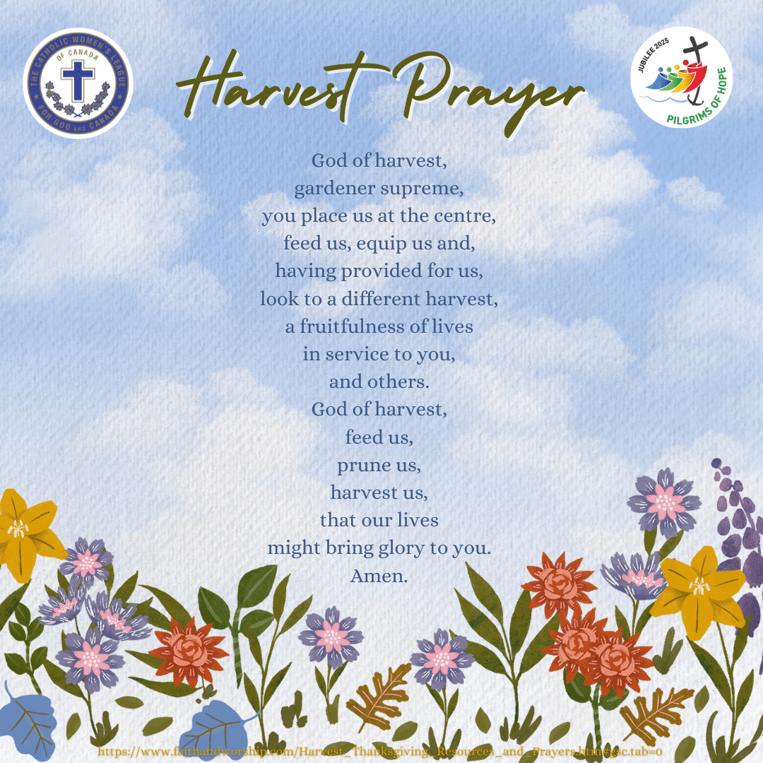

In our weekly prayers for our parish
This week we pray for God’s blessing on Limetree Court, Little Hallam Hill and Lock Close.

All Saints Church
Distribution of Communion –new arrangements!
Thank you to everyone who fed back about communion distribution, especially about the wine. We will now have at the altar two chalices, one where the priest will continue to dip the wafer into the wine and a separate chalice for those who want to sip the wine.

Please help us by letting us know what you prefer, and be gracious as it takes a little longer at the altar rail.
Refreshments After the Morning Service
Please stay seated after the service and a hot drink will be brought to you in the pews. Do not get up and head to the back of church, it is becoming a hazard, and a risk as trays of hot drinks could be knocked over.
Church contact information
Contact: Rev’d Christine - revchristine@outlook.com
The Rectory, The Village, West Hallam, DE7 6GR
Landline 0115 646 1497
Rev’d Ailsa -revailsahunt@gmail.com
Tel - 07356064856

Churchwardens – Mrs Janet Wheeldon, -Tel: 0115 8771593
Mrs Linda Gregory – linda.gregory3@icloud.com
https://www.achurchnearyou.com/church/13402/
https://www.facebook.com/allsaintskirkhallam
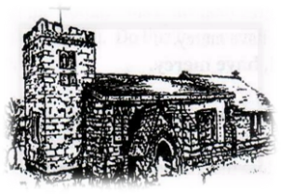
Kirk Hallam
Disabled Toilet in Friendship House.
Disabled Toilet in Friendship House.

Working with God to transform lives & communities.
Please can you ensure your mobile is on silence, or off during the service, it is affecting people with hearing aids and the loop system.
20th September – Sixteenth Sunday After Trinity
10.00am CW Communion Service with Rev’d Christine
2.00pm Baptism of Henry Robinson by Rev’d Christine
6.00pm BCP Holy Communion with Rev’d Christine

Forthcoming Events
Mon 21st 1.00pm Funeral for Baby Rayley in church
Tues 22nd 6.30pm Home Group in Friendship House
Weds 23rd 9.30am Morning Prayer at UCAS
Weds 23rd 11.00am Safeguarding Team meeting
Thurs 24th 11.30am Funeral for Nora Crookes at Markeaton
Fri 25th 6.00pm Choir in Friendship House
Sat 26th 10.00am Prayer Meeting in Friendship House

27th September – Seventeenth Sunday After Trinity
10.00am CW Communion Service with Rev’d Ailsa & Eileen
6.00pm BCP Evening Prayer with Rev’d Christine
It’s Good to Talk! If you spot that someone is missing, please pop a news sheet through their door, & if you’ve time, call for a chat - just to check they’re OK & to let them know that they are not forgotten!

‘In everything give thanks: for this is the will of God in Christ Jesus concerning you’ 1 Thessalonians 5:18

