St Peter’s Church, Upwell
Harvest Fish & Chip Supper
Plus, choice of Dessert
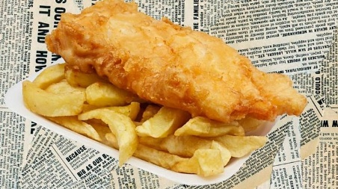
Friday 9th October
7.00 pm
With entertainment by
 ‘Just Us Two’ 
ballads - country & western - pop - easy listening

Gerry’s Jewellery and Suncatchers
available for purchase
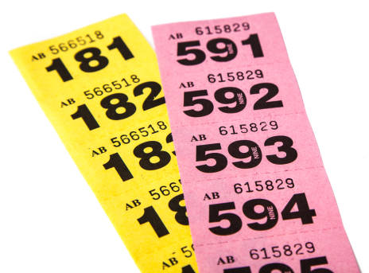
£12.00 per person Contact Liz Ferris
on 01945 774078 or in person to book!

