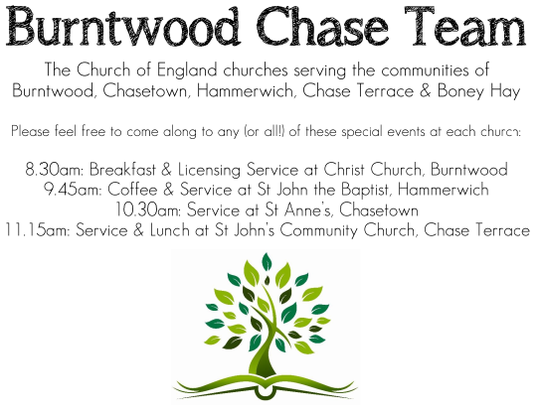
CHRIST CHURCH, BURNTWOOD
Registered Charity Nos: 1217129

SERVICE ON SUNDAY 20TH SEPTEMBER 2026 AT 10AM

HOLY COMMUNION

The 16th Sunday after Trinity

First Bible Reading – Jonah 3:10 to 4:11

¹⁰ When God saw what they did, how they turned from their evil ways, God changed his mind about the calamity that he had said he would bring upon them, and he did not do it.
But this was very displeasing to Jonah, and he became angry. ² He prayed to the Lord and said, “O Lord! Is not this what I said while I was still in my own country? That is why I fled to Tarshish at the beginning, for I knew that you are a gracious and merciful God, slow to anger, abounding in steadfast love, and relenting from punishment. ³ And now, O Lord, please take my life from me, for it is better for me to die than to live.” ⁴ And the Lord said, “Is it right for you to be angry?” ⁵ Then Jonah went out of the city and sat down east of the city and made a booth for himself there. He sat under it in the shade, waiting to see what would become of the city.
⁶ The Lord God appointed a bush and made it come up over Jonah, to give shade over his head, to save him from his discomfort, so Jonah was very happy about the bush. ⁷ But when dawn came up the next day, God appointed a worm that attacked the bush, so that it

withered. ⁸ When the sun rose, God prepared a sultry east wind, and the sun beat down on the head of Jonah so that he was faint and asked that he might die. He said, “It is better for me to die than to live.”
⁹ But God said to Jonah, “Is it right for you to be angry about the bush?” And he said, “Yes, angry enough to die.” ¹⁰ Then the Lord said, “You are concerned about the bush, for which you did not labour and which you did not grow; it came into being in a night and perished in a night. ¹¹ And should I not be concerned about Nineveh, that great city, in which there are more than a hundred and twenty thousand persons who do not know their right hand from their left and also many animals?”

Gospel Reading – Matthew 20: 1-16

“For the kingdom of heaven is like a landowner who went out early in the morning to hire labourers for his vineyard. ² After agreeing with the labourers for a denarius for the day, he sent them into his vineyard. ³ When he went out about nine o’clock, he saw others standing idle in the marketplace, ⁴ and he said to them, ‘You also go into the vineyard, and I will pay you whatever is right.’ So they went. ⁵ When he went out again about noon and about three o’clock, he did the same. ⁶ And about five o’clock he went out and found others standing around, and he said to them, ‘Why are you standing here idle all day?’ ⁷ They said to him, ‘Because no one has hired us.’ He said to them, ‘You also go into the vineyard.’ ⁸ When evening came, the owner of the vineyard said to his manager, ‘Call the labourers and give them their pay, beginning with the last and then going to the first.’ ⁹ When those hired about five o’clock came, each of them received a denarius. ¹⁰ Now when the first came, they thought they would receive more; but each of them also received a denarius. ¹¹ And when they received it, they grumbled against the landowner, ¹² saying, ‘These last worked only one hour, and you have made them equal to us who have borne the burden of the day and the scorching heat.’ ¹³ But he replied to one of them, ‘Friend, I am doing you no wrong; did you not agree
with me for a denarius? ¹⁴ Take what belongs to you and go; I choose to give to this last the same as I give to you. ¹⁵ Am I not allowed to do what I choose with what belongs to me? Or are you envious because I am generous?’ ¹⁶ So the last will be first, and the first will be last.”

Collect for Today

O Lord, we beseech you mercifully to hear the prayers of your people who call upon you; and grant that they may both perceive and know what things they ought to do, and also may have grace and power faithfully to fulfil them; through Jesus Christ your Son our Lord, who is alive and reigns with you, in the unity of the Holy Spirit, one God, now and for ever.

Amen

Forthcoming Services in Church

Wednesday 23rd September Morning Prayer 9.30am

Sunday 27th September Morning Worship 10am

Wednesday 30th September Morning Prayer 9.30am

Sunday 3rd October Holy Communion 10am

Future Event For Your Diary
Saturday 3rd October Art Café 3pm
Monday 5th October Cameo Café (£1) 10am
Saturday 14th November Christmas Fayre 2-4pm

Food bank

We are continuing to support this important ministry for people in need in our local community, for which the following items are always needed: ‘Long Life Milk, Custard, Rice Pudding, Cereals. Many thanks for your support. The Food Bank is very grateful for whatever you may be able to donate.

Floodlighting
If you would like to commemorate a special occasion by floodlighting our Church, please contact Chris Brown on 01543 683862 for details.

Prayer Chain

Christ Church is blessed with a very active prayer chain. If you, or anyone you know, feel that they would like others to pray for them, please speak to Chris Brown on 01543 683862.
Home Visits and Communion

For anyone who is unable to attend church and would like a Home Visit and Communion, please contact the Vicar and he will be able to carry this out.
Vicar’s Contact Details

Rev’d Stephen Morgan - Telephone: 07305 852152
Church Wardens Contact Details

Judith Rogers - Telephone: 01543 324718
Mike Holmes - Telephone: 01543 672970
Church Office Telephone: 01543 642187 [Please leave a message and we will respond in due course]
Church Web Site:www.christchurchburntwood.org.uk
Church Email: christchurchburntwood15@gmail.com
Facebook: www.facebook.com/group/christchurchburntwood/

Next Sunday’s Service – The 17th Sunday after Trinity
Sunday 27th September 2026 – Morning Worship at 10am
Bible Readings: Philippians 2:1-13 and Matthew 21:23-32

