St Thomas’ Church and Community Project
“A Place for You”
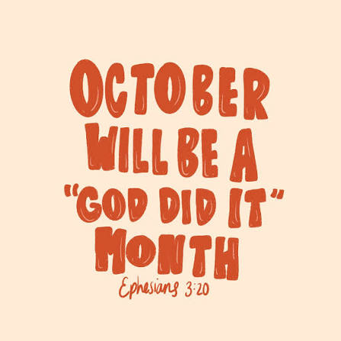
October Newsletter

God has already done a lot for the Church of St Thomas in September; we wait with anticipation to see what He will do in October. In September we saw 11 candidates be confirmed in their faith by Bishop Michael (Bishop of Birmingham) and a visit from Bishop Esther (Bishop of Aston) saw me complete my curacy and be licensed as Assistant Priest (known locally in Birmingham as Associate Priest). This is a ministry I will serve across the two parishes of St Thomas Garretts Green and St Richard’s Lea Hall. I am definitely looking forward to seeing how God will use this new ministry to sustain and grow us together. I was so chuffed to see so many people at the service from both churches as well as my lovely family and friends. Thank you for coming to support me. It was a joyous and fun-filled experience, I hope for everyone, and there were donuts and cake too!
I was privileged to be able to choose the readings and the songs for the licensing service and I chose one of my favourite Old Testament passages from the Book of Ezekiel Chapter 37 about the Valley of Dry Bones. This passage talks to us about what it feels like to be so desolate and broken, that the only hope is God, God has the power to bring absolute restoration, hope, and new life to situations that humanly seem entirely dead and hopeless. For me it reaches part that no other passages reach… it talks directly into situations where there is no hope, where people are marginalised and excluded and feel at rock bottom. We may feel powerless in these situations. This can happen to any of us at any time. There is always God, and he is always there and will never forsake us. He has promised.
September has always been a special month for me, and I have enjoyed the sunrises, sunsets and the glorious weather and the way the sun shines through the leaves as they change their colours into majestic golds and oranges. I was reminded of Stuart Townsend worship song Who Paints the Skies? The first of which reads:
Who paints the skies into glorious day?
Only the splendour of Jesus.
Who breathes His life into fists of clay?
Only the splendour of Jesus.
Who shapes the valleys and brings the rain?
Only the splendour of Jesus.
Who makes the desert to live again?
Only the splendour of Jesus.
Very much echoing my thoughts on the Ezekiel passage.
For Christians, October holds significant meaning through major historical commemorations, liturgical traditions, and seasonal reflections, culminating in Reformation Day and the eve of All Saints' Day. Protestants mark October 31 as Reformation Day to remember when Martin Luther posted his Ninety-five Theses in 1517. It celebrates the foundation of salvation by grace through faith alone and the rediscovery of biblical authority. The same date of course is Hallowe’en and while widely commercialised today, it historically serves as a bridge to remembering the Christian community of saints and departed believers and is it precedes All Saints Day 1st November. For Catholics it is the feast day of St Wolfgang, a German saint, and begins a three-day focus on those who have died in faith and gone before us. As Anglicans we hold the “Middle Way” between Protestantism and Catholicism.
Rev Sue Round

October church services
If you want to discover more, come and join us any Sunday morning or at any of our community activities throughout the week.
Sunday 4th October 10.30am – Our Harvest Festival with Holy Communion
Sunday 11th September 10am - Morning Prayer
Sunday 18th September 10am - Holy Communion
Sunday 25th September 10am – Morning Prayer

Children are always welcome to join us. We have some toys for babies and will provide activities for older children to do in their seats. Please do not worry if you arrive a bit late or need to leave before the end.

If you are on the rota to read during October, please assume that you will be reading the gospel. These may be subject to change. The readings are listed here in case you want to practice:

Sunday 4th | Book of Ruth (Harvest)
Sunday 11th | Matthew 22.1-14
Sunday 18th | Matthew 22.15-22
Sunday 25th | Matthew 22.34-46

Everyday Faith

What is ‘Everyday Faith’?

Everyday Faith is the name given to a wide range of activities across the church of England that support and equip us all to ‘find and follow God’ in our everyday lives – Sunday to Saturday.

When we are together worshipping on Sunday, we are as a GATHERED church. When we are active as Christians Monday to Saturday, we are the SENT church. Whatever we are doing for the glory of God in our hearts is also worship.

Worship, prayer, teaching and Christian fellowship doesn’t just happen in church on Sunday mornings, the church is active out in the community throughout the week.

- Stay and Play group for babies and toddlers on Monday (resumes 13th September)

- Children’s club with fun and games, crafts, cooking, activities, challenges and bible stories on Mondays from 4.00 till 5.30 and youth club 5.45 till 7.15 – resumes 13th September

- Young Adults discipleship group – Monday evenings from 7.30 till 8.30

- A church service Heartlands Care home happens twice monthly

- Pastoral visits at West Hall Court every other Thursday morning and at Heartlands Care Home on Friday afternoons.

- Godly Play at Oasis Blakenhale Juniors every Tuesday – Christian teaching with classes from years 3 to year 6.

- The Open the Book team make monthly visits to the school assembly at Oasis Blakenhale Infants School. We are busy, we have just delivered David the Giant killer in Blakenhale Oasis Infants school we will be visiting Elms Farm for their Harvest assembly with the story of Ruth. If anyone is interested in joining the team please speak to Susan, Jo, Linda or Jan - it's great fun and very rewarding

- Activities for those over 50 on Thursday and Friday – continues throughout the summer. A digital literacy experience begins in October. (see posters at the end of this newsletter)

- We are also being Everyday Faith when we are chatting at the school gates, talking to someone in a coffee shop, the library, the post office etc, or reading quietly at home etc.

Foodbank Update
The foodbank is open on Wednesday mornings from 10.00 till 11.00 p.m. and we have a wonderful team of volunteers from the church and community. We are very busy serving on average 25 people a week with food to feed around 60 people. With high demand all donations are very welcome; if you can provide occasional tins of beans, spaghetti, soup, vegetables etc please leave them in the collection tray at the back of the church or in the hall entrance. We now also provide fresh fruit and vegetables and there are usually some left after our Foodbank session so please help yourselves rather than letting them go waste. A small donation is welcome.
Thank you to everyone.
If you have any spare shopping bags, or bags-for-life, we will be very grateful for them and we are happy to re-use plastic carrier bags you may have. Please leave them in the donation boxes or pass to Jan or Jo.

Harvest Festival

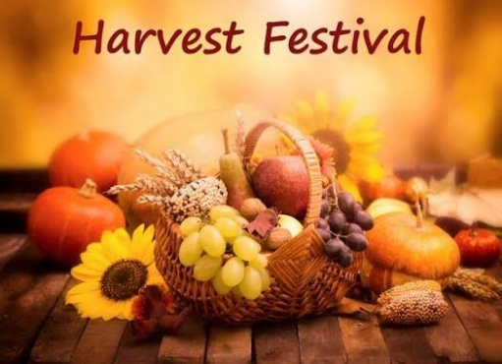
Sunday 4th October we will celebrate harvest with a service of thanksgiving and sharing, we will be joined by St Richard's congregation. And there may be a story from our Open the Book team.This is an opportunity to donate cash or goods to help stock up our Foodbank for the winter months; any tinned foods, rice, pasta, pasta sauce, cereals, biscuits, tea, coffee and toiletries are very much appreciated. All items need to be in date please. Your support at harvest time and throughout the year is much appreciated by our foodbank clients and our volunteer team.
We will leave our harvest display out until Tuesday when Brays school are visiting us to celebrate harvest, enjoy the display and help us make up some food parcels. A visit from Brays is always chaotic but a great joy and their families are usually generous with their harvest gifts to the foodbank.
Rev Susan Larkin

Website update
Our website reflects everything that happens in church on Sundays, including other acts of worship and study groups, as well as what happens during the week, all in the name of St Thomas. Please have a look if you are able. If you have any comments, observations of additional thoughts, please contact Rev Sue. In future all our newsletters will also be available on the website so don’t worry if you lose it. If you would like your own copy emailed to you, again, please contact Rev Sue.

Our web address is www.st-toms.com

If you use Facebook please like and follow us on St Thomas Church & Community Project.
Please note that our internet connection is still unstable. We do have connection through an alternative method than Virgin, but it doesn’t reach the church. It will be fixed shortly but, in the meantime, if you are responsible for preparing the worship please bring the service backed up to a flash drive or your own laptop.

Prayer Requests and Prayer Pointers

Prayer means putting ourselves into a communicating relationship with the divine God. Prayer is often used to build a relationship with God, offering thanksgiving, asking for help, and seeking forgiveness. It is described as a means to express gratitude and find comfort and strength. It is a gift for our own sense of identity as children of God, and for our own sense of purpose. It is often helpful to end or begin our prayer time with the prayer Jesus taught us:
Our Father in heaven,
hallowed be your name,
your kingdom come,
your will be done,
on earth as in heaven.
Give us today our daily bread.
Forgive us our sins
as we forgive those who sin against us.
Lead us not into temptation
but deliver us from evil.
For the kingdom, the power, and the glory are yours
now and for ever.
Amen.

In your prayers this month please consider including these pointers:
- Pray for all those who are currently unwell, receiving treatment, recovering from illness or surgery and those in residential care.
- For those who work in nursing and caring roles in hospitals, residential homes and at home. For social workers and those who work in prisons.
- For those with families affected by the troubles in the Middle East.
- For world leaders striving to negotiate peace.
- For the UK Government and our new Prime Minister.
- For our congregation to continue to grow in faith and numbers.
- For our work in local care homes and at Oasis Blakenhale School.
- For yourself, and your own family and friends.


John and I spent an hour one evening last month listening for bats in the churchyard. It is a project called NightWatch in Sacred Places which is being run by the Bat Conservation Society and they are particularly keen to survey urban churches. We were supplied with a listening device, which was a good job, what with me being rather deaf and there being traffic pouring up and down Garretts Green Lane just a few feet away from us! We were also tasked with looking for foxes, hedgehogs, mice, birds and a variety of insects and moths. Sadly we didn’t see any signs of life at all in the space of one hour, however, the listening device, which was left in place overnight, has gone back to the BCS and we await to hear what, if anything, it recorded.
Our washer/dryer packed up at home last week after 14 years. I was keen to keep it going for as long as possible as this is the most sustainable option but, unfortunately, the repair man wrote it off, declaring that it was ‘a problem with the main board and that even supposing he could still get the part for it, it was likely to be very expensive’. So, somewhat daunted, we spent a few days looking at new machines. They have certainly changed a lot since we bought our last one, now they all seem to have numerous programmes and are ‘smart’ so you can work them through an app on your phone. (Why can’t I find an ironing board and iron that will do my ironing via an app on my phone??!!). Knowing us we will use one easy-care cycle, one wool cycle and one for the towels and that will be it. Anyway, I discovered we could have a washer/dryer that has a heat pump for drying and that it just needed either a drain hose or you can collect the water in a little tank, so it is as easy to install as our old condenser dryer. The benefit of the heat pump is that the dryer is cheaper to run than a condenser version; it should save us about £45 a year in electricity costs – that’s £225 over 5 years, based on us drying one load of towels or tea towels per week. The downside is that the drying cycle is quite a bit longer because it runs at a lower temperature, but that doesn’t bother us as we don’t do more than one or two wash loads a day. We found a machine that cost just £55 more than one with a condenser dryer so we think it’s worth giving it a go. We’ll let you know how we get on with it.
Linda Nugent (Parish Environment Champion)

New Windows
Work is underway to replace the single glazed windows in the chancel with double glazed units. This is the second phase of our planned replacement programme which is an investment for the future. So far, the work has mostly taken place from the outside.
Gardening Work
Shortly some gardening work will be done to restore the area in front of the Community Centre to its weed free former glory with new turf being laid and brambles removed. In addition the wild flower meadow in front of the large church window will be strimmed back in readiness for next year’s sowing!

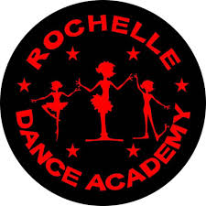
Rochelle Dance Academy are open for new recruits, our Tiny Stars from age 3yrs upwards, right up to our senior superstars, experienced dancers also welcome.
RDA is more than a dance school, it’s a family where we make memories, have lots of fun, and make lifelong friendships.
So, if you have a little one, bursting with energy and loves to dance bring them along for a free trial.
Contact Debbie for more information 07957460968.

22 dancers from RDA are performing at Drayton manor in October, aged from 6-17yrs.
Our rehearsals start in September and we are very excited.

Stay and Play

Are you left at home with an active toddler? Come and join us on Monday mornings from 9.00 till 11.00 to meet other parents and carers with pre-school children. Lots of toys and activities for you to enjoy with your children and to help them make friends, grow and confidence and learn social and communication skills in a friendly, relaxed atmosphere. We have free time where parents, carers and children can play together, be creative and grow together in preparation for nursery or school. After play time the children sit together for toast and then we finish with sing along and story time.
Cost is £2.00 per child (£1.00 for siblings), pay by cash or card, includes free refreshments. Come along for a free trial session and bring some friends and share your ideas for play with us.
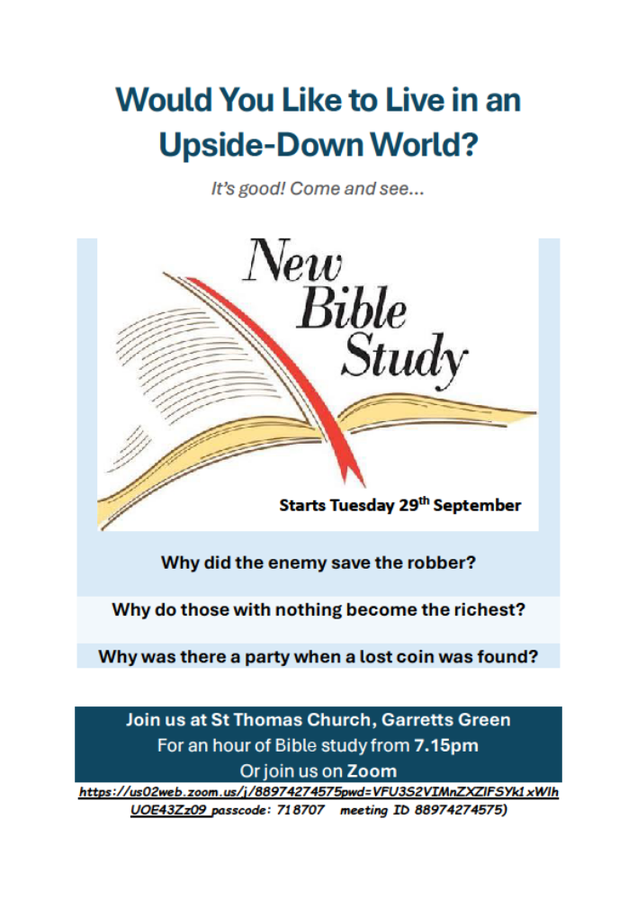
https://us02web.zoom.us/j/88974274575pwd=VFU3S2VIMnZXZlFSYk1xWlhUOE43Zz09 passcode: 718707 meeting ID 88974274575)

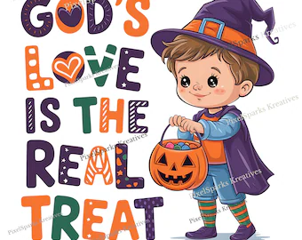
Halloween
It wouldn’t be right to have an October Newsletter and not mention Halloween. Christians hold widely different views on Halloween, choosing to reject, tolerate or fully participate in the holiday based on their personal conscience and interpretation of faith.
If you are interested read on..
Many Christians avoid Halloween completely because they view it as having dark, pagan roots that glorify evil, fear, or witchcraft. Some churches host alternative activities on October 31 to keep children away from darker themes.
Many Christian families feel that sweets and chocolates and dressing up as friendly characters, and trick-or-treating are not inherently evil.
Christian leaders often teach that participation is a personal choice guided by individual conscience rather than a strict biblical command. In fact Halloween is a new celebration and is not mentioned in scripture.
Scripture encourages believers not to judge one another or fight over different personal convictions. At St Thomas we do not encourage the celebration of Halloween but do not judge those who do. So, in partnership with St Richard’s Church we will be hosting a Craft event making lanterns, having some sweet treats and going outside to sing and shine our lights. This will take place on Saturday 31st October (of course) at 4pm so you have plenty of time to trick-or-treat afterwards! Please don’t dress up but if you could make a halo at home and wear that instead.

Christmas Bazaar

Gosh! Yes it's already that time of year. Our bazaar will be on Saturday 28th November so we are already collecting - we need good quality items for the tombola, bottles of wine and soft drinks for the bottle stall and nearer the time cakes and homemade jams and pickles plus lots of volunteers to help set up on Friday as well as on the day itself. We have of course booked Santa and we will be creating a wonderful grotto experience for all the children who come to visit him.
Look out for November’s Newsletter for the calendar of Christmas events including Journey to the Stable.

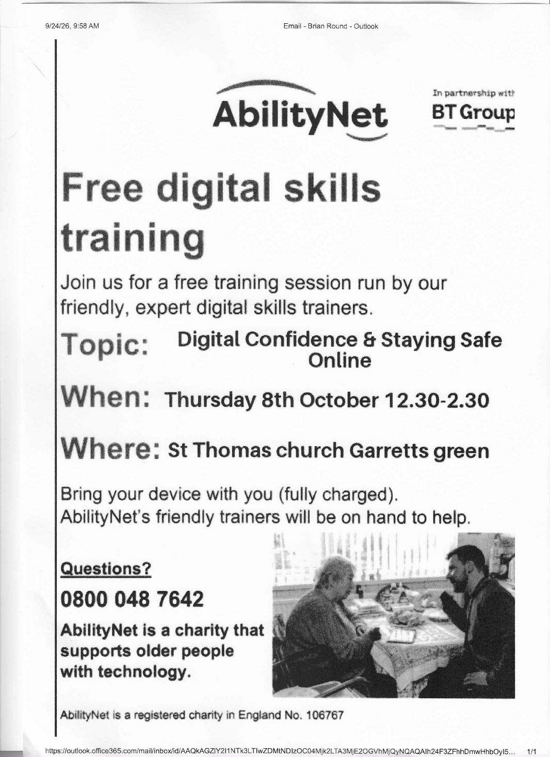

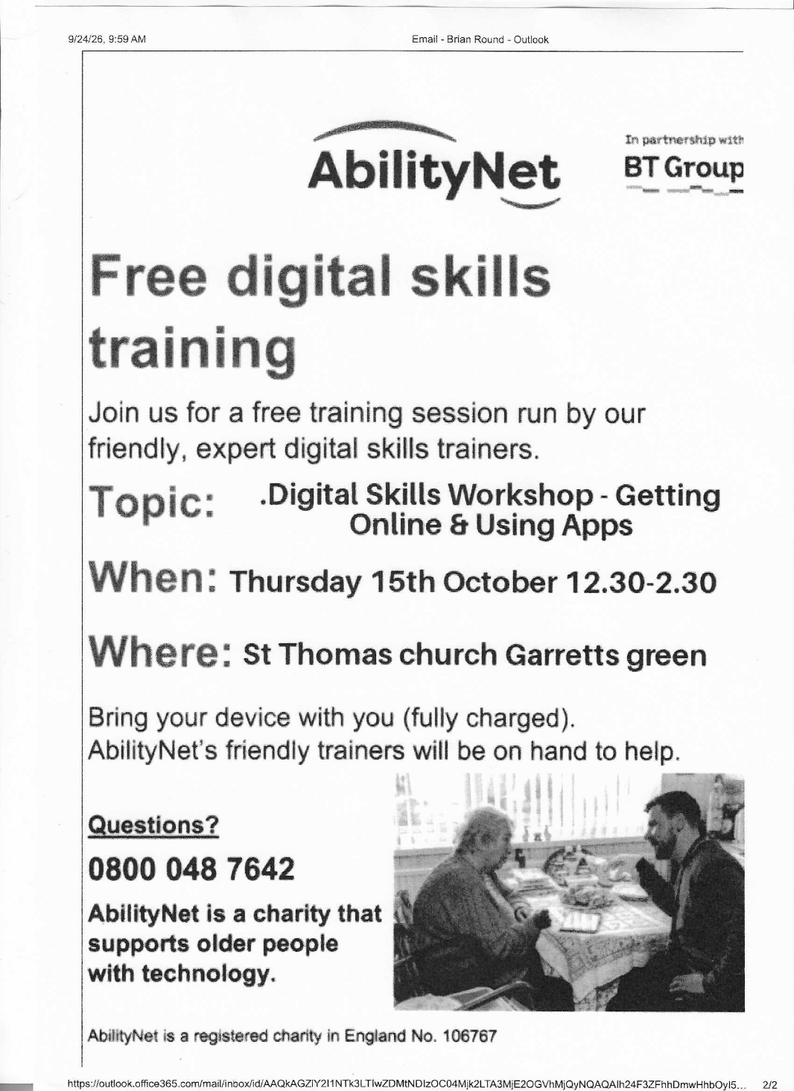

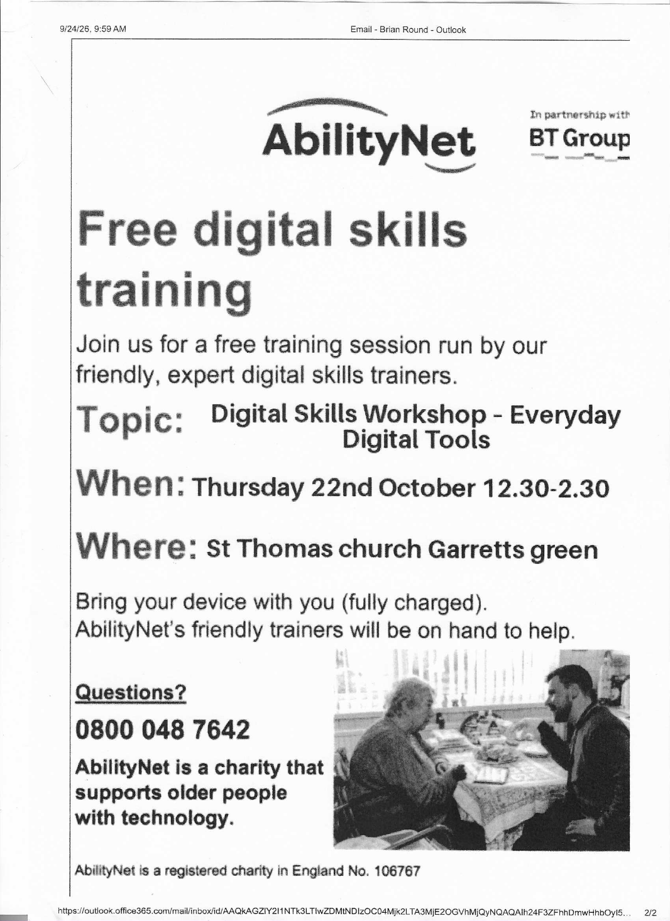

Line Dancing Evening

This event is being organised by Sharon Ellgood (Sam’s Mum) who runs the weekly Line Dancing sessions. Please come along for this evening of dancing! Yee – Haa!!!!

For a quiet moment

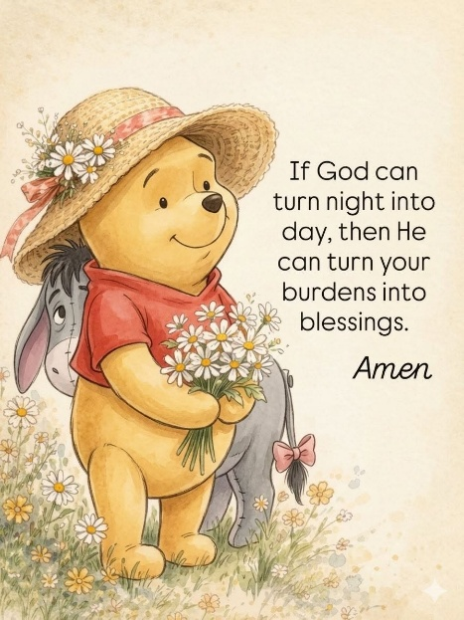
There’s something quietly comforting about the way light always finds its way back into the sky… no matter how long the night feels.
Sometimes life gives us moments that feel heavy— like carrying a weight no one else can see, like holding onto worries that don’t seem to have an answer yet.
And in those moments, it’s easy to wonder if things will ever change… if the darkness will ever lift.
But just like night never stays forever, neither do our struggles.
God has a way of working gently, silently…
turning what once felt impossible
into something beautiful in time.
The burdens you carry today,
the silent prayers you whisper when no one is listening,
the tears you hide behind a brave smile— none of it goes unseen. Every worry…
every ache…
every moment of doubt…
He holds it all with care.
And one day, you’ll look back and realize that what felt like an ending was actually the beginning of something softer, something kinder, something meant just for you.
So, hold on a little longer.
Trust a little deeper.
And breathe a little easier knowing— the same God who turns night into day is already working on your story too.
Your burdens will not stay burdens forever…
they will bloom into blessings in ways you never expected.



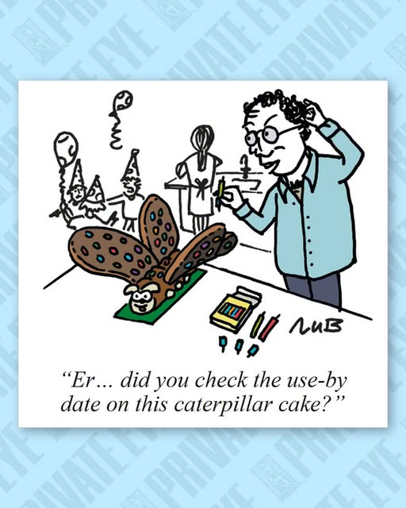

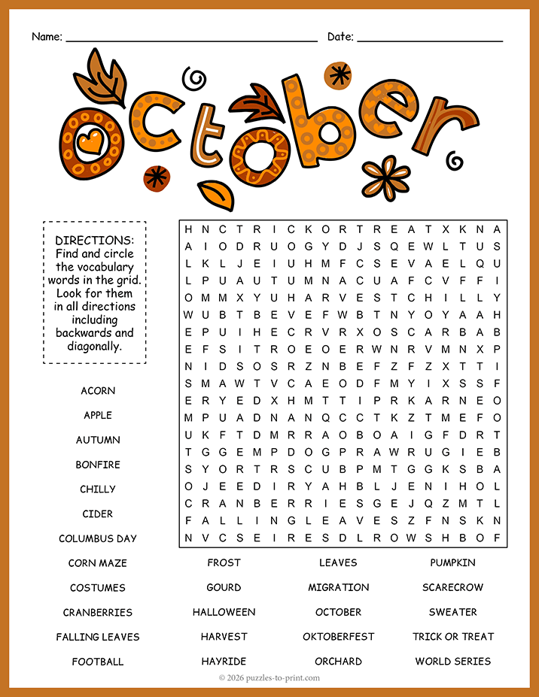





Items and articles for this newsletter are always welcome.
For the November Newsletter please send your articles and items of interest to
Revd Sue Round Sue.Round@st-toms.com
Clergy contact details:
Rev Paul Bracher 0121-783 2319 paul.bracher@Saintrichards.org.uk
Rev Sue Round 0777 343 1028 sue.round@st-toms.com
Rev Susan Larkin 0785 038 7183 revsusan@st-toms.com

Main telephone number for the office 0121-743 7040
The office is manned on a part-time basis but our posh new phone will take an answerphone message and forward as an email to the recipient.

