YOU ARE INVITED TO A
‘SERVICE OF LIGHT’
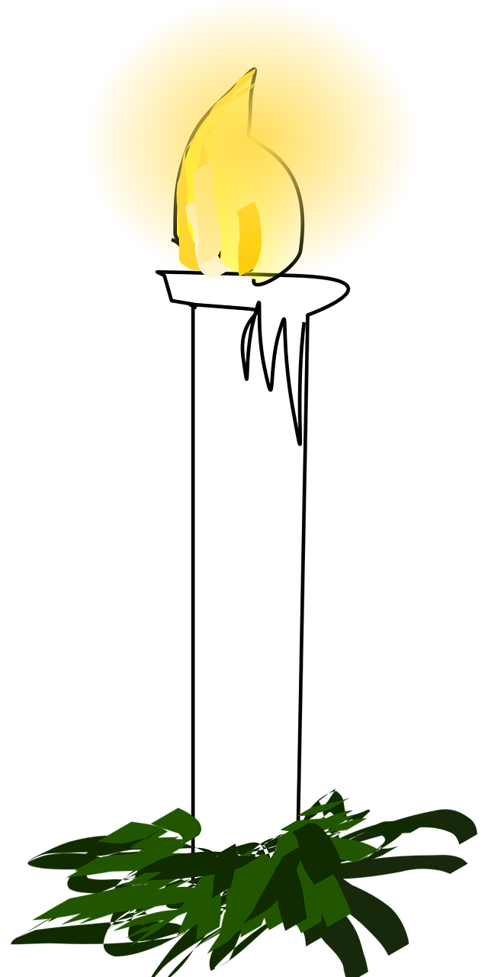
All Saints’ Church, East Clevedon
on Wednesday, 28th October
at 6.00 pm

A simple service to remember any loved ones who have died either recently or in years past and offering our support and prayers in these difficult months.

You and your family will have an opportunity to light a candle in remembrance of your loved ones and see their name in the Book of Remembrance.

If you have any names to be added to the Book of Remembrance please contact the Parish Office.
Names from previous years, remain in the book.

Light refreshments following the service

