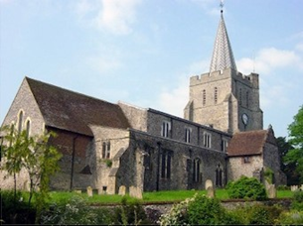
Please visit our website for information about our churches, services & events www.elhamvalleygroupofchurches.co.uk

Every Tuesday at St. Mary’s…

Traditional Morning Prayer at 8.30am in the Jesus Chapel. Download the free Church of England app or use the red book. A good way to begin the day. https://play.google.
com/store/apps/details?id=com.aimermedia.dailyprayer&pli=1


Every Monday at the Methodist Hall …
Coffee and cake, a warm welcome and friendship, 10.30am –
12pm

Churches Together in Elham Valley
Please contact -: Ruth Collie (01303 840773) for information

4th October – 18th Sunday after Trinity
0800 Said Holy Communion – 0930 Morning Service
Lectionary readings:
Exodus 20.1-4,7-9,12-20; Psalm 19*; Philippians 3.4b-14; Matthew 21.33-46

11th October – 19th Sunday after Trinity
0930 Morning Service
Lectionary readings:
Exodus 32.1-14; Psalm 106.1-6,19-23*; Philippians 4.1-9; Matthew 22.1-14

18th October – 20th Sunday after Trinity
0930 Eucharist
Lectionary readings:
Exodus 33.12-23; Psalm 99.1-9; 1 Thessalonians 1.1-10; Matthew 22.15-22

25th October – 21st Sunday after Trinity
0930 Morning Service
Lectionary readings:
Deuteronomy 34.1-12; Psalm 90.1-6,13-17*; 1 Thessalonians 2.1-8; Matthew 22.34-46

Elham Methodist Church
(all at 9.30am unless otherwise stated)
Services for October
4th Valley United Service 1015 at Lyminge
11th Local arrangement
18th Rev K Taylor -Valley United Service
25th Rev A Roux

Events for the November Notice sheet Please send to Margaret Keeble by 5th of each preceding month. m.keeble@outlook.com

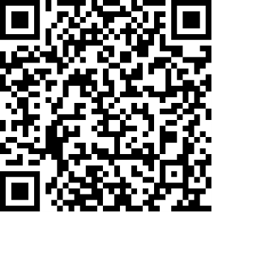
Donations
We would greatly appreciate your help to continue our work for God in the village of Elham and surrounding areas. If you can, please consider making a donation. This is our QR code for St Mary’s Elham. To donate using this code, open up the camera on a mobile phone - point the camera at the QR code – follow the instructions.
The offertory plate will go round in the service, during one of the hymns. There is also the opportunity to donate by card using the PAYAZ machine by the North door.

Safeguarding / ‘A Safe Church’:
If you ever have any concerns, contact our Parish Safeguarding Officer:
Susannah Pallot : susannahpallot@gmail.com

Paper Copies of Notices
Some copies are available on back table in church. Please take a copy to give to those unable to access the internet.

